Ancient language Sanskrit for cognitive robotics with emotions and consciousness
Madhavendra Saxena
RIT Roorkee, India
Abstract
Statement of the problem: Conducting research with the objective of enabling a robot to perform human-like autonomous behaviour and communication. For this purpose, we have developed consciousness and emotional modules, which by means of groups of neurons comprise the elements that make up the functions of consciousness, 9 emotions and 42 feelings that are possessed by humans, and mounted them on a robot. In research study, we propose a consciousness and emotional model based on epic Hindu Ramayana and the charter is Ravan which he created 9 artificial heads with 9 emotions with consciousness [Figure 1] he that enables a robot to evolve in accordance with rules based on our definitions of pleasant and unpleasant states in a conscious system comprised of. For the definitions of the pleasant and unpleasant states, we are using the “smoothness of the information flow” in the conscious system. Technology is introducing the possibility of recording various reactions, emotions or 42 feelings of a person at a given moment. It will combine monitoring and analysis of behaviour patterns, measuring actions, and noting facial expressions, voice intonation and body language.
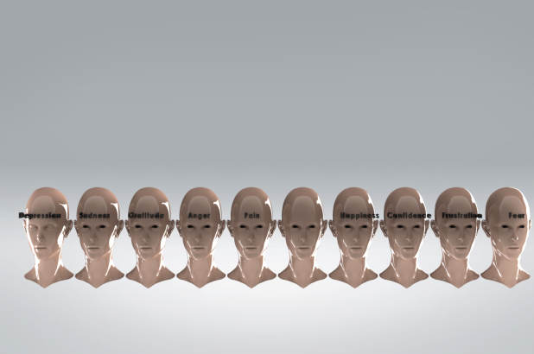
Figure 1. Artificially crated 9 emotions in robots.
Findings: While applications and benefits of robot emotion-sensing technology are limited only by our imagination, there are some obvious benefits. Emotion-sensing technologies can help employees make better decisions, improve their focus productive working styles. The ultimate scientific question we want to address with this kind of work is to understand the role emotion-like processes might play in socially situated learning and social development of robots that co-exist with people in the human environment. Mood sensor technology can help children or the elderly, who are in need of care, to receive timely assistance and support from family members or caregivers, who can then alert doctors.
Conclusion: A robot is the fundamental human development principle of evolving based on emotions. And, by defining the many outstanding unresolved mysteries 9 emotions in a robot of the principles of human development in a visible way that we call the “smoothness of information,” we have established the capability of emotion-based decision-making in the robot. As a result, we believe that we have achieved on the robot a system that takes into account the unification of reason with emotions and feelings.
Biography
Madhavendra Saxena is a qualified senior dynamic academician with nearly about 28 years of overall experience including over 14 years in the field of teaching, academics and Research. He is an International speaker Machine Vibration Analysis Conference to be an invited speaker hosted by Mobius Institute D Orlando, FL USA, on Bearing Faults Diagnosis by Using Brain Wave with Machine Consciousness and Emotions, Artificial Intelligence, Machine learning signal processing Session chair in the 7th International congress on logistics and SCM system, Seoul Korea and Sharjah UAE Challenges in supply chain forecasting uncertainty in inventory fuel management system.

