Applications and Opportunities Associated with Plastics Recycling
Denis Rodrigue, PhD, Laval University, CANADA

Abstract
Statement of the Problem: Every day, plastics are generating a high amount of waste. This is not only associated with single-use plastics (SUP) for packaging, but also from several other applications including automotive, building, construction, energy, leisure, sports, transport, etc. All these materials must now be recycled/revalorized after their end-of-life (EOF) to comply with the concepts of sustainable development (SD) and circular economy (CE). This also helps to reduce their accumulation into landfills or eventually in the oceans. Methodology & Theoretical Orientation: In this study, statistics on plastics recycling were gathered and analyzed to determine the main applications/areas generating plastics wastes. Then, different options were proposed for specific material recycling, especially for different structures or compositions (blends, composites, foams, multilayers, etc.). In all cases, the focus was on mechanical recycling. As a first application, a two-component wheel was produced, each part being made of 100% recycled polymers. For example, the inside was made of high density polyethylene (HDPE) from rigid bottles, while the exterior was a blend of the same HDPE (good interfacial adhesion/compatibility between both parts) with different concentrations (0-95% wt.) of ground tire rubber (GTR). The compounds were made by twin-screw extrusion and the final parts were produced via compression molding. Conclusion & Significance: The results obtained showed that after an optimization of the processing conditions (pressure, temperature, time, etc.), a wide range of different properties (elasticity, hardness, impact, rigidity, strength, etc.) can be easily obtained by simply changing the GTR content. This indicates that 100% recyclable and sustainable parts can be produced for an application as reported in Figure 1. Depending on the initial materials used, different looks can be produced without special processes and even additives. These results open the door for future development by using different polymers for the dispersed and the continuous phases.
Image

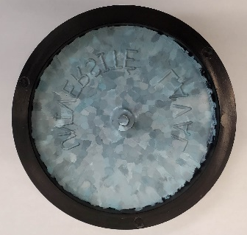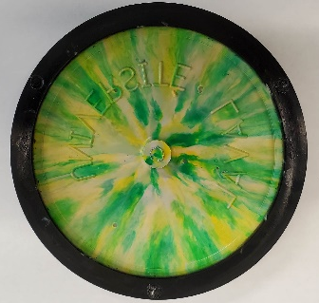
Figure 1. Examples of wheels based on 100% recycled materials.
Recent Publications
- Vázquez Fletes RC, Rodrigue D (2021) Effect of wood fiber surface treatment on the properties of recycled HDPE/maple fiber composites. Journal of Composites Science, 5(7): 177.
- Fazli, A, Rodrigue, D (2021) Effect of ground tire rubber (GTR) particle size and content on the morphological and mechanical properties of recycled high-density polyethylene (rHDPE)/GTR bends. Recycling, 6(3): 44.
- Fazli, A, Rodrigue, D (2021) Morphological and Mechanical Properties of Thermoplastic Elastomers Based on Recycled High Density Polyethylene and Recycled Natural Rubber. International Polymer Processing, 36(2): 156-164.
- Fazli, A, Rodrigue, D (2021) Recycling Waste Tires into Ground Tire Rubber (GTR)/Rubber Compounds: A Review. Journal of Composites Science, 4(3): 103.
- Fazli, A, Rodrigue, D (2021) Waste Rubber Recycling: A Review on the Evolution and Properties of Thermoplastic Elastomers, Materials: 13(3): 782.

Biography

Denis Rodrigue obtained a B.Sc. (1991) and a Ph.D. (1996) in chemical engineering from Université de Sherbrooke (Sherbrooke, Canada). In 1996 he moved to Université Laval (Quebec City, Canada) where he is now full professor. Since then, he has been an invited professor at the University of Guadalajara (Mexico), the Technical Institute of Karlsruhe (Germany), the University of Castilla-La Mancha (Spain), the University of Arts and Sciences of Hunan (China), the Technical University of Lodz (Poland), Polytech Tours (France) and Cracow University of Technology (Poland). His main research is the characterization and modelling of the morphological / mechanical / thermal / rheological properties of polymer foams and composites based on thermoplastics and elastomers, with a focus on polymer recycling and rheology. He is the co-editor of Current Applied Polymer Science and a member of the editorial board of Biopolymer Applications Journal, Cellular Polymers, Elastomery, Polymers, and Recycling.
.

Email: denis,rodrigue@gch.ulaval.ca

Notes/Comments:

Presenting author details
Full name: Denis Rodrigue
Contact number: +418-656-2903
Mail id: denis.rodrigue@gch.ulaval.ca
Category: Oral presentation

