

Success is not the key to happiness. Happiness is the key to success. If you love what you are doing, you will be successful.
Albert Schweitzer

Title: HPLC- High Performance Liquid Chromatography
Name: Kassandra Kakkarou

Utrecht University, Heidelberglaan 8, 3584 CS Utrecht, The Netherlands

Email: kassandrakakkarou@gmail.com

High-Performance Liquid Chromatography is a specific form of column chromatography that is used in the field of chemistry and biochemistry. It is a form of liquid chromatography which separates, identifies, and quantifies components in a mixture. High-Performance Liquid Chromatography utilizes a column that holds the packing material (stationary phase), a pump that moves the mobile phase(s) through the column, and a detector that shows the retention times of the molecules. Retention time varies depending on the interactions between the stationary phase, the molecules being analyzed, and the solvent(s) that is used.(Bansal V. et al., Journal of Global Pharma Technology. 2010) In the High-Performance Liquid Chromatography, the mobile phase is liquid, which is typically pressurized to flow through the separation column which is filled with the stationary phase. The High-Performance Liquid Chromatography system consists of the pump, the injector, the HPLC column, the detector, the data system, and the solvent reservoir. There are different types of High-Performance Liquid Chromatography such as reverse-phase, normal-phase, ion-exchange, and size-exclusion chromatography. The variety of the stationary and mobile phases that can be selected for the High-Performance Liquid Chromatography allows the separation of a wide variety of compounds starting with the small molecules and extending to polymers such as proteins and nucleic acids.(Moldoveanu et al., Selection of the HPLC method in chemical analysis, 2017) High-Performance Liquid Chromatography is a widely used analytical technique in various fields and industries. Its versatility, sensitivity, and ability to separate complex mixtures make it valuable in many applications.

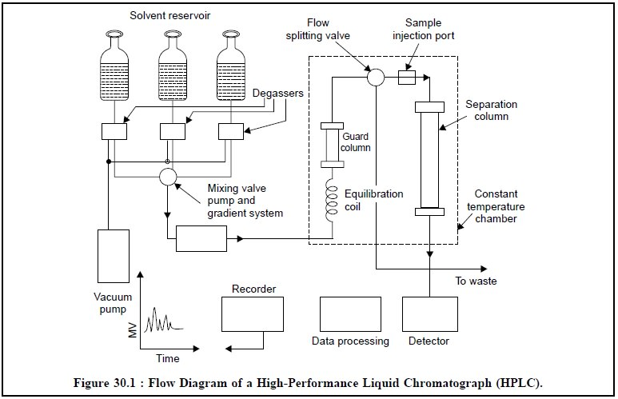
Pharmaceutical Drug Analysis, Instrumentation - High Performance Liquid Chromatography (HPLC)

Biography

Kassandra Kakkarou is a master student in Marine Sciences at Utrecht University. She was born in Lesvos, Greece. She graduated from the high school of Kalloni in 2016. She participated in panhellenic exams in 2016 and she collected 15127 points. She studied in the department of Chemistry at University of Crete. She attended the seminar ‘’High Performance Liquid Cromatography Method’’ in 2020. She graduated from the department of Chemistry at University of Crete in 2021. She has the full basic level diploma of the ECDL. She attended the summer school Marine Masters in Nioz sea research in 2023.

Notes/Comments:

Presenting author details
Full name: Kassandra Kakkarou
Contact number: 306973166029
Twitter account:-
Linked In account: https://www.linkedin.com/in/kassandra-kakkarou-716163209/
Sessionname/number:-
Category: (Oral presentation)

