Tackling the decontamination challenge: nanorecycling of plastic waste
Jocelyn Doucet, Jean-Philippe Laviolette, Ali Eslami

Abstract (300 word limit)
The end-of-life management and recycling of polymer wastes remains a key environment issue in on-going efforts to increase resource efficiency and attaining GHG emission reduction targets. Half of all the plastics ever produced were made in the last 13 years, and only about 16% of that plastic waste is collected for recycling, while 25% is incinerated, 40% is landfilled, and 19% is unmanaged and leaks in the environment and waterways. In addition to the plastic collection issue, the UN recently published a report on chemicals in plastics, which adds another layer of challenge when integrating recycled content containing toxic products into new products. To tackle these important issues, innovative solutions are required. Chemical recycling of plastics provides new complementary alternatives to the current recycled plastic market by converting waste material into a high value chemical commodity that can be reintegrated in a variety of applications, making the total market size of the output – virgin-like, high value products - larger than the market size of the input – plastic waste. Access to high-quality feedstock also remains a major obstacle, primarily due to material contamination issues. Pyrowave approaches this challenge with its innovative nano-recycling technology, which purifies polymers at the molecular level, removing undesirable contaminants and restoring the resin to its virgin state without having to depolymerise it. This breakthrough approach expands the range of plastics that can be effectively recycled, including mixed plastics with various contaminants such as lead, inorganic pigments, and flame retardants. The technology allows yields below 100ppm, and purity can be adjusted to an infinitesimal level depending on the customer's specifications. The separation of the polymer and contaminants in Pyrowave's nano-recycling process offers the unique ability to customize the solution on targeted additives and contaminants to be removed based on the difference in molecular size. This precise control enables the attainment of a final polymer purity equivalent to virgin resin. The patented process involves dissolving the contaminated material using a specially formulated solvent, purifying the mixture at the molecular level, and subsequently extracting the solvent to yield a purified polymer resin that can directly be reintegrated in new products without further treatment. Notably, this technology offers simplicity, effectiveness, and flexibility while minimizing environmental impact and preserving valuable resources in the manufacturing circuit. Pyrowave has successfully applied this nano-recycling technology to decontaminate polymers and supply purified, high-quality recycled plastics to critical industries, including food-contact compliance. The technology is low-carbon, electrified, and provides 100% traceable resins with properties identical to those of virgin resins. Additionally, the issue of low recycling rates and the limited market for traditionally hard-to-recycle plastic waste has fueled the need for new complementary alternatives. Chemical recycling, such as Pyrowave's microwave depolymerization, presents a sustainable and efficient solution by converting plastic waste into high-value commodities. By employing microwave catalytic depolymerization, Pyrowave enables a truly circular economy of plastics, particularly in treating polystyrene waste to produce virgin-like styrene monomers. This revolutionary approach boasts low energy consumption, high yields, and a reduced carbon footprint. Pyrowave offers a portfolio of sustainable, low-carbon, electric solutions to give plastic waste a second life and paves the way to the new circular economy of plastics. Here, particularly for polystyrene, we show that styrene monomer yields from Pyrowave’s polystyrene microwave depolymerization reactor is 2,2 to 1,5 times higher than that of the thermal conventional pyrolysis. In addition, we provide a detailed understanding of the microwave assisted depolymerization via analyzing the effects of microwave power, pyrolysis time, microwave receptor and temperature on the styrene product yields. Furthermore, we investigate life cycle environmental impact assessment of microwave assisted pyrolysis of polystyrene in commercial-scale production. Finally, it is worth pointing out that Pyrowave is able to treat several tons of polystyrene to produce virgin styrene monomers and manage waste/contaminated polymeric materials as well in a truly circular economy.
Recent Publications (minimum 5)
No recent publications

Biography (150 word limit)
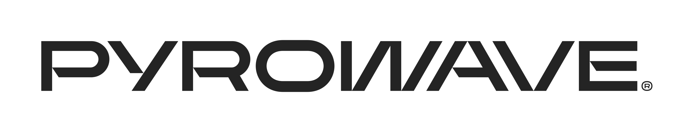
Jocelyn Doucet is a chemical engineer and an entrepreneur dedicated to the development and marketing of innovations in connection with the transition in the use of our non-renewable resources to a circular economy business model. With a team of professionals under his leadership, he developed a patented technology—the Catalytic Microwave Depolymerization—for the local processing of mixed plastics, including polystyrene, into a raw material identical to the original feedstock, to be reused by the chemical industry in new plastics manufacturing. This innovation has an undisputable positive environmental impact, as it helps recycle materials found in soils and oceans.
Mr. Doucet holds a Ph. D. in Chemical Engineering from Polytechnique Montreal, where he has been an adjunct professor since 2011. As part of his education, he started a first company specializing in the scale up of chemical processes and developed several innovations now released on global markets. He then focussed on resource efficiency and led a team responsible for the development of a technology using microwaves to break down molecules into their original components. In 2014, this idea led to the creation of Pyrowave, a company which developed the most advanced high power microwave technology platform worldwide and is now at the forefront of the new revolution intended to increase resource efficiency. Pyrowave works in tandem with the largest stakeholders in the global polymer industry, including Total, INEOS Styrolution and America Styrenics, and is currently at the marketing stage in North America and Europe.

Notes/Comments:
No research has currently been published on the process but the technology is patented. The patent can be sent upon request.
Presenting author details
Full name: Jocelyn Doucet

Pyrowave contact – Mathieu Pagé, public relations advisor
Contact number: 438-227-8344
Mail id: mpage@pyrowave.com
Category: Oral presentation

