Effects of Carbonization use the Hydrothermal Treatment Carbonization(HTC) For Microplastic
Dongkyu Park, University of Seoul,
Geongwoo Choi, University of Seoul

Abstract (300 word limit)
Study was apply hydrothermal carbonization (HTC) to microplastics generated by various degradation and erosion processes of persistent plastic waste. To achieve this, samples of microplastic raw material and microplastic waste were selected by particle size. HTC subjected to generate solid and oil fractions. The raw materials and microplastics, trends were identified. The First fuel potential of t raw materials and microplastics was confirmed through physical and chemical analysis before apply HTC. The conditions of reaction temperature and time were varied to obtain optimal conditions for yield of oil (C15, C16). Physical and chemical analysis of the microplastic raw material and microplastic waste showed that both had combustible fractions of over 90% and ash content differences of 0.5-1.0% for raw material and 5.9-7.3% for waste, attributed to additives or colorants in the waste. The fixed carbon content was 0.1-0.2% for raw material and 1.1-2.3% for microplastic waste. Analysis of heavy metals indicated that both microplastics met quality standards for solid fuel products. TGA analysis showed weight loss at around 200℃ for PE in both raw material and waste, and at 100-200℃ for PS and PP in both raw material and waste, enabling selection of HTC reaction temperature for each plastic type. Optimal reaction times for each plastic type were also determined. Therefore, it was confirmed that microplastic raw materials and microplastic waste produced solid fuels when subjected to HTC, while liquid fuels showed the highest yield of C15, C16 from PE at 240℃ for 40 min, PS at 270℃ for 60 min, and PP at 240℃ for 60 min.

Image
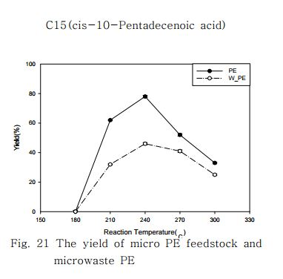
Recent Publications (minimum 5)
- Ryu Ji-hyun, Jo Chung-yeon, 2019 "Current Status and Impact on Human Health of Microplastics" KIC News, Vol. 22, No. 2.
- Ahn Dae-han, 2018, "A Study on Improvement Directions for Policies to Prevent Marine Pollution Caused by Microplastics", Master's thesis, Chung-Ang University.
- Ahn Hyun-gyu, 2019, "A Study on the Stabilization of Heavy Metals in Contaminated Soil Using Hydrothermal Carbonization (HTC)", Master's thesis, Seoul City University.
- Lee Hee-sun, 2019, "Generation and Recycling Status of Plastic Waste", Social Trends in Korea 2018, Statistics Korea Statistical Research Institute
- Korea Environmental Industry & Technology Institute, 2018, "Current Status and Solutions for Domestic and International Plastic Waste Issues", Konetic report

Acknowledgement

This work was supported by the Korea Ministry of Environment as Waste to Energy-Recycling Human Resource Development Project.(YL-WE-22-001)

Biography (150 word limit)
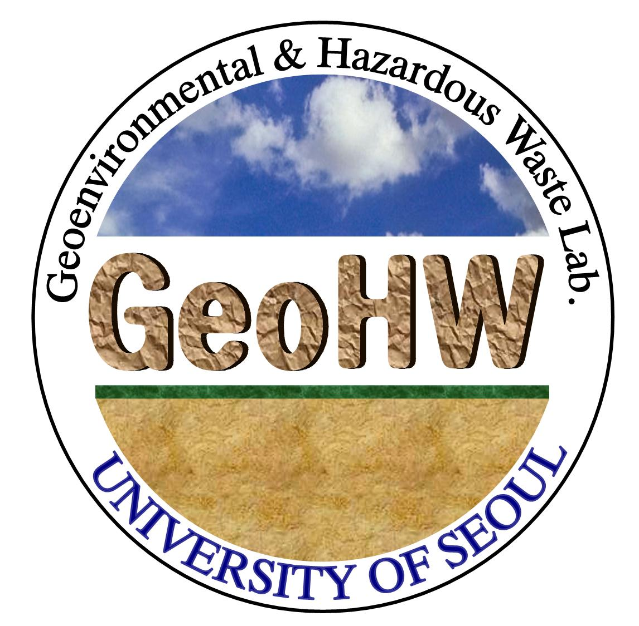
Dongkyu Park has expertise in evaluation and passion in improving the enoviormental engineering. he has researched this thesis after years of experience in study, evaluation, teaching and administration both in site and education institutions. The aim of this study was to apply hydrothermal carbonization (HTC) to microplastics generated by various degradation and erosion processes of persistent plastic waste, in order to produce solid and liquid fuels
Email: ehdrb5110@uos.ac.kr

Notes/Comments:

Presenting author details
Full name: Park Dong Kyu
Contact number: +82-10-5335-5104
Twitter account: -
Linked In account: -
Session name/ number:
Category: Poster presentation

