Global prevalence of nosocomial infection: A systematic review and meta-analysis
Samira Raoofi, PhD, Iran University of Medical Sciences, Iran
Ahmad Ghashghaee, MSc, University of Glasgow, UK

Abstract (300 word limit)

Hospital-acquired infections (HAIs) are significant problems as public health issues which need attention. Such infections are significant problems for society and healthcare organizations. This study aimed to carry out a systematic review and a meta-analysis to analyze the prevalence of HAIs globally.

We conducted a comprehensive search of electronic databases including EMBASE, Scopus, PubMed and Web of Science between 2000 and June 2021. We found 7031 articles. After removing the duplicates, 5430 studies were screened based on the titles/ abstracts. Then, we systematically evaluated the full texts of the 1909 remaining studies and selected 400 records with 29,159,630 participants for meta-analysis. Random-effects model was used for the analysis, and heterogeneity analysis and publication bias test were conducted.

The rate of universal HAIs was 0.14 percent. The rate of HAIs is increasing by 0.06 percent annually. The highest rate of HAIs was in the AFR, while the lowest prevalence were in AMR and WPR. Besides, AFR prevalence in central Africa is higher than in other parts of the world by 0.27 (95% CI, 0.22-0.34). Besides, E. coli infected patients more than other micro-organisms such as Coagulase-negative staphylococci, Staphylococcus spp. and Pseudomonas aeruginosa. In hospital wards, Transplant, and Neonatal wards and ICU had the highest rates. The prevalence of HAIs was higher in men than in women.

We identified several essential details about the rate of HAIs in various parts of the world. The HAIs rate and the most common micro-organism were different in various contexts. However, several essential gaps were also identified. The study findings can help hospital managers and health policy makers identify the reason for HAIs and apply effective control programs to implement different plans to reduce the HAIs rate and the financial costs of such infections and save resources.
Image
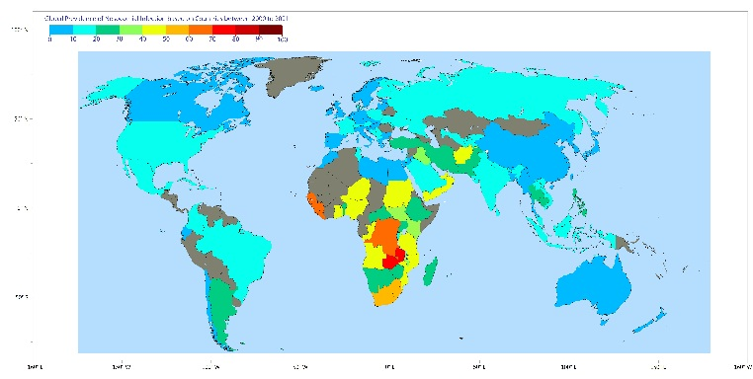
Figure 1. The prevalence of HAIs based on countries.
Recent Publications (minimum 5)
1- Hazard, D., et al., Predicting Potential Prevention Effects on Hospital Burden of Nosocomial Infections: A Multistate Modeling Approach. Value in Health, 2021. 24(6): p. 830-838.
2- Šuljagić, V., et al., A nationwide assessment of the burden of healthcare-associated infections and antimicrobial use among surgical patients: results from Serbian point prevalence survey, 2017. Antimicrob Resist Infect Control, 2021. 10(1): p. 47.
3- König, E., et al., Prospective Surveillance of Healthcare-Associated Infections in Residents in Four Long-Term Care Facilities in Graz, Austria. Antibiotics (Basel), 2021. 10(5).
4- Hoxha, A., E. Duysburgh, and L. Mortgat, Healthcare-associated infections in home healthcare: an extensive assessment, 2019. Euro Surveill, 2021. 26(5).
5- Gozel, M.G., et al., National Infection Control Program in Turkey: The healthcare associated infection rate experiences over 10 years. American Journal of Infection Control, 2021.

Email: ahmad.ghashghaee1996@gmail.com

Notes/Comments:

Presenting author details
Full name: Ahmad Ghashghaee
Contact number: +447310917653
Linked In account: ahmad.ghashghaee
Session name/ number:
Category: (Oral presentation/ Poster presentation)

