Association of PDO threads and Technologies —
Facial Treatment protocols
Clessya Rocha Miranda, MD, Grupo Andre Borba, São Paulo Brazil

Abstract
Aging is part of the human being, and the search for treatments to alleviate facial wrinkles is frequent in the dermatological office, where minimally invasive facial rejuvenation techniques often associate technologies and polydioxanone (PDO) threads that together present satisfactory result. The concern of most medical professionals when using these technologies, which initially heat the skin, is the possibility of breaking or melting the wires. However, it is well established that the melting point of PDO polymer is 110° to 115° C, a temperature well above the maximum temperature reached by thermal damage to tissues caused by technologies. Although there are still no publications on protocols and technologies for associating PDO threads, however, through the scientific evidence already well established by the basic principles of the technologies and their mechanisms of action, interaction with the tissue, it is possible to associate these techniques. A summary of the associations of the most common current technologies with PDO threads can be found in Table 1. Among the technologies, microfocused ultrasound (HIFU) acts in the same anatomical plane as the PDO threads, which is the superficial subcutaneous layer. For contextualization, I report the case of a patient where HIFU and PDO wires with claws were performed and the result after 60 days. 150 shots were performed per hemiface with Ultraformer® technology with the tips: 4.5 - 30 shots 0.8 mj; 3.0 - 30 shots, 0.7 mj; 2.0 - 50 shots 0.3 mj and 1.5 0.2 mj 40 shots. Then, 2 PDO Sculpt® wires 18 G x 165 mm were made in the middle third and 2 PDO spiculated wires 19 G x 160 mm in the lower third per hemiface, totaling 8 (Figure 1). This poster aims to bring clarity on how to use the technology associated with PDO threads.

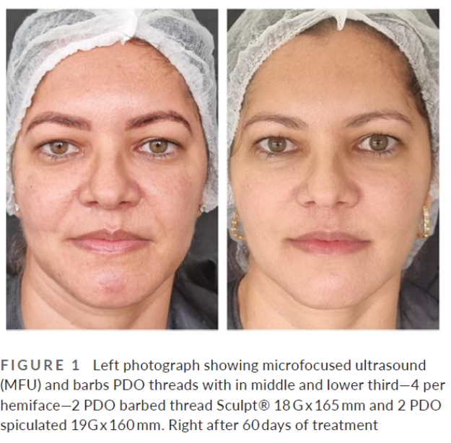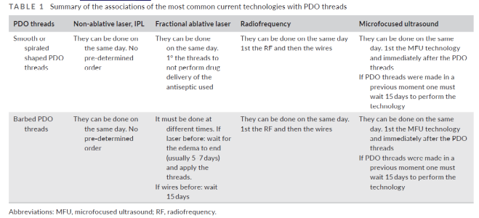

Recent publications
- FABI, S. G.; GOLDMAN, M. P. Retrospective evaluation of micro-focused ultrasound for lifting and tightening the face and neck. Dermatologic surgery, v. 40, n. 5, p. 569–575, 2014.
- MARTINS, J. A. et al. Polydioxanone implants: A systematic review on safety and performance in patients. Journal of biomaterials applications, v. 34, n. 7, p. 902–916, 2020.
- SADICK NS, MAKINO Y. Selective electro- thermolysis in aesthetic medicine: a review. Lasers Surg Med. 2004; 34 (2):91-7.
- STRATIGOS, A. J.; DOVER, J. S. Overview of lasers and their properties. Dermatologic therapy, v. 13, n. 1, p. 2–16, 2000.
- TANNOUS Z. Fractional resurfacing. Clin Dermatol. 2007; 25: 480-6.
- TAVARES, J. DE P. et al. Facial thread lifting with suture suspension. Brazilian journal of otorhinolaryngology, v. 83, n. 6, p. 712–719, 2017.
- YOON, J. H. et al. Tissue changes over time after polydioxanone thread insertion: An animal study with pigs. Journal of cosmetic dermatology, v. 18, n. 3, p. 885–891, 2019

Clessya Rocha is an experienced Brazilian certified dermatologist, who over her 17 years of practice has built protocols with minimally invasive technologies and treatments for facial rejuvenation, bringing beauty and naturalness to her patients. Currently, in addition to being a dermatologist, she works as a professor of dermatology at the State University of Southwest Bahia and is a researcher in PDO threads, her doctoral thesis in progress. International speaker, recently published the article on Association of PDO threads and Technologies Facial Treatment protocols.

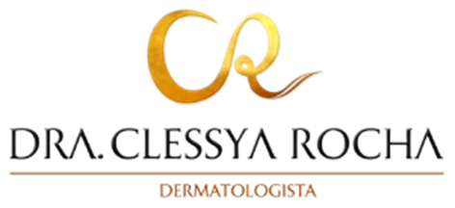

Email: keurocha@hotmail.com
Full name: Clessya Rocha Miranda
Contact number:55-73988440972
Instagram account: @draclessyarochadermato
Session name/ number: Cosmetic Dermatology
Category: Oral presentation

