Sinus venous atrial septal defect with partial anomalous pulmonary venous return and subsequent atrial remodeling with atrial flutter

Xiarepati Tieliwaerdi, MD, Allegheny General Hospital, USA

Fouad Jabbour, MD, Allegheny General Hospital, USA

Victor Farah, MD, Allegheny General Hospital, USA

Abstract
A 58-year-old male presented to emergency department with a complaint of worsening episodic fluttering in his chest associated with dizziness, lightheadedness, dyspnea and occasional chest pain. His symptoms started about 7 years ago and previously saw a cardiologist but lost to follow up afterwards. His past medical history was significant for sinus venous atrial septal defect (SVASD) status post patch repair at age 13 and partial anomalous pulmonary vein return. Physical exam was remarkable for tachycardia and irregular rhythm. Laboratory testing was notable for mildly elevated proBNP, normal troponin. EKG showed superiorly and leftward directed flutter waves, positive in lead V1 and V2, transition to negative by V3, most consistent with cavotricuspid isthmus-dependent atrial flutter (AFL). However, incisional flutter given his history of SVASD repair might be contributory as well. He was started on anticoagulation and outpatient ablation was planned. Transesophageal echocardiogram (TEE) was performed prior to rule out left atrial appendage thrombus. TEE was negative for thrombus but showed failed prior SVASD repair with shunting, no evidence of patent foramen ovale (PFO). Computed tomography angiography (CTA) of the chest (Figure 1) showed persistent anomalous right upper middle lobe vein drains anatomically into superior vena cava (SVC). Cardiac MRI (Figure 2) demonstrated the anomalous venous drainage and showed a small leak in SVASD repair patch, enlarged right ventricle (RV), with Qp/Qs of 1.4. Multidisciplinary team includes cardiologists, electrophysiology cardiologists and cardiothoracic surgeons followed the case and suspected that the left to right shunting led to RV volume overload and increased pulmonary hypertension, which subsequently resulted in atrial tissue remodeling and resultant AFL. They recommended proceeding with right heart catheterization next to directly assess oxygen saturation step-up before deciding whether redo SVASD repair is necessary or not. Patient was also planned to have AFL ablation outpatient.

Image
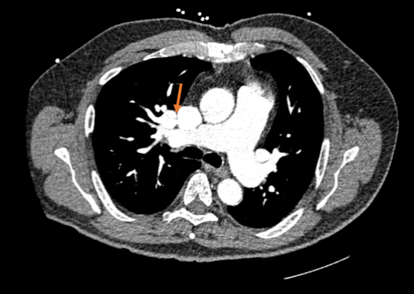

Figure 1 CTA right upper pulmonary vein connection to SVC (arrow)
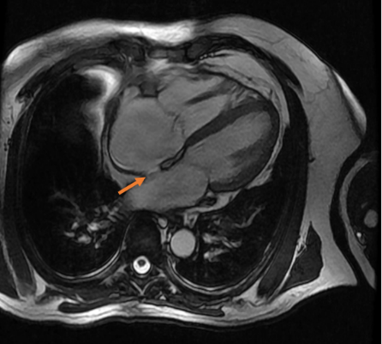
Figure 2 Cardiac MRI SVASD (arrow)

Recent Publications
- Tieliwaerdi, X & Aripova, N & Duryee, M & Jiang, X & Klassen, L & O'Dell, J & England, B & Anderson, D & Mikuls, T & Thiele, G. Matrix Gla Protein (MGP) Modified with Malondialdehyde/Acetaldehyde Is Increased in Rheumatoid Arthritis and Cardiovascular Patients. Arthritis & Rheumatology , 72(Suppl 10), Oct, 2022
- Aripova, N & Duryee, M & Tieliwaerdi, X & Jiang, X & Klassen, L & O'Dell, J & England, B & Mikuls, T & Thiele, G. Modification of THP-1 Cells with Malondialdehyde-Acetaldehyde Increases Cellular Calcium Load Rendering Cells Susceptible to Citrullination of Self-Proteins. Arthritis & Rheumatology, 72(Suppl 10), Oct, 2020
- Ahmad, S & Khan, BA & Muhammad, S & Yousaf, A & Abdelazeem, B & Ahmad, M & Tieliwaerdi, X & Qavi, AH. Comparison of Impella Support versus Extracorporeal Membrane Oxygenation in Patients with Cardiogenic Shock: A Systematic Review and Meta-analysis. Cardiogenic shock and hemodynamic support , volume 1, issue 3, supplement, May 01, 2022
- Jabbour F, Kanmanthareddy A. Sinus Node Dysfunction. 2022 Jul 5. In: StatPearls [Internet]. Treasure Island (FL): StatPearls Publishing; 2022 Jan–. PMID: 31334973.
- Jabbour F, Grossman SA. Atrioventricular Reciprocating Tachycardia. 2021 Aug 29. In: StatPearls [Internet]. Treasure Island (FL): StatPearls Publishing; 2022 Jan–. PMID: 30969587


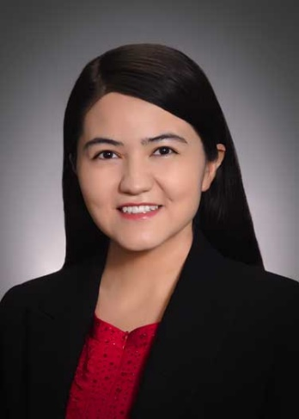
Biography
Xiarepati Tieliwaerdi has completed her MD University of Nebraska Medical Center , USA. She is an internal medicine resident in Allegheny General hospital in Pittsburgh, Pennsylvania, USA. She developed her interest in cardiology when she was working in autoimmune disease laboratory in medical school focusing on autoimmune disease and its cardiovascular comorbidities. She has been continuing her research in complex cardiac clinical cases diagnosis and management and advanced cardiac imaging interpretation during her residency training.

Email: x.tieliwaerdi@outlook.com

Notes/Comments:

Presenting author details
Full name: Xiarepati Tieliwaerdi
Contact number: +1 402-457-9633
Twitter account: NA
Linked In account: NA
Session name/ number:
Category: (Oral presentation/ Poster presentation)

