NECTAR Project: an initiative to maintain normothermia for the preterm infant in a tertiary care centre in UK.

Ali M, Aslam Q, Yadav K.

Background:
Normothermia (36.5°C to 37.5°C) is vital in neonatal resuscitation. Admission temperatures in preemies inversely correlate with mortality, every 1°C drop below the range increases mortality by 28%¹. It also increases the risk of sepsis, intraventricular hemorrhage, hypoglycemia, Necrotizing enterocolitis and death.^{2,4,5}

Aim & Objectives:
To improve normothermia rates in preterm admissions <32 weeks promoting better outcomes.

Methods:
The project commenced in 2019 with planned 6 monthly cycles coinciding with the rotation of junior doctors. Focusing on pre-birth, birth and post-birth areas, interventions were put in place to optimize preterm stabilisation.

Results:
Audit cycles demonstrated inconsistencies in using thermoregulation procedures, variations in the timing of temperature checks from the delivery suite to the neonatal unit and suboptimal delivery room temperatures. A thermoregulation flowchart was devised and an education initiative with bedside training was rolled out. Timing of temperature check was standardised and steps to establish normothermia before mobilising the baby to the neonatal unit were put in place.
To achieve the best results, a multidisciplinary approach was adopted in subsequent cycles. The training was more robust with posters, and e-learning packages including videos. Representatives from midwifery, neonatal medical and nursing were appointed to tackle issues from pre-birth, during birth and post-birth angles. Debrief forms were used to recognise and solve the hurdles in real-time.
Significant improvements were reflected in various areas of this project. Regular meetings between the multidisciplinary champions ensured that progress was maintained. We introduced continuous temperature monitoring probes with teaching packages to further optimise thermoregulation rates.

Conclusion:
The project showed significant improvement in the overall normothermia rates in preterm stabilisation reflecting the importance of a multi-disciplinary approach and robust interventions.

References:

Lyu Y, Shah PS, Ye XY et al. Association Between Admission Temperature and Mortality and Major Morbidity in Preterm Infants Born at Fewer Than 33 Weeks’ Gestation. JAMA Pediatr. 2015; 169(4):e150277. doi:10.1001/jamapediatrics.2015.0277

Yu YH, Wang L, Huang L, Wang LL, Huang XY, Fan XF et al. Association between admission hypothermia and outcomes in very low birth weight infants in China: a multicentre prospective study. BMC Pediatr. 2020 Jun 29;20(1):321. doi: 10.1186/s12887-020-02221-7.

3.Andrews C, Whatley C, Smith M, Brayton EC, Simone S, Holmes AV. Quality-Improvement Effort to Reduce Hypothermia Among High Risk Infants on a Mother-Infant Unit. American Academy of Paediatrics. 2018; 141(3).
4. Wang L, Liu ZJ, Liu FM, Yu YH, Bi SY, Li B et al. Implementation of a temperature bundle improves admission hypothermia in very-low-birth-weight infants in China: a multicentre study. BMJ Open Quality. 2022; 11(2).
5. Miller SS, Lee HC, Gould JB. Hypothermia in very low birth weight infants: distribution, risk factors and outcomes. J Perinatol. 2011; 31 (suppl 1):S49-S56.

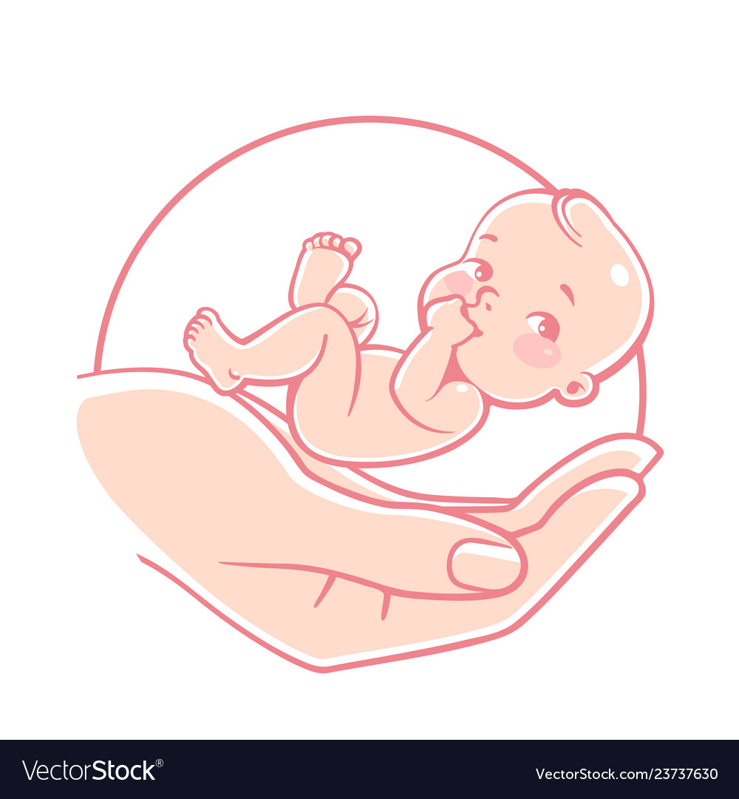

Biography
I am Quratulain Aslam. I have expertise in Paediatrics and neonates. I am an international doctor and currently working in one of the biggest neonatal unit in the United Kingdom. We aim to provide the best care to babies born in our unit and keep on taking steps aiming to provide quality care to the babies.
Email: quratulain.aslam@nhs.net

Notes/Comments:

Presenting author details
Full name: Quratulain Aslam
Contact number: 07508438958
Twitter account: none
Linked In account: quratulain-aslam@hotmail.com
Session name/ number:
Category: (Oral presentation/ Poster presentation). Either

