Burnout among nurses working in Ethiopia

Ephrem Tanga
Ottona Referral Hospital, Ethiopia

Abstract
Background: Burnout is a condition of emotional exhaustion, depersonalization, and low personal accomplishment that can occur among individuals who work with people in some capacity. Nursing is a stressful profession that deals with human aspects of health and illness and can ultimately lead to job dissatisfaction and burnout. Although burnout among nurses has been addressed in previous research, the heterogeneous nature of the result findings highlights the need for a detailed meta-analysis in Ethiopia. Thus, this review is aimed at identifying the prevalence of burnout among nurses in Ethiopia.
Methods: A search strategy was implemented using electronic databases (PubMed/MEDLINE, Google Scholar, Web of Science, Cochrane Library, Africa-Wide Information, and African Index Medicus) which were systematically searched online to retrieve related articles using keywords. Studies which were included in this review were written in the English language because writing articles in other languages in Ethiopia is uncommon. The combination of key terms including "burnout", "nurse" and "Ethiopia", "systematic review" and protocols was used. The Preferred Reporting Items for Systematic Reviews and Meta-Analysis checklist guideline was followed stepwise. All published articles starting from inception to February 2020 were included, and we did not find unpublished studies. Heterogeneity across the included studies was evaluated by the inconsistency index. All statistical analysis was done using R and RStudio software for Windows, and a random-effects model was applied to estimate the overall prevalence of burnout among nurses in Ethiopia.
Results: The database searched produced 1060 papers. After adjustment for duplicates and inclusion and exclusion criteria, seven articles with 1654 total nurses were found suitable for the review. Except for one cohort study, all studies were cross-sectional. The overall pooled prevalence of burnout among Ethiopian nurses was estimated to be 39% (95% CI: 27%-50%). Conclusions: Burnout affects two out of five nurses in Ethiopia. Therefore, effective interventions and strategies are required to reduce burnout among nurses.
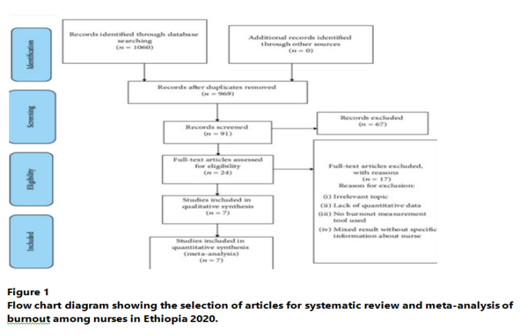
Recent publications
- Pisanti R., Lombardo C., Lucidi F., Violani C., Lazzari D. Psychometric properties of the Maslach Burnout Inventory for Human Services among Italian nurses: a test of alternative models. Journal of Advanced Nursing. 2013;69(3):697–707.
- Sabbah I., Sabbah H., Sabbah S., Akoum H., Droubi N. Burnout among Lebanese nurses: psychometric properties of the Maslach burnout inventory-human services survey (MBI-HSS) Health. 2012;4(9):644–652.
- Maslach C., Jackson S. E., Leiter M. P. Maslach Burnout Inventory 3rd edition manual. Mountain View, CA: CPP Inc; 1996.
- Karthik L., Kumar G., Keswani T., Bhattacharyya A., Chandar S. S., Bhaskara Rao K. V. Protease inhibitors from marine actinobacteria as a potential source for antimalarial compound. PLoS One. 2014;9(3, article e90972)
- Crawford E. R., LePine J. A., Rich B. L. Linking job demands and resources to employee engagement and burnout: a theoretical extension and meta-analytic test. Journal of Applied Psychology. 2010;95(5):834–84
Biography
I am a BSC Nurse currently working at Ottona referral hospital, Wolayta Sodo, Ethiopia. I have been working in this profession for the past 12 years in different hospitals and the main obstacle that I have noticed in our work environment was a massive emotional exhaustion related to different reason. I tried to implement a research strategy using electronic data base which were systematically searched online to retrieve related articles. Based on our brief result two out of five nurses in Ethiopia are affected with emotional exhaustion related to their work. This serious problem needs to be issued by the responsible sectors and ensure a better care and working environment for professionals.

