Important Advances in Antibacterial Porphyrin and Nanoparticle-Mediated Photodynamic Therapy
Prof Sandile Phinda Songca School of Chemistry and Physics, University of KwaZulu-Natal, Pietermaritzburg, South Africa

Abstract
Apart from enhancing the selectivity of Photodynamic therapy (PDT) for the disease over host tissue cells, nanotechnology also facilitates combinations of PDT with several non-invasive technologies, resulting in even further efficacy enhancement, and innovations for target specificity. The applications of PDT have expanded to disease types other than cancers, including bacterial, fungal, and viral diseases. The achievement of enhanced target specificity, which implies reduced systemic dose requirements for sufficient photosensitizer at the disease site and in the disease cells, is showing promise in research studies to reduce the emergence of resistance by microbial pathogens. The pursuit for selectivity has also ushered in various combinations of chemotherapy with PDT, essentially presenting the possibility of repurposing several antibiotics that are being used less because of resistance. Inorganic and organic dye nanoparticle photosensitizers are a novel nanotechnology discovery that has shown enhancement of PDT because of disease targeting. This paper describes the type I and II mechanisms of photodynamic and sonodynamic therapy, first and second-generation photosensitizers in the market, and the roles played by nanomaterials across the therapeutic value chain. The paper discusses the synthesis of photosensitizer porphyrins as organic dye photosensitizers, applications in the encapsulation of nanorods of silver, gold and iron oxide, and applications of the resulting nanoconjugates as delivery systems for the porphyrin photosensitizers, smart stimulus-responsive photosensitizer release and disease cell-targeting. The paper introduces the folate- and glycan-based targeting nanoconjugates, pH and external stimulus-responsive release of the photosensitizer. Folate targeting is currently attracting increasing antibacterial applications. Anticancer and antibacterial applications of nanoparticles used as agents for combining PDT with other therapies are discussed. These are some of the reasons why the World Health Organization identified PDT among promising new technologies for localized antibacterial treatments.

Keywords: Bacterial wounds and burns, antibacterial photodynamic therapy, photodynamic antimicrobial chemotherapy, sonodynamic therapy, nanoparticle-mediated photodynamic therapy, bacterial resistance, bacterial cell specificity, selectivity, drug carrier, drug delivery.

Image
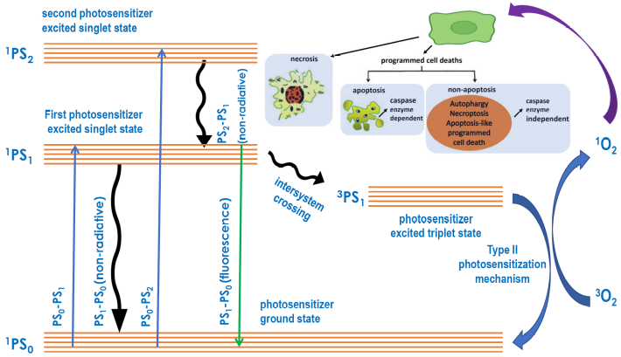
PDT process showing only the type II as the principal mechanism for the generation of reactive oxygen species.
Recent Publications
- Mona LP, Songca SP and Ajibade PA, 2022. Synthesis and encapsulation of iron oxide nanorods for application in magnetic hyperthermia and photothermal therapy, Nanotechnology Reviews, 11(1): 176-190.
- Songca SP and Adjei Y, 2022. Applications of Antimicrobial Photodynamic Therapy against Bacterial Biofilms, International Journal of Molecular Sciences, 23(6): 3209.
- Songca SP, 2022. Applications of Nanozymology in the Detection and Identification of Viral, Bacterial and Fungal Pathogens, International Journal of Molecular Sciences, 23(6): 23(9), 4638;
- Tsolekile N, Parani S, de Macedo EF, Lebepe TC, Maluleke R, Ncapayi V, Matoetoe MC, Songca SP, Conceição K, Tada DB and Oluwafemi OS (2022) Photodynamic therapy and antibacterial activities of a novel synthesized quaternary Zn-Cu-In-S/ZnS QDs- mTHPP Porphyrin conjugate, International Journal of Nanomedicine, 17:5315-5325.
- Tsolekile N, Parani S, Lebepe TC, Maluleke R, Ncapayi V, Matoetoe MC, Songca SP, Oluwafemi OS (2023). Cell Viability Study of ZnCuInS/ZnS–TPPS4 Conjugates against Different Cell Lines as a Promising Fluorescent Probe. Organics, 4, 126–136.



Prof Songca is the deputy Vice-Chancellor for Teaching and Learning at the University of waZuluNatal. He is serving at the HEQC of the CHE as a member of the NSRC. He qualified with a Ph.D. from Queen Mary and Westfield College, University of London, in organic chemistry with a medicinal slant and has experience in this area spanning over three decades. He has attracted several research grants, so far in excess of R70 million. He has read more than 90 conference papers and published more than 110 articles as journal articles and book chapters. He is has graduated more than 25 postgraduate students, and is currently supervising 2 PhDs. He has lectured chemistry 25 between 1983-2008. He has been married to Reverend Nokulunga Patricia Songca for 40 years.
Email: songcas@ukzn.ac.za

Presenting author details
Full name: Sandile Phinda Songca
Contact number: +27768687122
Mail id: songcas@ukzn.ac.za
Category: (Oral presentation)

