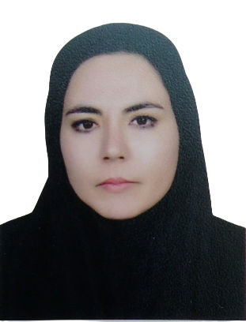

Title: The prevalence of musculoskeletal disorder and its related factors among female teachers in Kabul city
Name: Amena Ahmadi
Rehabilitation Sciences and Social Welfare university, Tehran, Iran

Background: Musculoskeletal Disorders (MSD) is one of the most common and important occupational health problems in working populations around the world. Some occupational groups, such as teachers, are more prone to musculoskeletal disorders due to occupational characteristics. The aim of this study was to investigate the prevalence of musculoskeletal disorders and related factors among female teachers in Kabul.
Methods: This study is a descriptive-analytical epidemiological study that involved 285 teachers form public and private school in the study randomly based on the inclusion criteria. Through relevant questionnaires, information was collected from personal, occupational and psychological characteristics.
Results: The prevalence of MSD in the six-month period was 55% in the lumbar region, 43% in the neck, 41% in the knee, 39% in the back, 30% in the ankle, 28% in the wrist, 26% in the shoulder, 20% in the thigh and 15% in the elbow. There was a significant relationship between weight, age, level of education, working hours, work experience, sports, body mass index, salary and education (P< 0/05). Writing on the board in the classroom, inappropriate posture during teaching, reviewing homework and checking students' exam papers, lack of desk and chair were identified as risk factors related to this disorder.
Conclusion: The prevalence of MSD is high among female teachers in Kabul. Factors such as weight, age, level of education, working hours, work experience, exercise, body mass index, smoking and education significantly increase the risk of this type of disorder among female teachers.
Keywords: musculoskeletal disorder, female teachers, prevalence of MSD, Kabul

Biography:
Ms. Ahmadi is a graduate of Master of Physiotherapy from Rehabilitation Sciences and Social Welfare university, Tehran, Iran. She has more than 10 years of experience in clinical physiotherapy and participated in many research programs.

Name: Amena Ahmadi
Email: amena.ahmadi67@gmail.com
Phone Number/ WhatsApp No: +989930441528

