A rare early-onset neonatal case of Birk-Barel syndrome presenting severe obstructive sleep apnea
Li Jinrog and Li YiFei
Sichuan University West China Second Hospital, China

Abstract

Background: Birk-Barel syndrome, also known as KCNK9 imprinting syndrome, is a rare fertility disorder. And the main clinical manifestations include congenital hypnotic, craniofacial malformation, developmental delay, and intellectual disability. Generally, such patients could be diagnosed beyond the infant period. Moreover, the delayed diagnosis might lead to a poor prognosis of rehabilitation therapy. However, neonatal obstructive sleep apnoea (OSA) was seldom reported in Birk-Barel syndrome. Here, we reported a severe neonatal OSA case induced by Birk-Barel syndrome, resulting in an early diagnosis with improved outcomes by integrative management.

Case presentation: The proband was a neonate presenting with recurrent severe OSA, with craniofacial deformity and congenital muscle hypotonia. Bronchoscopy examinations indicated a negative finding of pharyngeal and bronchus stenosis, while laryngomalacia had been observed. Whole exon sequencing demonstrated a c. 710C>A heterozygous variant resulting in a change of amino acid (p.A237D). This variant resulted in a change of amino acid sequence, affected protein features and changed splice site leading to a structural deformation in KCNK9 protein. This p.A237D variant also affected the crystal structure on the p.G129 site. Additionally, we used the mSCM tool to measure the free energy changes between wild-type and mutant protein, which indicated highly destabilizing. (Figure 1 & Figure 2)

Conclusion: This case report expands the understanding of Birk-Barel syndrome and indicates that OSA could serve as the on-set manifestation of Birk-Barel syndrome. Adequate WES assessment promotes early intervention and improves the prognosis of neurological disorders in young children.

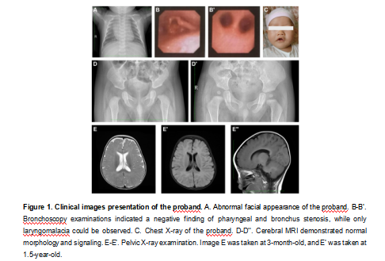
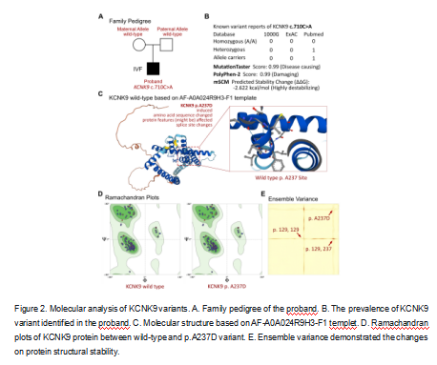
Recent Publications:

- Chandrasekar I, Tablizo MA, Witmans M, Cruz JM, Cummins M, Estrellado-Cruz W. Obstructive Sleep Apnea in Neonates. Children (Basel). 2022;9(3).
- Varisco G, Peng Z, Kommers D, et al. Central apnea detection in premature infants using machine learning. Comput Methods Programs Biomed. 2022; 226:107155.
- Cielo CM, Duffy KA, Taylor JA, Marcus CL, Kalish JM. Obstructive Sleep Apnea in Children With Beckwith-Wiedemann Syndrome. J Clin Sleep Med. 2019; 15(3):375-81.
- Kerz J, Schürmann P, Rothämel T, Dörk T, Klintschar M. Gene variants associated with obstructive sleep apnea (OSA) in relation to sudden infant death syndrome (SIDS). Int J Legal Med. 2021;135(4):1499-506.
- Bando Y, Hirano T, Tagawa Y. Dysfunction of KCNK potassium channels impairs neuronal migration in the developing mouse cerebral cortex. Cereb Cortex. 2014;24(4):1017-29.

Biography
Dr. Li Jinrong is mainly committed to research on metabolic management of high-risk infants and the diagnosis and treatment of rare diseases. She conducted in-depth research on iron metabolism in premature infants, verifying the growth and development of premature infants under different iron homeostasis conditions; At the same time, she discovered many new clinical phenotypes and gene profiles of rare diseases.

