Study of Blood Flow in the Skin Vascular Using Laser Doppler Imaging
Ammar A. Oglat, PhD, Department of Medical Imaging, Faculty of Applied Medical Sciences, The Hashemite University, Zarqa, 13133, Jordan.

Abstract

Laser Doppler Imaging (LDI) is a non-invasive method of measuring microcirculatory blood flow in tissues. The aim of this study is to measure the Doppler shift induced by moving red blood cells toward the illuminating coherent light. The study was done by a Laser Doppler Vibrometer (LDV) that measures the surface of tissues by moving a mirror. And single-point measurement gives (40 Hz) temporal resolution. So, this enables rapid blood flow changes to be recorded. The magnitude of the Doppler shift is related to the optical geometry and the velocity of the scattering object. The measurement of vibration mode shapes is made by sensing the structural response at a series of locations on the structure. As a result, when using an LDV system, the straightforward solution is to translate the test object or the complete LDV system so that various points of interest can be probed. Furthermore, when the diameter of the circular scan is small, it will give the angular vibration of the structure at the center of the circle.

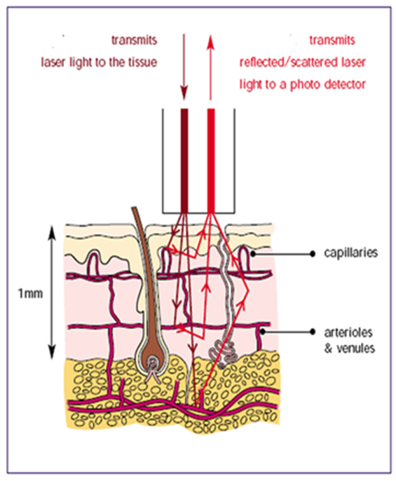
Figure 1. An incident light from the laser inside the small micro- circulate capillary. Which it is reflected/scattered because of movement of blood flow and this movement because vibration leads to reflect the beam light.
Recent Publications (minimum 5)
- Oglat, A. A. (2022). Performance Evaluation of an Ultrasonic Imaging System Using Tissue-Mimicking Phantoms for Quality Assurance. Biomimetics, 7(3), 130.

- Oglat, A.A., Hasan, H. Jordanian women’s (studying or working in medical fields) awareness in terms of the use of dental imaging during pregnancy. BMC Oral Health 22, 427 (2022).

- Ammar A. Oglat, Mohammad A. Oqlat, et al. "Imaging Aspects (Chest Radiographic and CT Scan Findings) of COVID-19 with Clinical Classifications. Jordan Journal of Biological Sciences, 15 (3),2022.

- Mousa, Mahmoud, Marwan Matar, Mohammad Matar, Sadi Jaber, Fouad S. Jaber, Yasser Al Ajerami, Amjad Falak, Mohammed Abujazar, Ammar A. Oglat, and Hammoda Abu-Odah. "Role of cardiovascular computed tomography parameters and lungs findings in predicting severe COVID-19 patients: a single-centre retrospective study." Egyptian Journal of Radiology and Nuclear Medicine 53, no. 1 (2022): 1-11.

- A. Oglat A, Fohely F, Masalmeh AA, Jbour IA, Jaradat LA, Athamnah SI. Attitudes toward the Integration of Radiographers into the First-Line Interpretation of Imaging Using the Red Dot System. Bioengineering. 2023; 10(1):71.

Biography (150 word limit)
Paste your Logo here
Ammar A. Oglat received the B.Sc. in Medical Imaging from the Jordan University of Science and Technology in 2014. The MSc in medical imaging and the Ph.D. in medical diagnostic imaging from Universiti Sains Malaysia (USM) in 2016 and 2019, respectively. Currently, he is an assistant professor and chairman at the Hashemite University (HU) in Jordan. His current research interest focuses on all medical imaging modalities and applications.
Email: ammar.oglat@yahoo.com

Notes/Comments:

Presenting author details
Full name: Ammar A. Oglat
Contact number:+962796311835
Twitter account:X
Linked In account: https://www.linkedin.com/in/ammar-a-oglat-680292177/?originalSubdomain=jo
Session name/ number: Others
Category: (Oral presentation/ Poster presentation)

