Fibrous Dysplasia of the Maxilla and Mandible- Our 5-year Institutional Experience in Light of Literature Review

Ahmed Lazim, MD; Yekaterina Belogrivtseva; Muhammad Hussain, MD: Riya Kuklani, DDS; Daniela Proca, MD, Lewis- Katz Medical School, Temple University

Abstract
Fibrous dysplasia is a benign intraosseous lesion. It is not a neoplasm, but a developmental condition of the bone which appears similar to a tumor on radiological studies. Fibrous dysplasia is a sporadic condition caused by the inability to produce mature bone due to a genetic mutation in GNAS1; it can present in two clinical forms, monostotic or polyostotic. Fibrous dysplasia (FD) can be a component of McCune-Albright syndrome with both dermatological and endocrinological features. The femur, ribs and maxillofacial skeleton are the most common sites of involvement. Monostotic forms account for 80-85 % of the cases. It is caused by somatic activating mutations in the GNAS gene, which lead to constitutive activation of adenylyl cyclase and elevated levels of cyclic AMP.
Herein, we report of six cases of fibrous dysplasia of the mandible and maxilla in our facility between November 2015 and October 2020 with mean age 44 years (range, 12-72 years). The maxilla was affected in the most cases (n=4), compared to mandible (n=2). The male to female ratio was 2:1. Some of the lesions showed ground-glass opacity on imaging. Microscopic examination of the biopsied specimens from each patient revealed fragments of relatively dense fibrous tissue containing irregularly shaped trabeculae of woven and lamellar bone. Some trabeculae were associated with newly forming, spontaneous bone derived from the surrounding fibrous tissue consistent with fibrous dysplasia. Each case demonstrated blending of fibrous and osseous tissue, with resultant secondary bony metaplasia, producing immature, haphazard, and weakly calcified woven bone.
The clinical, radiographic, and the morphological appearance of FD exhibit a substantial overlap with other fibro-osseous lesions, including malignant neoplasms, such as low grade osteosarcoma. FD involves the maxilla almost two times more often than the mandible. It frequently appears in the posterior region of the jaw bone and is usually unilateral. The importance of this study is to differentiate FD from other fibro-osseous lesions of the mandible and maxilla.

Case Age Sex Location
1 23 Female Right Posterior Maxilla
2 12 Male Left Maxilla
3 53 Male Right Maxilla
4 50 Male Right Mandible
5 72 Female Right Posterior Maxilla
6 56 Male Left Mandible

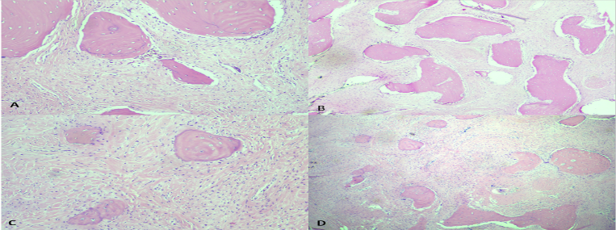
A&B. Fibrous dysplasia, HE 200x and 40x
C&D. Fibrous dysplasia, pronounced spindled proliferation, HE 200x and 40x
Recent Publications
- Wirth T. Fibröse Dysplasie [Fibrous dysplasia]. Orthopade. 2020 Oct;49(10):929-940. German. doi: 10.1007/s00132-020-03984-8. PMID: 32960303.
- Ricalde P, Magliocca KR, Lee JS. Craniofacial fibrous dysplasia. Oral Maxillofac Surg Clin North Am. 2012 Aug;24(3):427-41.
- Burke AB, Collins MT, Boyce AM. Fibrous dysplasia of bone: craniofacial and dental implications. Oral Dis. 2017 Sep;23(6):697-708.
- Pereira, Thaís dos Santos Fontes, et al. "Fibrous dysplasia of the jaws: Integrating molecular pathogenesis with clinical, radiological, and histopathological features." Journal of Oral Pathology & Medicine 48.1 (2019): 3-9.
- Davidova, L. A., et al. "An analysis of clinical and histopathologic features of fibrous dysplasia of the jaws: a series of 40 cases and review of literature." Head and Neck Pathology 14 (2020): 353-361.
- Shi, Ruirui, et al. "Clinicopathological and genetic study of a rare occurrence: Malignant transformation of fibrous dysplasia of the jaws." Molecular Genetics & Genomic Medicine 10.1 (2022): e1861.



Biography
Dr. Daniela Proca is Professor of Clinical Pathology at Temple University, Philadelphia, Pennsylvania, USA and studies together with colleagues and residents bone and soft tissue lesions, particularly neoplasms.
Email:
daniea.proca@tuhs.temple.edu

Notes/Comments:
Presenting author details
Full name: Daniela Proca
Contact number: 267 541 4812
Session name/ number:
Category: (Oral presentation/ Poster presentation): Poster

