ABSTRACT
Tackling Triple negative breast cancer through nanotechnological interventions: Promise and Pitfalls
Partha Roy
Global socioeconomic revolution with overlying stress motivators remains as the main stimulus behind rising cancer cases across global frontiers. Among diverse cancer variants, female breast cancer has emerged as the most detected type although it is predominantly gender selective. This stands out as the prominent cause of the rapid spread of the disease. Triple negative breast cancer (TNBC) is an extremely intrusive variant of BC and is visible in approximately 20% of all BC cases. Moreover, the disease offers poor prognosis with increased risk of relapse after conventional chemotherapy. TNBC also leads to metastasis of the lung, liver and brain and presents the highest death rate among all other breast cancer types. Spotlight on the etiology of TNBC related mortality confirms tumour migration and ancillary tumour growth in migrated sites as the pivotal causes. Adding to the complexity, strategies for TNBC management often involves non-targeted chemotherapeutic schedules leading to undesired fatalities, as the disease lacks suitable targets like Estrogen Receptor, Progesterone Receptor and HER-2 Receptor. Contemporary treatment strategy for TNBC involves a blend of chemotherapy, surgery and radiation depending on the patient condition. Designing formulation stratagems for site-directed nanotherapeutics can provide a suitable solution to the complex clinical condition. However, biocompatibility and absence of residual toxicity remains a major challenge in the clinical translation of these technology-guided newer therapeutic arsenals.

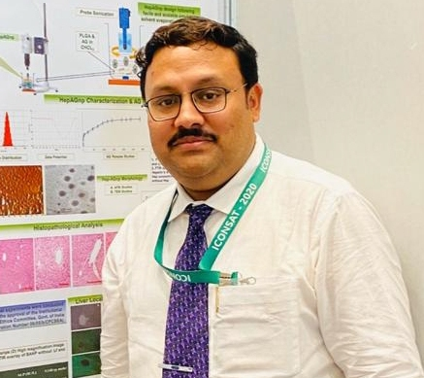
Biography Prof. Partha Roy
Dr. Partha Roy is a Professor in Gitam School of Pharmacy, GITAM (Deemed to be University), India. He completed his Ph.D. from University of Calcutta with post-doctoral assignments from University of Calcutta and University of Szeged, Hungary. He received several distinguished fellowships including Indian Council of Medical Research, Council of Scientific and Industrial Research and Indo-Hungarian Research fellowship. His academic and research engagements include both India and overseas. Prof. Roy research focuses on nanotechnological interventions in medicine, drug delivery, formulation development and cell-imaging. Currently he is experimenting with carbon/ gold nanomaterials as newer arsenals in therapy and diagnostics. His research assignments include several high-impact publications in peer reviewed journals journal editorial board membership, invited lectures and presentations in national / international conferences. He is the recipient of several research funds, research awards and travel grants in both India and overseas. Prof. Roy is a passionate researcher and academician motivated to excel in pharmaceutical and other healthcare domains.

Presenting Author Details
Prof. (Dr.) Partha Roy
GITAM School of Pharmacy, GITAM (Deemed to be University)
Visakhapatnam, Andhra Pradesh, India.
Mob: +919831338010
Email: proy@gutam.edu/ partharoy2502@gmail.com
Category: Invited Oral Presentation

