Physical Rehabilitation of Motor Functional Neurological Disorders: A Narrative Review
Ayelet N. Kelmanson

Ben Gurion University, Israel

Abstract
Statement of the Problem: Functional Neurological Disorders (FNDs) are of the most common and disabling neurological disorders, affecting approximately 10–30% of patients in neurology clinics. FNDs manifest as a range of motor, sensory, and cognitive symptoms that are not explained by organic disease. This review aims to assess the current state of knowledge in physical-based rehabilitation for motor/movement FNDs in the adult population, with the goal of improving research and medical care for this patient population. To ensure optimal outcomes for patients, several domains must be considered as pertains to FNDs: fields of discipline, methods of investigating and treating, rating outcome measures and optimal courses of treatment. In the past, FNDs were primarily treated with psychiatric and psychological interventions. Recent literature supports the inclusion of physical rehabilitation in the treatment of FNDs. Physical-based approaches specifically tailored to FNDs have shown promising results.
Methodology & Theoretical Orientation: A narrative review of the current literature on physical rehabilitation in FMDs was conducted using the PubMed database. The search terms "Functional Movement Disorder," "Functional Motor Disorder," "Motor Functional Neurological Disease," "Movement Functional Neurological Disease," "Rehabilitation," and "Physical Rehabilitation" were used to identify relevant literature published from 2014 to September 2022. Additional publications were identified from the references cited in the initial papers. Only literature in English was included, and clinical trials were prioritized. The focus was on the most current literature related to the DSM-V's revised definition of FND, specifically FMDs.
Findings and Conclusions: The traditional approach of psychological and psychiatric interventions was the norm, however, the most recent literature suggests that physical rehabilitation should be a crucial part in the management of FNDs. Physical rehabilitation is shown as effective in improving motor function and quality of life. Further research is needed to establish optimal rehabilitation protocols, including the intensity, frequency,and duration of physical therapy interventions.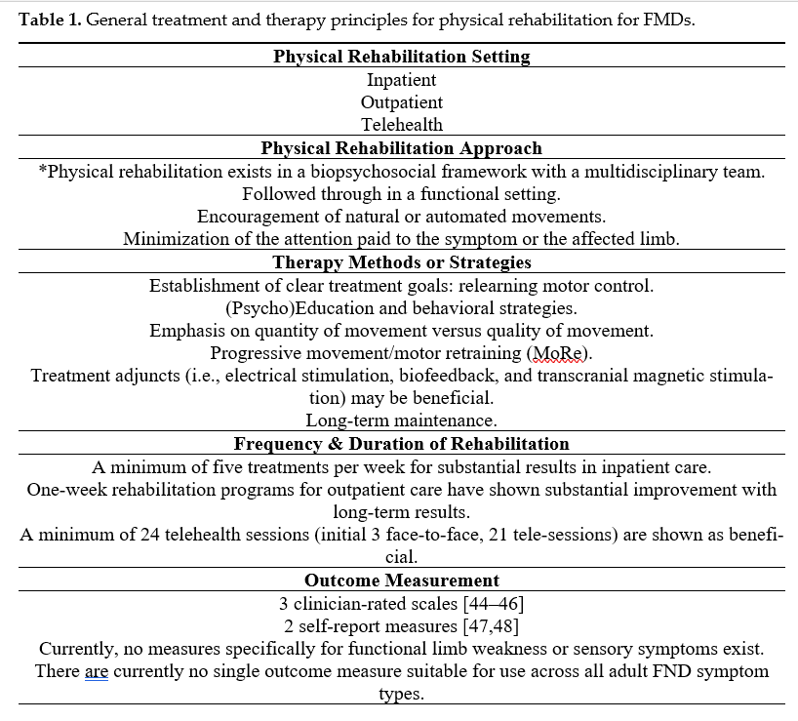

References
- Heruti, R.J.; Levy, A.; Adunski, A.; Ohry, A. Conversion motor paralysis disorder: Overview and rehabilitation model. Spinal Cord 2002, 40, 327–334. https://doi.org/10.1038/sj.sc.3101308.
- Guérit, J.M. Neurophysiology of conversive disorders. Neurophysiol. Clin. 2014, 44, 301–304. https://doi.org/10.1016/j.neucli.2014.09.062.
- Bennett, K.; Diamond, C.; Hoeritzauer, I.; Gardiner, P.; McWhirter, L.; Carson, A.; Stone, J. A practical review of functional neurological disorder (FND) for the general physician. Clin. Med. 2021, 21, 28–36. https://doi.org/10.7861/clinmed.2020-0987.
- Carson, A.; Lehn, A. Epidemiology. Handb. Clin. Neurol. 2016, 139, 47–60. https://doi.org/10.1016/b978-0-12-801772-2.00005-9.
- Trimble, M.; Reynolds, E.H. A brief history of hysteria: From the ancient to the modern. Handb. Clin. Neurol. 2016, 139, 3–10. https://doi.org/10.1016/b978-0-12-801772-2.00001-1.
Biography
Ayelet Kelmanson Physical Therapy at the University of Tel Aviv, and is currently finishing her Masters and Thesis in Physical Therapy at Ben Gurion University, Israel. She has been working as a clinical Physical Therapist in rehabilitation since 2016, with an emphasis on neurological rehabilitation. Additionally, she specializes in Vestibular and Pelvic Floor therapy and treatment. She currently balances clinical treatment with neurological laboratory research, and is currently working on MRI and balance clinical trials with Professors Itzik Melzer and Moti Salati from Ben Gurion University and Soroka Hospital.

