Performance Indicators for the diagnosis of waste management in Municipalities in Mexico
*Dr. Lorena De Medina-Salas, Dr. Eduardo Castillo-González, Dr. Mario Rafael Giraldi-Díaz, Facultad de Ciencias Químicas, Región Xalapa, Universidad Veracruzana, México
Dr. Gerardo Bernache-Pérez, Centro de Investigaciones y Estudios Superiores en Antropología Social (CIESAS), Unidad Regional Occidente, México

Abstract

Waste management in Mexico is one of the main challenges that municipal authorities must face due to the lack of planning, infrastructure, investment, citizen participation, and public policies, which causes deficiency in the collection system, scarce treatment, and inadequate final disposal, generally in open dumps. To address this problem, it is necessary to carry out a diagnosis based on performance indicators that allow municipalities to know their strengths and weaknesses and that serve as a basis for proposing strategies for adequate comprehensive management. Therefore, the aim of this paper is to show the importance of using performance indicators for the diagnosis of the current situation of waste management in Mexico. The methodology for its realization includes the determination of 43 indicators according to the following classification: a) general, b) coverage, c) efficiency, d) quality, e) cost, and f) attitude of employees. The information for the calculation of the indicators must be obtained through the application of surveys and interviews with those responsible for waste management in the municipalities. The results obtained from each indicator must be analyzed and compared with the values reported in the literature and in cases where this is not fulfilled, the necessary strategies must be established so the municipalities optimize the public cleaning services. In conclusion, the importance of the application of these indicators is highlighted to provide results and serve in the evaluation of the environmental policy implementation.

Recent Publications
- SEMARNAT (2001). Guía para la gestion integral de los residuos sólidos municipales. Secretaría de Medio Ambiente y Recursos Naturales. Mexico. Available online: http://centro.paot.org.mx/documentos/semarnat/guia_integral_residuos_solidos.pdf
- SEMARNAT (2020). Diagnóstico básico para la gestión integral de los residuos. Secretaría de Medio Ambiente y Recursos Naturales. Mexico. Available online:
- 3. SEMARNAT–GTZ (2006). Guía para la elaboración de programas municipales para la prevención y gestión integral de los residuos sólidos urbanos. Secretaría de Medio Ambiente y Recursos Naturales and Deutsche Gesellschaft für Technische Zusammenarbeit. Mexico-Germany. Available online: https://ciudadesytransporte.mx/wp-content/uploads/2021/07/Guia_PMPGIRSU_2006.pdf
- Jiménez, M.N.M. (2015). La gestión integral de los residuos sólidos urbanos en México: reflexiones sobre su implementación. 20° Encuentro Nacional sobre Desarrollo Regional en México. AMECIDER-CRIM, UNAM. Available online:
- Salazar-Rodríguez, A. & Hernández-Diego, C. (2018). Evaluation of the efficiency integrated management system for urban solid waste of in the municipality of Benito Juárez, Quintana Roo. Quivera. Revista de Estudios Territoriales, 20 (2), 73-102. Available on https://www.redalyc.org/journal/401/40158030009/html/
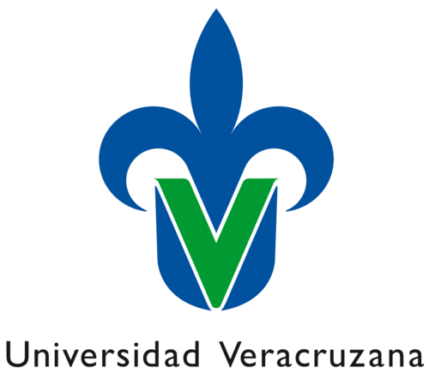

Biography
Lorena De Medina-Salas completed her Ph.D. at Pacific Western University, USA. She is a professor and researcher in the waste management area of the Environmental Engineering Program at Facultad de Ciencias Químicas, Universidad Veracruzana in Mexico, with 18 years of experience. She has published more than 40 papers and has been serving as a scientific reviewer for reputed journals. She also belongs to the National System of Researchers in Mexico.
E-mail: ldemedina@uv.mx

Eduardo Castillo-González is a Civil Engineer with professional certification, master's degree in Environmental Engineering and a doctorate (PhD) in Education. Full-time professor at the Faculty of Chemical Sciences of the Universidad Veracruzana. He has published more than 30 papers and belongs to the National System of Researchers in Mexico. He is currently the Principal of the Faculty of Civil Engineering in the Xalapa region of the Universidad Veracruzana.
E-mail: educastillo@uv.mx

Mario Rafael Giraldi-Díaz, earned a doctorate (PhD) in Environmental Engineering at the Polytechnic University of Catalonia, Spain. He was granted with two postdoctoral research fellowships. He has more than ten years of experience in the scientific field of industrial ecology, he has several international publications and theses directions in this field. He has professional experience in the industry and government agencies, currently, he is a full professor and researcher of environmental engineering at the Faculty of Chemical Sciences of the Universidad Veracruzana, Mexico.
E-mail: mario.giraldi.d@gmail.com

Gerardo Bernache-Pérez. Ph.D. in social anthropology from the University of Arizona (1994), research professor at the Centro de Investigaciones y Estudios Superiores en Antropología Social (CIESAS). Specialty is on the line between society and the environment. Develops projects focused on studies of the production and management of urban solid waste. The environmental impact of landfills. Electrical and electronic waste generation and management. Contaminated communities and environmental human rights. Sustainable urban development, citizen participation, and integrated solid waste management.
E-mail: gerardo.bernache@gmail.com.

Notes/Comments:

Presenting author details
Full Name: Dr. Lorena De Medina-Salas, Dr. Eduardo Castillo-González, Dr. Mario Rafael Giraldi-Díaz, Dr. Gerardo Bernache-Pérez.
Contact number: +52-2281375419, +52-2281008335, +52-2281597581, +52-3331156450
Session name/ number: Solid waste management
Category: Oral presentation
Email ID: ldemedina@uv.mx , educastillo@uv.mx , mario.giraldi.d@gmail.com, gerardo.bernache@gmail.com

