LYELL’S SYNDROME INDUCED BY PHENYTOIN COMPLICATED BY ROAD TRAFFIC ACCIDENT

Shravan V, Senior Resident, Dept. of Clinical Pharmacology, JIPMER, Puducherry
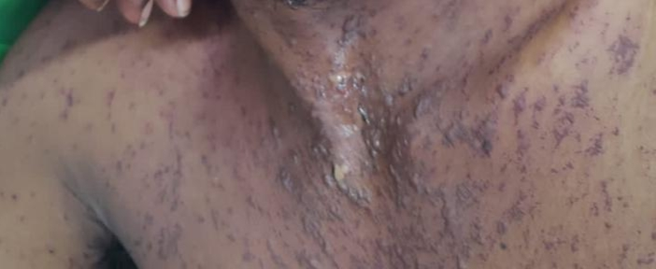
Jefry Wilson, Junior Resident, Dept.of Pharmacology, MGMCRI, Puducherry.

Abstract (300 word limit)
INTRODUCTION: Even after approval of the drug and coming to the market, there are many tragedies reported due to drug resulting in withdrawal of drug from the market for that particular indication. Eg: Thalidomide tragedy. In order to monitor this, there should be vigilant people who should identify the adverse reaction of the drug and to report in an expedited way to the authorities concerned.
CASE: A 18 Year old patient had a history of road traffic accident (RTA) followed by seizures. He was admitted in the hospital and prescribed Inj. Phenytoin 900 mg IV stat followed by Tab. Phenytoin 100 mg. Following the oral administration, patient developed fever and bullous lesions all over the body with oropharyngeal ulcer and eye infection. On examination, patient was found to have multiple vesicles over chest, abdomen, bilateral upper extremities, crusted erosion over lips and conjuctival congestion. Patient was stopped T. Phenytoin in suspect of phenytoin induced Lyell’s syndrome. Patient was treated with pulse therapy of Dexamethasone (80 ml in 250 ml of 5% dextrose), Azithromycin, Paracetamol infusion, Tobramycin eye drops and ointment. For the seizure complaint, the patient was started on Inj. Levetiracetam infusion.
CONCLUSION: Phenytoin should be stopped at the onset of development of rash and genetic cause (HLA-B*1502 and HLA-A*3101) should also be borne in mind as the suspectibility increases with genetic etiology. Preventive measures should be educated to the patient as RTA also increases the risk of seizures.

Images:

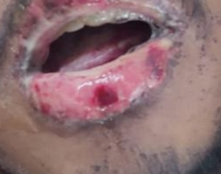

Publications:
- Rai R, Srinivas CR. Suprapharmacologic doses of intravenous dexamethasone followed by cyclosporine in the treatment of toxic epidermal necrolysis. Indian J Dermatol Venereol Leprol. 2008;74(3):263-5
- Al-Quteimat OM. Phenytoin-induced toxic epidermal necrolysis: Review and recommendations. J Pharmacol Pharmacother. 2016;7(3):127-32
- Sundelin HEK, Chang Z, Larsson H, Lichtenstein P, Almqvist C, Tomson T, Ludvigsson JF. Epilepsy, antiepileptic drugs, and serious transport accidents: A nationwide cohort study. Neurology. 2018;90(13):e1111-e1118.



BIOGRAPHY: Shravan V has his knowledge in pharmacogenetic studies and pharmacovigilance ( Monitoring and reporting adverse drug reactions). He has participated in many conferences (national and international) and won poster, quiz and essay competitions. He has published articles on pharmacogenetics and now currently pursuing DM in the field of Clinical Pharmacology in JIPMER, Puducherry. He has passed DNB examination (Pharmacology) conducted by National Board of Examinations to his credit. He has experience in teaching MBBS students and other allied subject students for 5 years. He is currently working on Systematic review and meta-analysis and he is open to constructive criticism.
Email: shravandhawan18@gmail.com

Presenting author details
Full name: Shravan V
Contact number: 9894953084
Mail id: shravandhawan18@gmail.com
Category: (Oral presentation/ Poster presentation) : Poster presentation

