Evaluation of the soil quality improvement potential through basalt rock dust amendment
Angelique Daniell (M.Sc.) North West University Potchefstroom South Africa

Abstract
Due to the increased global population, the demand for food and the land area has also increased dramatically. This places considerable strain on arable soil resources for food production. The food produced on the same soil needs to increase exponentially unless non-arable, poor soil quality areas can be improved to contribute to food production globally. This study aims to investigate the usage of basalt and the evaluations of weathering of primary minerals to secondary minerals where upon nutrients would be released for plant utilization and ultimately increase plant production. During this study experimental data were obtain by adding rock dust to non-arable soils to increase the soil quality by using, two different amendment ratios one t/ha and three t/h added rock dust to a sandy medium in correlation with control samples. This was done to also evaluate the germination, survivability, and growth potential together with photochemical efficiency for pasture species such as Brachiaria brizantha and Lolium multiflorum in basalt enriched soils. It was observed that the one t/ha basalt amended samples performed better than the three t/ha and the control samples. It was concluded from the weekly measurement of the pH that basalt has a high pH buffering capacity keeping the pH level of the water around 8. It was also observed that the availability of nutrients is influenced by the pH of the environment as well as the formation of clay minerals specifically vermiculite and garnierite and metal oxides such as Mn -oxides, which retained some of the nutrients as the basalt weathers. The evidence suggest that basalt do increase the soil and plant quality.

Image
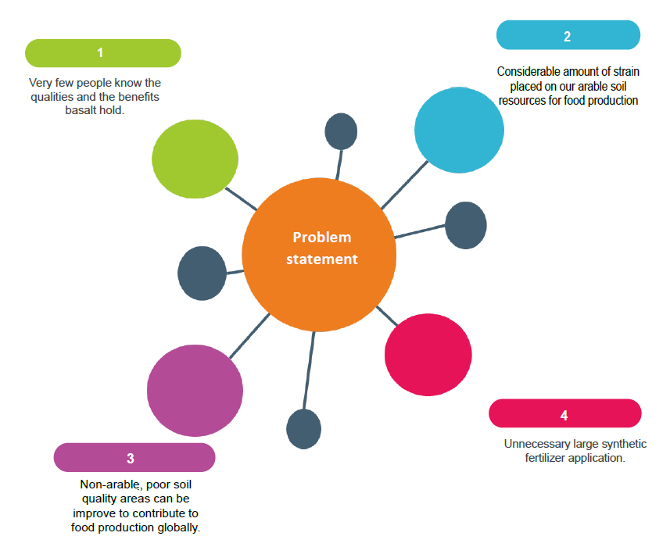
Recent Publications
- PROXIMAL SENSOR ANALYSIS OF MINE TAILING ANTHROSOLS: AN EXPLORATORY STUDY – Jaco Koch, Somsubhra Chakraborty, Bin Li, Jennifer Moore Kucera, Piet Van Deventer, Angelique Daniell, Cindy Faul, Titus Man, Delaina Pearson, Bogdan Duda, Camille A. Weindorf, and David C. Weindorf – Geochemical Exploration. DOI 10.1016/j.gexplo.2017.06.020

- AN OVERVIEW OF PEDOGENESIS IN TECHNOSOLS, SOUTH AFRICA – Angelique Daniell and Pieter W. van Deventer – South African Journal of Plant and Soil -DOI: 10.1080/02571862.2018.1470265

- POLLUTION CONTROL OF THE SELATI TAILINGS STORAGE FACILITY BY MEANS OF A DECISION SUPPORT SYSTEM – A CASE STUDY - Angelique Daniell and Pieter W. van Deventer - Paper published in Proceedings of the 3rd World Congress on Civil, Structural, and Environmental Engineering (CSEE'18) - DOI: 10.11159/awspt18.104, ISBN: 978-1-927877-40-1 ISSN 2371-5294

- MONITORING THE POLLUTION EFFECTS FROM A GOLD TAILING STORAGE FACILITY ON ADJACENT LAND THROUGH LANDSCAPE FUNCTION ANALYSIS – Angelique Daniell, Pieter W. van Deventer, Dawid S. Malo – Environmental Earth Science Journal. DOI: 10.1007/s12665-019-8095-5

- OPPORTUNITY FOR INCREASING THE SOIL QUALITY OF NON-ARABLE AND DEPLETED SOILS IN SOUTH AFRICA: A REVIEW – Angelique Daniell and Danel van Tonder – Journal of Soil Science and Plant nutrition DOI: 10.1007/s42729-023-01205-7



Biography
I am currently a lecturer at the School of Geo- and Spatial Sciences, Geology department based at the North-West University, South Africa. Additionally, I am currently enrolled as a part-time Ph.D. student at the North-West University. I have completed a Magister of Scientiae (M.Sc.) degree for Environmental Sciences at the North-West University, Potchefstroom, cum laude. Currently, I am continuing my studies for a Bachelor of Science in Agricultural Science (Plant Science Stream) through the University of South Africa. I am interested in soil science, environmental geology, agriculture, environmental rehabilitation, and chemistry. I relish the fieldwork and research elements within each of these domains, as well as imparting the knowledge I have accumulated to students as a lecturer. In addition, I have been privileged to broaden the inside of my fields of interest by participating and presenting at local and international conferences and contributing to academic journals.
Email: 21859442@nwu.ac.za

Notes/Comments:

Presenting author details
Full name: Angelique Daniell
Contact number: +27842431230
Linked In account: linkedin.com/in/angeliquedaniell
Session name/ number:
Category: Oral presentation

