Sanitary Excellence Program (PES): Contribution to the strengthening and development of livestock in small producers
Julio César Tobón, PhD (c), National Coordinator PES -VECOL, Colombia;
Paula Luque Isaza MsC. (s), PES Professional - VECOL, Colombia

Abstract

The Colombian livestock sector consists of small-scale producers. The report from the Ministry of Agriculture states that as of 2023, 82% of the country's livestock farmers own between 1 and 50 head of cattle. Other livestock sectors, such as sheep and goats, are led by Wayuu indigenous communities and residents of La Guajira, one of the big producers in the country. Besides being a source of economic resources, these livestock are also a form of cultural exchange as they are used for funerals, weddings, and various local festivities. Information has been obtained from 10 out of the 15 municipalities in La Guajira, which include the southern and central areas. Currently, the project of the northern area of La Guajira, which accounts for over 50% of sheep and goat production, is being developed. One of the most criticisms of livestock farming in South America is the deforestation processes carried out for land grabbing, where the forests are cut down to introduce cattle. The Agrosilvopastoral systems and use of native forages and foliages has been implemented for the program in areas like Chocó in the pacific coast. Projects have been undertaken in dual-purpose cattle, a significant activity for poor communities that utilize cattle for meat and milk. Different ethnic communities have been implicated, such as Bahia Solano in Chocó and Patia in Cauca (Afro-Colombian communities), as well as Puracé in Cauca (indigenous communities).

Through the PES, important information is obtained on the health status of important diseases in the livestock sector, improving production, facilitating trade, strengthening registration, diagnosis, research and extension services to promote productions that are free from traces of medications and antibiotics in products such as meat and milk. The program has facilitated the collaboration between producer associations and institutions such as local universities, research centers, private laboratories and peasants, bringing together over 200 allies to support farmers through the country.

Image

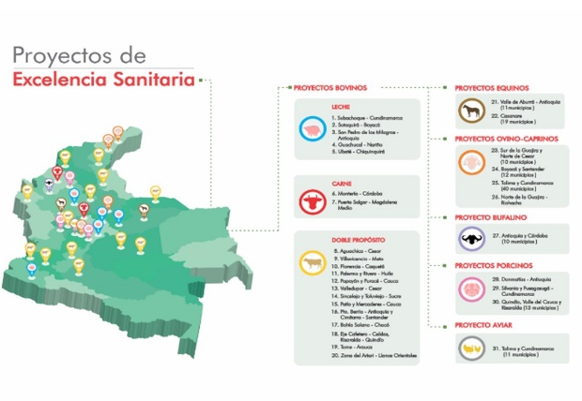
Resent Publications
- Bulla-Castañeda, D. M., Buitrago, H. A. L., Lancheros-Buitrago, D. J., Díaz-Anaya, A. M., Garcia-Corredor, D. J., Tobón-Torreglosa, J. C., Ortega, D. O., & Pulido-Medellín, M. O. (2022). Seroprevalence and risk factors associated with the presence of bovine leptospirosis in the municipality of Sotaquirá, Colombia. Open Veterinary Journal, 12(5), 668–675. https://doi.org/10.5455/OVJ.2022.v12.i5.11
- Conde-Muñoz, J., Reyes-Bernal, N., Guatibonza-Garzon, M. F., Tobon, J. C., Valero, D. L., & Barragan, B. L. G. (2023). Seroprevalence and risk factors associated with leukosis in cattle from Villlavicencio, Colombia. Ciência Animal Brasileira, 24, e-74298. https://doi.org/10.1590/1809-6891v24e-74298e
- García, A. A., Torreglosa, J. T., Marín, D. D., Bernal, M. K. M., Rolim Filho, S. T., & Pereira, W. L. A. (2022). Leptospirosis, bovine viral diarrhea and infectious bovine rhinotracheitis: prevalence in Colombian cattle and buffaloes. Acta Scientiarum. Animal Sciences, 44, e54875. https://doi.org/10.4025/actascianimsci.v44i1.54875
- Guzman-Barragan, B. L., Martínez-Rodríguez, L. C., Tobón-Torreglosa, J. C., & Tafur-Gómez, G. A. (2021). Seroprevalence and risk factors for Leptospira spp. in small ruminants of semi-arid zone in northeastern Colombia. Tropical Animal Health and Production, 54(1), 10. https://doi.org/10.1007/s11250-021-03019-0
- Guzman-Barragan, B., Monroy-Roberto, Y. A., Tobón, J., Blanco-Angarita, L. C., & Guzman, Y. L. (2023). Seroprevalencia y factores de riesgos asociados a Mycobacterium avium subsp. paratuberculosis en bovinos de Villavicencio, Colombia. Revista de investigaciones veterinarias del Peru, 34(2), e22959. https://doi.org/10.15381/rivep.v34i2.22959
- Orjuela, A. G., Reyes Castañeda, L. J., Tobón, J. C., Parra Arango, J. L., & Guzmán-Barragán, B. (2022). Seroprevalence of antibodies to Chlamydia abortus and risk factors in cattle from Villavicencio, Colombia. Heliyon, 8(5), e09481. https://doi.org/10.1016/j.heliyon.2022.e09481
- Ortiz-González, A. D., Buitrago, H. A. L., Bulla-Castañeda, D. M., Lancheros-Buitrago, D. J., Garcia-Corredor, D. J., Díaz-Anaya, A. M., Tobón-Torreglosa, J. C., Ortiz-Ortega, D., & Pulido-Medellín, M. O. (2022). Seroprevalence and risk factors associated with bovine herpesvirus 1 in dairy herds of Colombia. Veterinary World, 15(6), 1550–1556. https://doi.org/10.14202/vetworld.2022.1550-1556
- Romero-Hurtado, C. S., Prada, G. A., Tobón, J. C., Uribe, A. del P., Calvo, P. C., & Ardila, A. (2022). Presencia de Dictyocaulus viviparus en bovinos de las sabanas de Arauca, Colombia. Revista de Investigaciones Veterinarias Del Perú, 33(6), e22148. https://doi.org/10.15381/rivep.v33i6.22148
- Manual Proyecto de excelencia sanitaria-PES Ganadería Bovina de leche / ISBN Obra independiente: 978-958-52843-7-1 2 (2022)
- Manual PES Ganadería Bovina de Tame (Arauca) / ISBN Obra independiente: 978-958-52843-5-7 1, 84 (2022)
- Manual Proyecto de excelencia sanitaria PES Avicultura / ISBN Obra independiente: 978-958-52843-3-3 1 (2022)
- Manual Proyecto de excelencia sanitaria-PES Ganadería ovino-caprina Media Guajira / ISBN Obra independiente: 978-958-52843-9-5 3 (2023)


Julio Tobón
I am an agricultural administrator, a specialist in epidemiology, magister in rural development. Currently finishing my doctorate in Agrosciences. All my life I have worked with indigenous communities in Colombia, developing agricultural strategies that allow improving activities in the field and instilling sustainable livestock that can compete in the current market. Among this development, with epidemiological information, we have been making management guides for peasants, with information from the regions, and in the academic sense, articles of great relevance, undergraduate and postgraduate theses, establishing ourselves as a model of health prevention animal for the country.
Email: juliotobon@gmail.com

Presenting author details
Full name: JULIO CÉSAR TOBÓN TORREGLOSA
Contact number: +57 3173832324
Twitter account: @Juliocetobon
Linked In account: https://co.linkedin.com/in/julio-cesar-tobon-torreglosa-96324b26
CV in science: https://scienti.minciencias.gov.co/cvlac/visualizador/generarCurriculoCv.do?cod_rh=0001155504
Session name/ number:
Category: Oral presentation



Paula Luque
I am a bacteriologist and clinical laboratory technician with an emphasis in veterinary diagnostics, currently finishing my master in science with an emphasis in project design. I have always worked in the diagnosis of reproductive diseases in production animals, official control tests, laboratory technical support, and their applications in the field; I have also trained in zoonotic diseases such as leptospira. I have always been interested in improving animal health, continually training and focusing my knowledge and skills, and ensuring accurate and efficient diagnosis and treatment for veterinary patients.
Email: luquei-p@javeriana.edu.co

Presenting author details
Full name: PAULA ALEJANDRA LUQUE ISAZA
Contact number:+57 3133800883
Linked In account: https://co.linkedin.com/in/paula-luque-isaza-71800a226
CV in science: https://scienti.minciencias.gov.co/cvlac/visualizador/generarCurriculoCv.do?cod_rh=0000143165
Session name/ number:
Category: Poster presentation

