Beyond Taste and Texture: Understanding the Social Determinants of Children's Resistance to Fruit and Vegetable Consumption

Zahra Hejazi, Institute Agro Dijon, Université Bourgogne Franche-Comté, F-21000, Dijon, France

Abstract

Fruits and vegetables consumption has been scientifically proven to enhance health and Various global guidelines have been established to encourage people to include more fruits and vegetables in their diets. Moreover, studies have revealed that the eating habits developed during childhood significantly influence one's inclination to consume these beneficial foods in later in life. Therefore, investigating the factors contributing to the avoidance of vegetables among children becomes crucial in promoting healthy behaviors and establishing them as a regular part of the population's daily routine. By doing so, numerous health issues later in life, such as non-communicable diseases, obesity, and other health-related problems, can be prevented, leading to reduced strain on healthcare systems. Previous research indicates that a considerable number of children, approximately 60 percent, fail to meet the recommended daily intake of fruits, while the figure rises to 93 percent for vegetable consumption. Children's aversion towards consuming fruits and vegetables can be attributed to various predominant factors across physiological, psychological, social, and genetic domains. Several social factors contribute to children's aversion towards vegetables. Peer influence plays a significant role, as children often imitate their peers' food preferences, leading to a reluctance to try unfamiliar vegetables. Parental attitudes and behaviors also impact children's vegetable intake, as negative attitudes or limited exposure can discourage their consumption. Societal norms and cultural practices surrounding food can further discourage vegetable consumption among children. Additionally, the availability of unhealthy food options in social environments, such as schools and fast-food establishments, can diminish the appeal of vegetables. With this overview, the aim of this study was to understand and address these social factors as effective factors for promoting healthy eating habits in children.

Keywords: fruit and vegetable, children, social factors, eating habits, aversion
Image
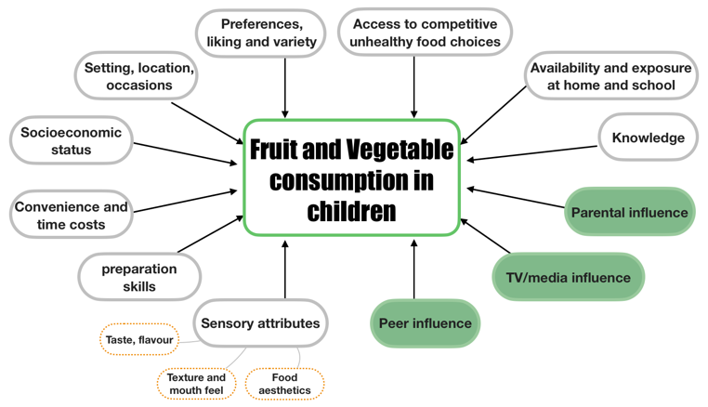
Recent Publications
- Ragelienė T 2021. The role of peers, siblings and social media for children’s healthy eating socialization: a mixed methods study. Food Quality and Preference, 93, p. 104255. DOI: 10.1016/j.foodqual.2021.104255
- Chau M.M. 2018. The use of social media in nutrition interventions for adolescents and young adults— A systematic review. International Journal of Medical Informatics, 120, p. 77‐91. DOI: 10.1016/j.ijmedinf.2018.10.001
- Krølner R. 2011. Determinants of fruit and vegetable consumption among children and adolescents: a review of the literature. Part II: qualitative studies. International Journal of Behavioral Nutrition and Physical Activity, 8 (1), p. 112. DOI: 10.1186/1479-5868-8-112
- Zeinstra G.G. 2007. Cognitive development and children’s perceptions of fruit and vegetables; a qualitative study. International Journal of Behavioral Nutrition and Physical Activity, 4 (1), p. 30. DOI: 10.1186/1479-5868-4-30
- McKinley M. 2005. It’s good to talk: children’s views on food and nutrition. European journal of clinical nutrition, 59(4), p. 542‐551


Zahra Hejazi
Zahra Hejazi is the first-year master’s student of “Physiological and Psychological Food Choice determinants (P2FOOD)” at Institute Agro Dijon, Université Bourgogne Franche-Comté. She holds bachelor in nutrition science and dietetics. Currently, she is working on perception and neuroscience during her internship at Karolinska Institute, Sweden.

Email: s.zahra.hejazi.t@gmail.com Contact No: +33 7 45 68 96 54

