Physiological Factors Contributing to Children's Resistance to Fruit and Vegetable Consumption: Allergic Reactions
Zahra Hejazi, Institute Agro Dijon, Université Bourgogne Franche-Comté, F-21000, Dijon, France
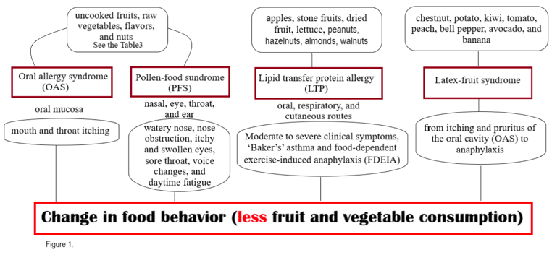

Abstract

This comprehensive review aims to explore the underlying causes of low fruit and vegetable intake in children, specifically focusing on allergies as physiological factors. Adequate fruit and vegetable consumption is critical for promoting children's overall health and well-being, as these nutrient-rich foods provide essential vitamins, minerals, and dietary fibre necessary for growth, development, and disease prevention. However, allergies, including oral allergy syndrome (OAS), pollen-food syndrome (PFS), Lipid transfer protein allergy (LTP), and Latex-fruit syndrome, can pose significant physiological barriers that impact children's willingness and ability to consume a diverse range of fruits and vegetables. Allergies occur when allergic individuals to certain pollens or compounds in fruit and vegetable experience reactions related to them due to cross-reactivity. These reactions can lead to itchiness, swelling, and discomfort in the mouth, throat, and lips, making it unpleasant or even unsafe for children to consume specific fruits and vegetables. Similarly, food allergies make the child avoid certain fruits and vegetables due to the potential for severe allergic reactions. This cautious approach limits the variety of fruits and vegetables in children's diets, potentially resulting in a reduced intake of these nutritious foods. Identifying the impact of allergies on children's dietary choices is necessary for developing effective strategies and interventions to promote fruit and vegetable consumption. Healthcare professionals, parents, and caregivers should be aware of any allergies or food intolerances in children and provide appropriate guidance, such as identifying alternative safe fruits and vegetables, exploring different preparation methods, and closely monitoring allergic reactions. By addressing these physiological barriers, we can support children in developing healthy eating habits and ensure they receive the essential nutrients from a diverse range of fruits and vegetables, contributing to their overall health and well-being.

Keywords: fruit and vegetable, children, physiology, allergy, eating habits, aversion
Image
Recent Publications
- Missaoui K. 2022. Plant non-specific lipid transfer proteins: An overview. Plant Physiology and Biochemistry, 171, p. 115‐127. DOI : 10.1016/j.plaphy.2021.12.026
- Muluk N.B. 2018. Oral Allergy Syndrome. American Journal of Rhinology & Allergy, 32 (1), p. 27‐30. DOI : 10.2500/ajra.2018.32.4489
- Mastrorilli C. 2019. Pollen-Food Allergy Syndrome: A not so Rare Disease in Childhood. Medicina, 55 (10), p. 641. DOI : 10.3390/medicina55100641
- Barradas Lopes J. 2023. Allergy to lipid transfer proteins (LTP) in a pediatric population. European Annals of Allergy and Clinical Immunology, 55 (2), p. 86‐93. DOI : 10.23822/EurAnnACI.1764-1489.229
- Skypala I.J. 2021. Non-specific lipid- transfer proteins: Allergen structure and function, cross-reactivity, sensitization, and epidemiology. Clinical and Translational Allergy, 11 (3), p. e12010. DOI : 10.1002/clt2.12010


Zahra Hejazi
Zahra Hejazi is the first-year master’s student of “Physiological and Psychological Food Choice determinants (P2FOOD)” at Institute Agro Dijon, Université Bourgogne Franche-Comté. She holds bachelor in nutrition science and dietetics. Currently, she is working on perception and neuroscience during her internship at Karolinska Institute, Sweden.

Email: s.zahra.hejazi.t@gmail.com Contact No: +33 7 45 68 96 54

