Efficacy of Omega-3 Supplementation in Olfactory Dysfunction: A Systematic Review of Randomized Controlled Trials
Raghad Alkanani, MS
College of Medicine, King Saud bin Abdulaziz University for Health Sciences, Jeddah, Saudi Arabia
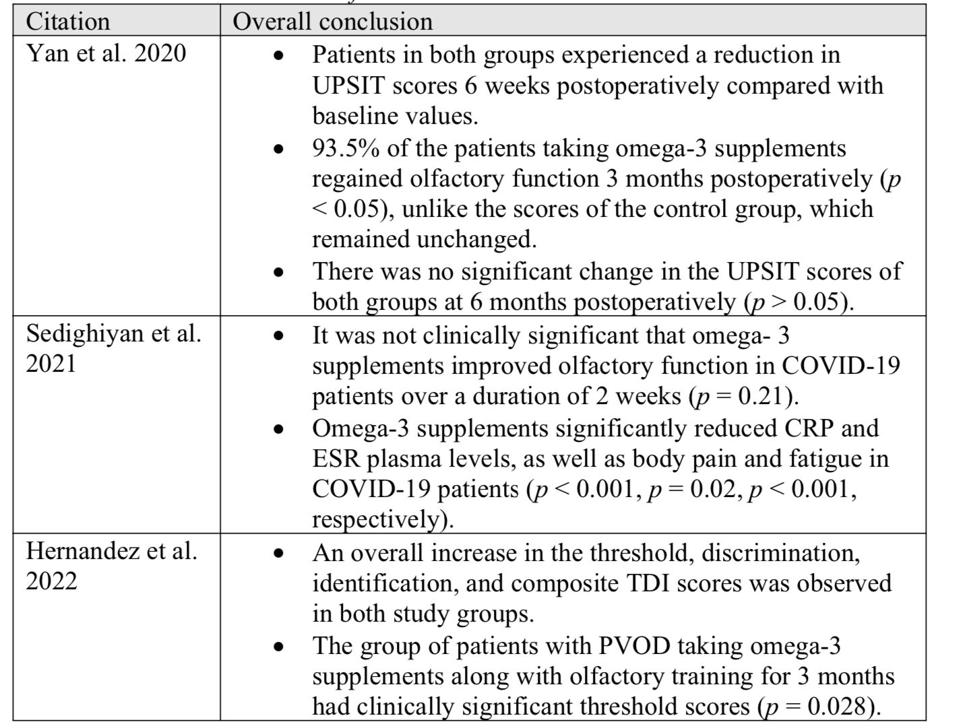

Abstract
SUMMARY
Background: Omega-3 supplementation has shown promising results in the treatment of olfactory dysfunction (OD). This systematic review assessed the effects of omega-3 supplementation on OD.
Methodology: A systematic literature search of Medline, Scopus, the Directory of Open Access Journals (DOAJ), and Google Scholar was conducted. Studies eligible for inclusion were Randomized Controlled Trials (RCTs) that included patients with OD whether received omega-3 or did not. The primary outcome measure was omega- 3 effectiveness in improving olfactory dysfunction symptoms.
Results: Three studies including 175 participants were included in this review. Of the three studies performed on patients with OD, two concluded that omega-3 supplements could act as a protective factor against the loss of olfaction over a period of at least 3 months. In contrast, a randomized clinical trial performed on COVID-19 patients stated that patients on omega-3 supplements showed insignificant improvement in olfactory function (p > 0.05). However, a significant reduction in ESR and CRP serum levels was observed two weeks after omega-3 intake (p = 0.02, p < 0.001, respectively).
Conclusion: Administering omega-3 supplementation improved olfactory function. However, omega-3 supplements have been administered along with olfactory training or nasal rinses with saline irrigation. Further studies are needed to investigate the therapeutic efficacy of omega-3 supplementation for the treatment of OD.

Table: overall conclusions of the included studies

Recent Publications (minimum 5)
- Alasmari, M. M., Alkanani, R. S., Alshareef, A. S., Alsulmi, S. S., Althegfi, R. I., Bokhari, T. A., Alsheikh, M. Y., & Alshaeri, H. K. (2022). Medical students' attitudes toward sleeping pill usage: A cross-sectional study. Frontiers in psychiatry, 13, 1007141. https://doi.org/10.3389/fpsyt.2022.1007141
- Omer, I., Abuthiyab, N., Al Zaid, N., Alkanani, R., Abualnaja, R., & Khan, G. (2022). Procalcitonin as a Tool to Antimicrobial Stewardship in COVID-19 Patients with Superimposed Bacterial Infections: A Systematic Review. Journal of inflammation research, 15, 6055–6064. https://doi.org/10.2147/JIR.S377644

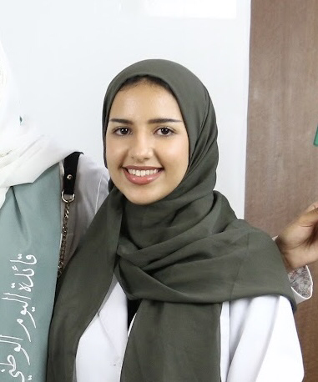Biography (150 word limit)
Paste your Logo here
Raghad Alkanani is a 5th year medical student and an aspiring researcher. She is very passionate about scientific research and public health. Raghad has participated in more than 10 health awareness campaigns. Although Raghad started conducting research only two years ago, she is currently working on 16 research projects and is willing to do more.
Email: Alkanani076@ksau-hs.edu.sa

Notes/Comments:
Presenting author details
Full name: Raghad Saleh Alkanani
Contact number: +966531481651
Mail id: raghdsaleh937@gmail.com
Category: (Oral presentation/ Poster presentation) Oral presentation is preferable, but poster is acceptable.

