Kinetic study of the sorption of paracetamol in batch mode by a new organic waste and polyethylene “Experimental and Modeling study”
Turkman M, Material and Environmental Laboratory, University of Medea, Algeria
Badaoui Bouthaina, University of Medea, Algeria
Mezyane Rayane, University of Medea, Algeria
Bouras Omar, Water Environment and Sustainable Development Laboratory, University of Blida 1, Blida, Algeria
Moulai-Mostefa Nadji, Material and Environmental Laboratory, University of Medea, Algeria

Abstract
Statement of the Problem: Pharmaceuticals as emerging pollutants have gained considerable attention due to their notable features such as low biodegradability, high persistence, and facile bioaccumulation[1]. Paracetamol was identified among various non-steroidal anti-inflammatory pharmaceutical compounds [2]. It has been reported in existing literature that water samples frequently exhibit the presence of paracetamol (PCT) pharmaceutical molecules. Different strategies have been put in place to address this problem in recent times. Various methods have been devised to reduce the occurrence of contaminants in water, amongst which the process of photodegradation has been prominently underscored [3].
The process of degradation caused by exposure to ultraviolet (UV) irradiation [4], as well as the adsorption process are all widely researched and utilized techniques in the field of environmental engineering. These methods have demonstrated considerable efficacy in removing a variety of contaminants from water and wastewater [5]. As such, they continue to be of significant interest to researchers and practitioners in the field. The present study concerns the study of the adsorption in batch mode of paracetamol by the waste resulting from the extraction of the essential oil of Mentha Spicata (WEM), by linear low density polyethylene (LLDPE 118WJ), and by the waste polyethylene granulated (WPEG). The waste used (WEM) was characterized by physico-chemical and structural methods (FTIR). A kinetic experimental study of the adsorption of paracetamol on the studied materials in batch mode was carried out with a modeling of the experimental results. The findings reveal that the pseudo-second-order model effectively fitted the kinetic profile of paracetamol sorption on the studied materials, as indicated by the relatively reduced values of the normalized standard deviation.
Obtained results demonstrated the effectiveness of these materials for the adsorption of paracetamol in batch mode (q_{e} = 133.25 mg/g for LLDPE, q_{e} = 118.91 for DPEG, q_{e} = 84.74 mg/g for DEM).

Image
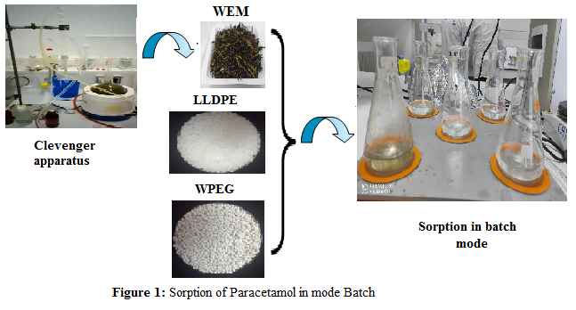
Recent Publications
- Ahmed M.J, Hameed BH (2018) Removal of emerging pharmaceutical contaminants by adsorption in a ﬁxed- bed column: A review. Ecotoxicology and Environmental Safety 149:247-266.
- Streit AFM, Collazzo GC, Druzian SP, Verdi RS, Foletto EL, Oliveira LFS, Dotto GL(2021) Adsorption of ibuprofen, ketoprofen, and paracetamol onto activated carbon prepared from effluent treatment plant sludge of the beverage industry. Chemosphere
262:128322.
- Shi E , Xu Z, Wang W, Xu Y, Zhang Y, Yang X, Liu Q, Zeng T, Song S, Jiang Y, Li L, Sharma V.K (2019) Ag2S-doped core-shell nanostructures of Fe₃O₄@Ag₃PO₄ ultrathin film: Major role of hole in rapid degradation of pollutants under visible light irradiation. Chemical Engineering Journal 366: 123–132.
- Baeza P, Aballay P, Matus C, Camú E, Fernanda Ramirez M, Eyzaguirre J, Ojeda J (2019) Degradation of Paracetamol Adsorbed on Inorganic Supports Under UV Irradiation. Water. Air. Soil Pollut 34: 230
- Afa Benjedim, Luis A. Romero-Cano, Agustín F. Pérez-Cadenas, M Isidora Bautista-Toledo, El Mostapha Lotfi, Francisco Carrasco-Marín, (2020) Removal of emerging pollutants present in water using an E-coli biofilm supported onto activated carbons prepared from argan wastes: Adsorption studies in batch and fixed bed. Science of The Total Environment 720:137491

Biography

Turkman Meriem has her PHD in modeling of transport phenomena in water and environmental sciences. She is a lecturer at the University Yahia Fares of MEDEA.Algeria
Email : turkmedea@gmail.com

Notes/Comments:

Presenting author details
Full name: TURKMAN Meriem
Contact number: +2130791239171
Mail id: turkmedea@gmail.com
Category: Oral presentation

