Viscosupplementation in the upper and lower compartments of the temporomandibular joint: control of temporomandibular Joint disfunction with degenerative disease
Susana Perdigoto, MSD
Invited speaker in Postgraduate Specialization in Orofacial pain, Oral Medicine, and Dental Sleep Medicine in European center of dentistry specialty - Portugal and European University - Spain

Abstract
Statement of the Problem: Temporomandibular joint disorder (TMD) is a widely researched disease in the literature since it has a high prevalence and is often associated with chronic pain and limited function of the temporomandibular joint (TMJ (1).
Osteoarthritis (OA) is considered a whole joint disease with deterioration and loss of the cartilage, changes in bone structures and subchondral and synovial inflammation(2) with reactive oxygen species formation producing the induction of neuropeptides and inflammatory cytokines (3).
TMJ viscosupplementation (VS) is a minimally invasive procedure that consists of an intra-articular injection of sodium hyaluronate (HA) into the joint compartments. HA is an efficient therapy to promote articular homeostasis and analgesia by stimulating type B synoviocytes to produce additional synovial liquid, with improvements on the lubrication, rheological properties of the synovial liquid, absorption of loads, and stimulation of chondrocyte proliferation in fibrocartilage(4).
Our group did a study to assess a VS protocol, with cone- beam computed tomography (CBCT)(5) and ultrasonography (US)(6). It was a 3 stages study. First stage: Check the correspondence between the facial points and the osseous components of the TMJ using CBCT. Second stage: Injection of the upper and lower compartments of 20 TMJs of frozen cadavers with colored liquids, and dissecting the specimens, Third stage: VS in 20 TMJs with verification by ultrasonography. The proposed protocol was effective for accessing the upper and lower compartments of the TMJ. The evaluated protocol proved to be accurate, safe, and clinically reproducible for the assessment of upper and lower compartments (4).
Superior and inferior joint space injections of Hyaluronic acid (HA) are effective methods for the treatment of temporomandibular without reduction (ADDWR) in association with TMJ OA. The injection of HA within the inferior joint space appears to result in better condylar reparative remodeling and improvement in jaw function (7).

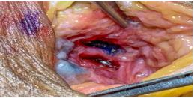
Fig.1- Colored fluids located in the upper and lower compartments of the TMJ
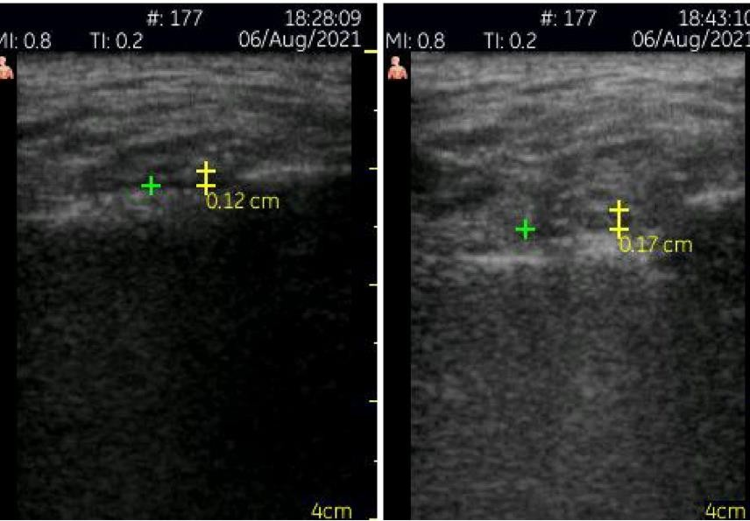
Fig.2- Preoperative and postoperative measurements of the thickness of the lateral joint space.

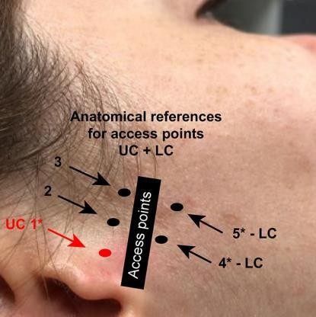

Fig.3- Reference points proposed by the evaluated protocol.


Biography
Susana Perdigoto passion is to enhance the health and well-being of patients. Has pursued a career in the study of orofacial pain, temporomandibular disorders, genetics and pharmacokinetics, and sleep disorders. Private practice in Klinicaperioimplantologica, and invited teacher in European University and ECDS group. Believes that in medicine one should spread knowledge for the good of all.
Email: susanaperdigoto1@gmail.com

Notes/Comments:

The work group is composed by Eduardo Januzzi, Thays Crosara Abrahão Cunha, Graziella Silva, Susana Perdigoto, Beatriz Dulcinéia Mendes Souza, Adriana Soares Bicalho Duarte, Marcella Rezende Serpa Zanini, Adriana Maria Andrade, Alexsander Ribeiro Pedrosa, Antônio Luís Neto Custódio and Maurício Augusto Aquino Castro, and we lecture in European center of dentistry specialty – Portugal.
The assessment protocol was conducted at Department of Dental Clinics, Oral Pathology and Oral Surgery of the Faculty of Dentistry of the Federal University of Minas Gerais by the Brazilian team.

Presenting author details
Full name:
Contact number:
Mail id:
Category: (Oral presentation)
Recent Publications
- Goiato MC, da Silva EV, de Medeiros RA, Túrcio KH, Dos Santos DM. Are intra-articular injections of hyaluronic acid effective for the treatment of temporomandibular disorders? A systematic review. Int J Oral Maxillofac Surg. 2016;45(12):1531-7.
- Orlowsky EW, Kraus VB. The role of innate immunity in osteoarthritis: when our first line of defense goes on the offensive. J Rheumatol. 2015;42(3):363-71.
- Skármeta NP, Katzmann Rider G, Heir GM. Understanding the phenotypical representations of temporomandibular osteoarthritis for effective management. J Oral Rehabil. 2021;48(1):106-7.
- Januzzi E, Cunha TCA, Silva G, Souza BDM, Duarte ASB, Zanini MRS, et al. Viscosupplementation in the upper and lower compartments of the temporomandibular joint checked by ultrasonography in an ex vivo and in vivo study. Sci Rep. 2022;12(1):17976.
- Honda K, Bjørnland T. Image-guided puncture technique for the superior temporomandibular joint space: value of cone beam computed tomography (CBCT). Oral Surg Oral Med Oral Pathol Oral Radiol Endod. 2006;102(3):281-6.
- Levorova J, Machon V, Hirjak D, Foltan R. Ultrasound-guided injection into the lower joint space of the temporomandibular joint. Int J Oral Maxillofac Surg. 2015;44(4):491-2.
- Li C, Long X, Deng M, Li J, Cai H, Meng Q. Osteoarthritic changes after superior and inferior joint space injection of hyaluronic acid for the treatment of temporomandibular joint osteoarthritis with anterior disc displacement without reduction: a cone-beam computed tomographic evaluation. J Oral Maxillofac Surg. 2015;73(2):232-44.

