Successful autotransplantation; a guideline.
Manfred Leunisse, Clinic for Orthodontics, Rotterdam, the Netherlands
Dick Barendregt, Proclin Rotterdam, clinic for Periodontoly, Endodontics and Restorative dentistry, Rotterdam, the Netherlands
Edwin Eggink, , Proclin Rotterdam, clinic for Periodontoly, Endodontics and Restorative dentistry, Rotterdam, the Netherlands
Marcel Linssen, , Proclin Rotterdam, clinic for Periodontoly, Endodontics and Restorative dentistry, Rotterdam, the Netherlands

Abstract (300 word limit)
Transplantation of teeth has a very long history, what started as intentional replantation with the pharaohs became autotransplantation in the 1950 in Denmark and Norway.
In 2004 we started to transplant premolars in Rotterdam. We evaluated our treatment results, as a team, and came to a successful guideline for this procedure. This guideline modified during the first 17 years of transplantation. The premolars we transplanted to the posterior region during this period were evaluated to establish the guideline to maximize the succes.
Indication, diagnosis and treatment planning will be discussed illustrated by a case and the results of our recents study.

Image

Recent Publications (minimum 5)
- Barendregt D, Andreasen JO, Leunisse M, Eggink E, Linssen M, van der Weijden F et al. An evaluation of 1654 premolars transplanted in the posterior region – A retrospective analysis of survival, success and complications. Dental Traumatology. 2023;00:1-13
- Nakdilok K, Langsa-Ard S, Krisanaprakornkit S, Suzuku EY, Suzuki B. Enhancement of human periodontal ligament by precpplication of orthodontic loading. Am J Orthod Dentofac Orthop. 2020;157:186093
- Kokai S, KannoZ, Koike S, Uesugi S, takahashi Y, Ono T et al. Retrospective study of 100 autotransplanted teeth with complete root formation and subsequent orthodontic treatment. Am J Orthod Dentof Orthop. 2015;148:982-9
- Chung WC, Tu YK, Lin YH, Lu HK. Outcomes of autotransplanted teeth with complete root formation: a systematic review and meta-analysis. J Clin Periodontol. 2014;41:412-23
- Tsukiboshi M. Autotransplantation of teeth: requirements for predictable success. Dent traumatol. 2002;18:157-80

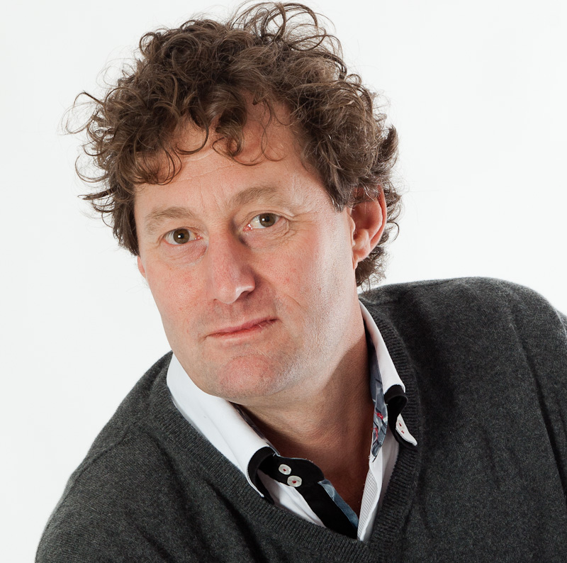Biography (150 word limit)
  o here

Manfred Leunisse started his dental training at the University of Amsterdam in 1982 and graduated in 1987. In 1989 he started his post graduate education in orthodontics at ACTA also in Amsterdam. He finished his post graduate training in 1993. Then he started a private orthodontic practice in Rotterdam. Next to his orthodontic practice he lectures and gives courses for dentists and oral hygienists.

The last 19 years his interest has shifted to treatment of patients based on a interdisciplinair team-approach with dentists, periodontologists, endodontologist, restorative dentists, oral surgeons and labtechniciens.

His fields of interest are dental traumatology, tooth wear and congenital dental abnormalities.

The last years he also publishes artikels and book chapters with the above mentioned colleagues.

Email: info@orthorotterdam.nl

Notes/Comments:

Presenting author details
Full name:
Contact number:
Twitter account:
Linked In account:
Session name/ number:
Category: (Oral presentation/ Poster presentation

