Machine Learning Integrated Graphene Nanoslit for Protein Sequencing
Sneha Mittal
Indian Institute of Technology (IIT) Indore, Indore, Madhya Pradesh, 453552, India

Abstract (300 word limit)

Protein sequencing has revolutionized the healthcare and life sciences fields by enabling the creation of more accurate diagnostic tools and personalized medicines for various serious illnesses. Ultra-fast Next-generation sequencing technologies such as nanopore/nanoslit sequencing can identify individual molecules and reading sequences with chromosome-size-long readability. However, the complexity of sequencing all 20 amino acids requires innovative approaches. To speed up the process of identifying these building blocks of proteins, we have developed a machine learning method that allows for quick and accurate prediction of the transmission function for sequencing of amino acids. Among the machine learning models tested, the XGBoost regression model was found to be the most effective, with a very low-test root mean square error (RMSE~0.05). Furthermore, using the random forest machine learning classification technique, it is possible to classify neutral amino acids with an accuracy rate of 100%. This approach represents a significant advancement in the prediction of transmission function through machine learning and can provide a platform for quickly and accurately identifying amino acids.

Image

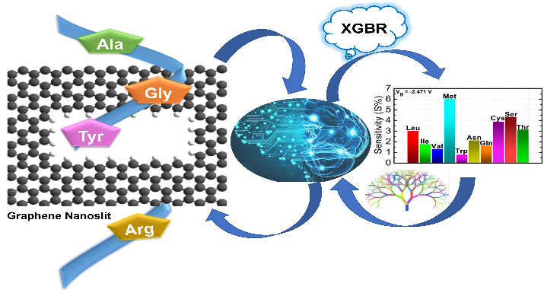

Recent Publications (minimum 5)
- Mittal, S.; Manna, S.; Pathak, B. Machine Learning Prediction of the Transmission Function for Protein Sequencing with Graphene Nanoslit. ACS Appl. Mater. Interfaces 2022, 14 (46), 51645–51655.
- Mittal, S.; Kumawat, R. L.; Jena, M. K.; Pathak, B. Graphene Nanoslit Device for Protein Sequencing: Ab Initio Quantum Transport Study. ACS Appl. Nano Mater. 2022, 5 (2), 2715–2727.
- Mittal, S.; Jena, M. K.; Pathak, B. Amplifying Quantum Tunneling Current Sensitivity through Labeling Nucleotides Using Graphene Nanogap Electrodes. ACS Appl. Nano Mater. 2022, 5 (7), 9356–9366.
- Mittal, S.; Pathak, B. Towards a Graphene Semi/Hybrid-Nanogap: A New Architecture for Ultrafast DNA Sequencing. Nanoscale 2022.
5. Mittal, S.; Pathak, B. A Step toward Amino Acid-Labeled DNA Sequencing: Boosting Transmission Sensitivity of Graphene Nanogap. ACS Appl. Bio Mater. 2022.



Biography (150 word limit)
Sneha Mittal works in the area of computational modelling of nanomaterials (particularly nanodevices) for biological (DNA/protein sequencing) applications. She has developed a machine learning tool for sequencing and classifying biomolecules based on the prediction of transmission function. The developed machine learning approach allows sequencing and classification of biomolecules, in particular protein at a fraction of time and cost of theoretical and experimental studies. This approach has potential to revolutionize the whole genome and proteome sequencing applications.
Email: phd1901231004@iiti.ac.in

Notes/Comments:

Presenting author details
Full name: Sneha Mittal
Contact number: 8826905857
Twitter account: @SnehaMi56251425
Linked In account: linkedin.com/in/sneha-mittal-95b6471a5
Session name/ number: Theoretical and computational chemistry
Category: Oral presentation

