Effect of Bridge on Rectification of Dibenzenethiol Molecular Junctions: Atomistic Modelling
Morad M. El-Hendawy, PhD,
New Valley University, Kharga 7251, Egypt

Abstract
Getting a marketable molecular rectifier is the "holy grail" of molecular electronics. A molecular rectifier is a single molecule assumed to conduct electric current in only one direction, ideally. The current project aims to investigate the precise role of the bridge in the molecular rectification of dibenzenethiols using computational screening methodology based on DFT-NEGF. In this context, the change in electron transport due to the frequent replacement of the bridge carbon atom by elements of groups 13-16 of the periodic table was investigated. Current-voltage characteristics, transmission spectra, the density of state (DOS), molecular projected self-consistent Hamiltonian (MPSH) states, and rectification ratio of the studied two-probe systems were calculated as a function of applied voltage. We demonstrate that electronegativity and the ionization potential of the bridging atom that maintain an asymmetric charge distribution in the dominant transport channel, HOMO, enhance rectification by approximating the energy difference between the channel and the Fermi level. These findings are precious for designing catalytic molecular assemblies work under an external electric field that could ensure the directionality of electron transport.

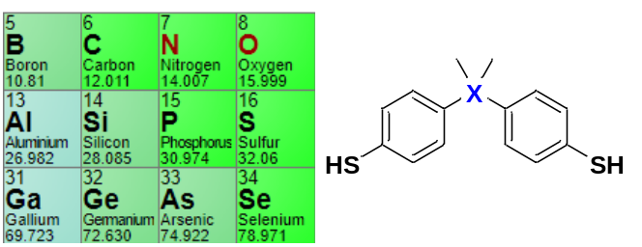
Recent Publications (minimum 5)
- El-Hendawy M. M., English N. J., El-Nahas A. M., (2014), Strategies for Design of New Organic Molecular Rectifiers: Chemical and Molecular-Simulation Perspectives, In D. Bove (Ed.) Computational Chemistry: Theories, Methods, and Applications (pp. 143-166) Nova Science Publishers, Inc. New York, USA.
- El-Hendawy M. M., Ahmed M. El-Nahas, and Awad M. K. (2010), Effect of Applied Voltage on the Geometrical and Electronic Structures of Dipyrimidinyl-diphenyl Diblock as a Molecular Diode: A DFT Study, Journal of Physical Chemistry C 114: 21728-21735.
- El-Hendawy M. M., El-Nahas A. M., and Awad M. K. (2011), The Effect of Constitutional and Conformational Isomerization on the Electrical Properties of Diblock Molecular Diode, Organic Electronics, 12: 1080-1092.
- El-Hendawy M. M., El-Nahas A. M., Awad M. K. (2012), Modification of the Electric Properties of Molecular Devices via Gradual Increment of Number of Nitrogen Atoms: A Computational Study, Organic Electronics, 13: 807–814.



Biography
El-Hendawy is an Associate Professor of Computational Chemistry at New Valley University, Egypt. He graduated in Chemistry in 2002 from Tanta University. Then he obtained an MSc degree in Physical Chemistry from the same university. He received his first Ph.D. in Physical Chemistry from Menoufia University, Egypt. Shortly after, he got another Ph.D. in Chemical Engineering from University College Dublin, Ireland. El-Hendawy found the computational chemistry group at New Valley University. The group applies computational chemistry approaches such as QM, QM/QM, QM/MM & MD to discover and investigate the chemical phenomena in our life. His research interests focus on molecular electronics, molecular and material catalysis, photochemistry, corrosion, etc.
Email: morad.elhendawy@aucegypt.edu

Notes/Comments:

Presenting author details
Full name:
Contact number:
Mail id:
Category: (Oral presentation/ Poster presentation)

