Immunomodulatory effects and structure-activity relationship of new diosgenin and tigogenin analogues
Olga Michalak ¹, Piotr Krzeczyński ¹, Marcin Cybulski ¹, Grzegorz Wojciechowski ¹, Piotr Cmoch ², Karolina Królewska-Golińska ³, Kinga Ostrowska ⁴, Bartosz Trzaskowski ⁵
¹Chemistry Section, Pharmacy, Cosmetic Chemistry and Biotechnology Research Group, Łukasiewicz Research Network–Industrial Chemistry Institute, Warsaw, Poland;
olga.michalak@ichp.lukasiewicz.gov.pl (OM), piotr.krzeczynski@ichp.lukasiewicz.gov.pl (PK), marcin.cybulski@ichp.lukasiewicz.gov.pl (MC); grzegorz.wojciechowski@ichp.lukasiewicz.gov.pl (GW);
² Institute of Organic Chemistry, Polish Academy of Sciences, Warsaw, Poland; piotr.cmoch@icho.edu.pl (PC)
³ Department of Bioorganic Chemistry, Centre of Molecular and Macromolecular Studies, Polish Academy of Sciences, Łódź, Poland; karolina.krolewska-golinska@cbmm.lodz.pl (KK)
⁴ Department of Organic Chemistry, Faculty of Pharmacy, Medical University of Warsaw, Warsaw, Poland; kostrowska@wum.edu.pl (KO)
⁵ Chemical and Biological Systems Simulation Lab, Center of New Technologies, University of Warsaw, Warsaw, Poland; b.trzaskowski@cent.uw.edu.pl (BT)

Abstract
Statement of the Problem: Currently, an increase in diseases that requires efficient body defense mechanisms to control them through the process of immunomodulation is observed worldwide. The main purpose of immunomodulators is to suppress immune response as a treatment for autoimmune diseases. [1]. Additionally, immunostimulant agents also act as an adjuvant to chemotherapy for various diseases [2]. Medicinal plants are important source of the active compounds, often acting as immunomodulators. The development of immunomodulatory and anti-tumor drugs from natural compounds has attracted considerable interest. Methodology: We designed, synthesized, and characterized a new family of diosgenin and tigogenin derivatives with new structural fragments at the C-3 position. All compounds have been evaluated in vitro for their antiproliferative activity against HUVEC and selected cancer cell lines by the MTT assay. Their immunomodulatory properties have been determined by examining the effect on the expression of several cytokine (IL-1, IL-4, IL-10, IL-12, TNF-α) genes by real time RT-PCR. Findings: Structure–activity relationship studies indicate that two of the tested compounds exhibit desired effects. They do not induce the gene expression of the pro-inflammatory cytokines (i.e. IL-12, IL-1, TNF-α) but strongly stimulate the expression of anti-inflammatory IL-10 and IL-4. A molecular docking study has revealed a high binding affinity of diosgenin and tigogenin analogues to the active site of the glucocorticoid receptor (GR). The GR is expressed in in the body cells and regulates genes that control, inter alia, the immune response. Conclusion: Promising results of the in vitro immunomodulating activity, molecular docking, and drug-likeness properties of new compounds presented here indicate that these compounds can be used as potential lead compounds for further development and investigation of novel immunomodulatory agents.
[1] U. Ilyas et al. Pharmacognosy Rev., 10 (19) (2016), pp. 66-70
[2] J. Pujol et al J. Thoracic Oncol., 10 (10) (2015), pp. 1458-1467

Recent Publications

1.P. Mehta, P. Miszta, P. Rzodkiewicz, O. Michalak, P. Krzeczyński, S. Filipek ‘’Enigmatic Histamine Receptor H₄ for Potential Treatment of Multiple Inflammatory, Autoimmune, and Related Diseases’’ Life (Basel), 2020, 24;10(4):50. doi: 10.3390/life10040050. PMID: 32344736.
2.K. Sidoryk, O. Michalak, M. Kubiszewski, A. Leś, M. Cybulski, E.U.Stolarczyk, J. Doubsky ‘’Synthesis of Thiol Derivatives of Biological Active Compounds for Nanotechnology Application’’ Molecules 2020, 25, 3470.
3.A. Gornowicz, W. Szymanowski, K. Bielawski, K. Leszczyńska, Z. Kałuża, O. Michalak, A. Bielawska ‘’Mucin 1 as a Molecular Target of a Novel Diisoquinoline Derivative Combined with Anti-MUC1 Antibody in AGS Gastric Cancer Cells’’ Molecules 2021, 26(21), 6504.
4.O. Michalak, P. Cmoch, A. Leś, M. Cybulski, P. Krzeczyński, K. Trzcińska, P. Miszta, P. Mehta, S. Filipek ‘’Unexpected Reaction Products of Uracil and Its Methyl Derivatives with Acetic Anhydride and Methylene Chloride’’ J. Org. Chem. 2021, 86, 14321-14332.
5. O. Michalak, P. Krzeczyński, A. Jaromin, P. Cmoch, M. Cybulski, K. Trzcińska, P. Miszta, P. Mehta, J. Gubernator, S. Filipek ‘’Antioxidant activity of novel diosgenin derivatives: Synthesis, biological evaluation, and in silico ADME prediction’’ Steroids 2022, 188, 109115.

Funding: This research was funded by the Polish Ministry of Education and Science under the framework of a Łukasiewicz–Industrial Chemistry Institute statutory project (grant Nº 841333)

Biography
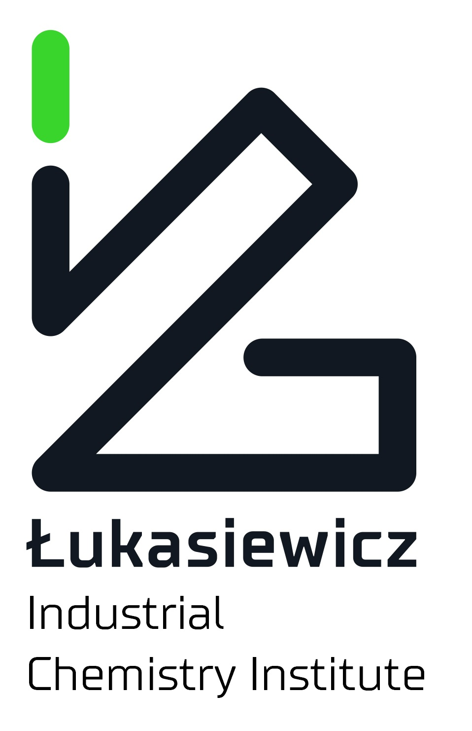
Olga Michalak (PhD Eng) has experience in the development of new synthetic methodologies and in the development of API synthesis. Her research interests include: synthetic organic chemistry, peptide synthesis and medicinal chemistry. She conducts research at the intersection of chemistry and biology. She is focusing on development of novel synthetic methodologies for the modification of biological molecules. Olga Michalak is currently a leader of Chemistry Group at Łukasiewicz – Industrial Chemistry Institute.

Email: olga.michalak@ichp.lukasiewicz.gov.pl

Notes/Comments:

Presenting author details
Full name: Olga Michalak, Grzegorz Wojciechowski
Contact number: +48 517 883 192
Twitter account:
Linked In account:
Session name/ number: Track 2:Medicinal Chemistry and Drug Discovery
Category: (Oral presentation/ Poster presentation)

