Chromatographic analysis of intact glucosinolate in leaves and flowers from Colombian nasturtium (Tropaeolum majus)
Eliana Yissel Aguilera Angel, Msc*, Ricardo Vera Bravo, PhD*, Néstor Julio García Castro, Msc, PhD*, Valentina Guzman Perez, Msc, PhD*.
*Pontificia Universidad Javeriana, Colombia

Abstract

Nasturtium (Tropaeolum majus L.) is an edible plant that grows wildly in South America[1], it is a plant with a high functional potential due to its content of bioactive compounds such as flavonoids, carotenoids and, glucosinolates[2]. Nasturtium bioactive compounds have been related with anti-inflammatory activity, modulation of glucose metabolism and antioxidant activity [3]–[5].
Nowadays the use of nasturtium is mainly ornamental [6] for that reason it is important to promote its study to know its content of bioactive compounds and its functional potential. Therefore, the aim of this study was to evaluate qualitative and quantitative the intact glucosinolates (Gls) content in freeze-dried leaves and flowers nasturtium collected in Cogua
- Cundinamarca, Colombia [6].
Intact GLs were evaluated by HPLC-DAD method using the extract methodology proposed by Förster et al (2015) without sulfatase treatment to obtain desulfoglucosinolates (which can cause degradation of the structure of some glucosinolates, forming artifacts) [7]. The content of intact glucosinolates was 3,03±0,49 mg/g dry weight (DW) from leaves and 4,58±0,37 mg/g DW from flowers. The result agrees with that reported by Schreiner, et al., 2009 [8], where 3.13 mg/g DW from leaves nasturtium was found by desulfoglucosinolates method. Then is possible determine the content of glucosinolates in nasturtium using a faster methodology, obtaining results comparable to those reported by the standardized method of quantification of desulfoglucosinolates.
This study contributes with the knowledge regarding the methodologies for the determination of intact glucosinolates in different plant matrices and to the study of the Colombian nasturtium as source of bioactive compounds.
In conclusion the determination of intact glucosinolates content is a quick method which facilitates the: i) nasturtium study, ii) quantification of glucosinolates rich extracts and products, and iv) promotes its use for supplements, phytoterapeutics , foods, and cosmetics development.

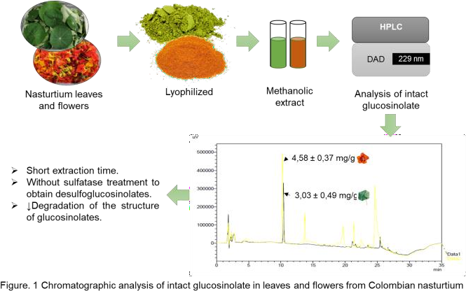

Recent Publications
- K. Jakubczyk, K. Janda, K. Watychowicz, J. Łukasiak, and J. Wolska, “Garden nasturtium (Tropaeolum majus l.) - a source of mineral elements and bioactive compounds,” no. 2, p. 8, 2018.
- J. C. Brondani et al., “Traditional usages, botany, phytochemistry, biological
activity and toxicology of Tropaeolum majus L. - A review,” p. 11, 2016.
- H. T. T. Tran, “Nasturtium (Indian cress, Tropaeolum majus nanum) dually blocks the COX and LOX pathway in primary human immune cells,” p. 10, 2016.
- A. Bazylko, A. Parzonko, W. Jeż, E. Osińska, and A. K. Kiss, “Inhibition of ROS production, photoprotection, and total phenolic, flavonoids and ascorbic acid content of fresh herb juice and extracts from the leaves and flowers of Tropaeolum majus,” Industrial Crops and Products, vol. 55, pp. 19–24, Apr. 2014, doi: 10.1016/j.indcrop.2014.01.056.
- V. Guzmán-Pérez, C. Bumke-Vogt, M. Schreiner, I. Mewis, A. Borchert, and A.
F. H. Pfeiffer, “Benzylglucosinolate Derived Isothiocyanate from Tropaeolum majus Reduces Gluconeogenic Gene and Protein Expression in Human Cells,” PLOS ONE, p. 28, 2016.
- M. C. Ospino, “Caracterización del uso y cultivo de la planta comestible, Tropaeolum majus, en la provincia de Ubaté y San Antonio de Tequendama,” PONTIFICIA UNIVERSIDAD JAVERIANA, Bogotá, 2015.
- N. Förster, C. Ulrichs, M. Schreiner, C. T. Müller, and I. Mewis, “Development of a reliable extraction and quantification method for glucosinolates in Moringa oleifera,” Food Chemistry, vol. 166, pp. 456–464, Jan. 2015, doi: 10.1016/j.foodchem.2014.06.043.
- M. Schreiner, A. Krumbein, I. Mewis, C. Ulrichs, and S. Huyskens-Keil, “Short- term and moderate UV-B radiation effects on secondary plant metabolism in different organs of nasturtium (Tropaeolum majus L.),” Innovative Food Science & Emerging Technologies, vol. 10, no. 1, pp. 93–96, Jan. 2009, doi: 10.1016/j.ifset.2008.10.001.



Eliana Yissel Aguilera Angel has her expertise in Food Chemistry. She is specialist in food science and technology and master's degree in chemistry. She currently is conducting her second year of Biological Sciences Ph.D. Her work is developed around bioactive compounds and functional foods.
Email: aguileraey@javeriana.edu.co

Presenting author details
Full name: Eliana Yissel Aguilera Angel, Msc. Contact number: 3057675697
Linked In account: https://co.linkedin.com/in/eliana-yissel-aguilera-angel-6a1561127
Full name: Ricardo Vera Bravo, PhD. Email: verar@javeriana.edu.co
Linked In account: https://co.linkedin.com/in/ricardo-vera-bravo-b87a196b
Full name: Néstor Julio García Castro, Msc, PhD. Email: nestor.garcia@javeriana.edu.co
Full name: Valentina Guzmán Perez Msc, PhD. Email: vguzman@javeriana.edu.co

Session name/ number:
Category: (Oral presentation/ Poster presentation)

