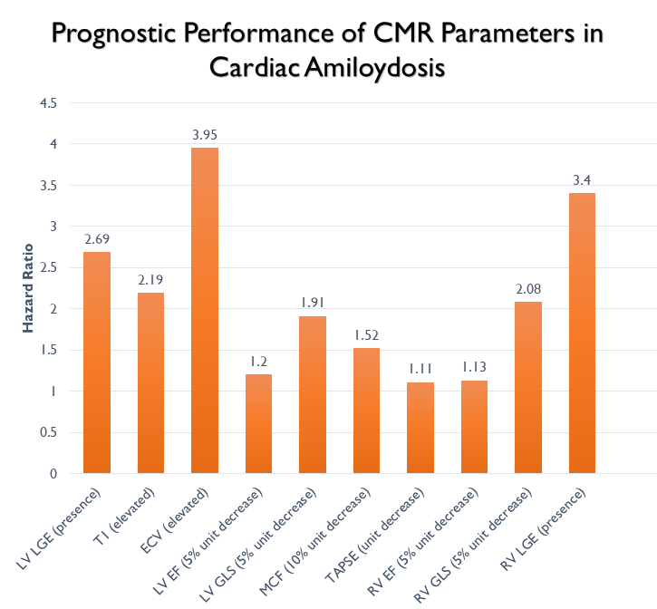
Prognosis and Prediction in Cardiac Amyloidosis by Cardiac Magnetic Resonance Imaging: A Systematic Review with Meta-Analysis
Paolo Boretto, M.D¹, Neal H Patel, B.Sc. (Hons.)², Keval Patel B.Sc. (Hons.)²

- Division of Cardiology, Department Cardiovascular and Thoracic, Città della Salute e della Scienza Hospital, University of Turin, Turin, Italy.
- UCL Medical School, UCLMS London

Objective:
This meta-analysis aimed to assess the prognostic role of CMR imaging modalities of left and right ventricle, including both anatomical and functional parameters in a large cohort of patients with AL and aTTR amyloidosis.
Background:
Cardiac involvement is the foremost determinant of the clinical progression of amyloidosis. The diagnostic role of CMR in cardiac amyloidosis has been established, but the prognostic role of various right and left CMR parameters (including GLS, LGE and parametric mapping) are still to be delineated, with an undetermined evidence base.
Methods:
We searched Embase, Pubmed and MEDLINE for studies analysing the prognostic use of CMR imaging in patients with AL or aTTR cardiac amyloidosis. Primary endpoint of the study was all-cause mortality. A random effects model was used to calculate a pooled odds ratio using inverse-variance weighting.
Results:
Our analysis included 19 studies with 2199 patients (66% males, median age: 59.7 years [IQR 58-67]). Median follow-up was 24 months [IQR 20-32], during which 40.8% of patients died. We found that both anatomical left heart parameters such as elevated ECV (HR 3.95 [3.01, 5.17]), extension of LV LGE (HR 2.69 [2.07, 3.49]) elevated native T1 (HR 2.19 [95% CI 1.12 – 4.28]) and functional parameters such as reduced LV GLS (HR 1.91 [95% CI 1.52 - 2.41]) and reduced LVEF (HR 1.20 [95% CI 1.17 - 1.23]) had increased HR for all cause mortality. Interestingly, alteration of right ventricular parameters such as RV GLS (HR 2.08 [95% CI 1.6 – 2.69]), RV EF (HR 1.13 [95% CI 1.05 – 1.22]) and TAPSE (HR 1.11 [95% CI 1.02 – 1.21]) also had significantly increased HR for mortality, while presence of RV LGE (HR 3.40 [95% CI 0.51 – 22.54]) was not significantly associated with adverse outcome.
Conclusions:
In this large meta-analysis, alterations of both functional and anatomical left ventricular and right ventricular parameters on CMR imaging are associated with increased risk of mortality in patients with cardiac amyloidosis.

Recent Publications (minimum 5)
Recent Publications:
- Adamo M, Pagnesi M, Ghizzoni G, et al. Evolution of tricuspid regurgitation after transcatheter edge-to-edge mitral valve repair for secondary mitral regurgitation and its impact on mortality. Eur J Heart Fail. 2022;24(11):2175-2184. doi:10.1002/ejhf.2637
- Adamo M, Inciardi RM, Tomasoni D, et al. Changes in Right Ventricular-to-Pulmonary Artery Coupling After Transcatheter Edge-to-Edge Repair in Secondary Mitral Regurgitation. JACC Cardiovasc Imaging. 2022;15(12):2038-2047. doi:10.1016/j.jcmg.2022.08.012
- Kheifets M, Angelini F, D'Ascenzo F, et al. Outcomes of Transcatheter Edge-to-Edge Repair in Degenerative vs. Functional Mitral Regurgitation. J Clin Med. 2022;11(20):6010. Published 2022 Oct 12. doi:10.3390/jcm11206010
- Bray JJH, Warraich M, Whitfield MG, et al. Oral Class I and III antiarrhythmic drugs for maintaining sinus rhythm after catheter ablation of atrial fibrillation. Cochrane Database Syst Rev. 2023;3(3):CD013765. Published 2023 Mar 13. doi:10.1002/14651858.CD013765.pub2
- Linardoutsos D, Frountzas M, Feakins RM, Patel NH, Simanskaite V, Patel H. Primary colonic squamous cell carcinoma: a case report and review of the literature. Ann R Coll Surg Engl. 2020;102(9):e1-e7. doi:10.1308/rcsann.2020.0149



Authors NHP and KP are final year medical students at UCL Medical School. They intercalated in Cardiovascular Sciences during their 3rd year of studies and formed a research group with Dr. Ahmad, a well published cardiologist who has a special interest in medical education and Meta-Analyses. Paolo Boretto is another cardiologist with a special interest in Medical Education who works with our team.
Email: neal.patel.18@ucl.ac.uk

Presenting author details
Full name: Neal Patel, Keval Patel
Contact number: 07775455462
Twitter account:
Linked In account:
Session name/ number:
Category: (Poster presentation) – would be open to oral presentation as wel

