Analysis of adherence and obstetric care to improve quality in private maternity hospitals in Brazil
Débora Cecília Chaves de Oliveira, RN PhD, UERJ, BRA
Andreza Rodrigues, RN PhD, UFRJ, BRA
Jacqueline Alves Torres, RN PhD, IHI, BRA
Elyne Montenegro Engstrom, doctor PhD, Fiocruz, BRA

Abstract (300 word limit)

Problem Statement: Unsatisfactory health realities, such as the high rates of unjustified cesarean sections in Brazilian private health, raise the need for complex interventions with a high degree of innovation, such as the Projeto Parto Adequado (PPA). Objective: To analyze contextual aspects related to adherence and the reorganization of care in the implementation of the PPA in private hospitals. Method & Theoretical Orientation: Research of the exploratory analytical type, through a single case study, incorporated, with a qualitative approach, being the case the PPA intervention. 83 professionals were interviewed (managers, leaders/coordinators, nurses and doctors) in 08 hospitals. Content Analysis was used; theoretical framework Diffusion of Innovations and the concept of interprofessionality. Results: The main reasons for joining the PPA were the absence of other quality improvement projects; social and market status when participating in the PPA; commitment to the quality of care; and the possibility of structural reforms related to the implementation of the project. Regarding the change in the work routine and the change in the care given to women after the beginning of the PPA, there were care practices that were incorporated, others that were adapted and practices that were rejected. In addition, two analytical dimensions of professional relationships at work were produced: Triggers for change in the cesarean section culture; and Midwifery in the private sector: the labor without the childbirth. Conclusion & Significance: Social, cultural and economic constructions motivated adherence to the PPA. There was also a reorganization of the ways of knowing how to do and caring in obstetrics after the implementation of the project. However, when analyzing interprofessional relationships in obstetric practice, it is still possible to perceive fragility in the attention to the desires and health needs of women and their families during labor and birth care.

Image

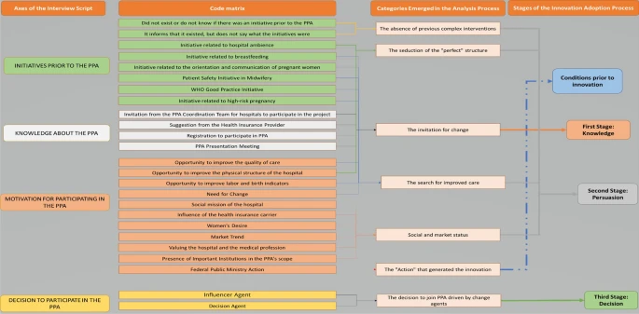

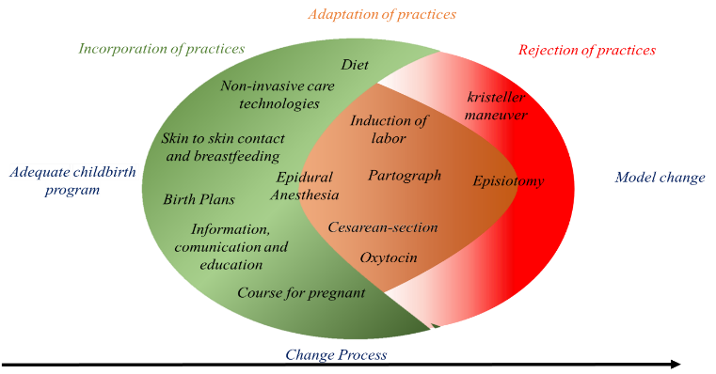

Recent Publications (minimum 5)
- DE OLIVEIRA, Débora Cecília Chaves et al. Process of adhesion of the Adequate Childbirth Program to improve obstetric care in private hospitals in Brazil. Reproductive Health, v. 20, n. 2, p. 1-12, 2022.
- NAKANO, Andreza Rodrigues; BONAN, Claudia; TEIXEIRA, Luiz Antônio. The normalization of c-section as a way of birth: material culture of birth in private hospitals in Southeastern Brazil. Physis, v. 25, n. 3, p. 885, 2015.
- TORRES, Jacqueline Alves et al. Evaluation of a quality improvement intervention for labour and birth care in Brazilian private hospitals: a protocol. Reproductive Health, v. 15, n. 1, p. 1-11, 2018.
- TORRES, Jacqueline Alves. Estudo comparativo sobre o modelo de Atenção obstétrica e neonatal em maternidades do Setor Suplementar de saúde no Brasil. 2014. Tese (Doutorado em Epidemiologia em Saúde Pública) – Fundação Oswaldo Cruz. Orientador: Maria do Carmo Leal
- FLICK, U. An introduction to qualitative fourth edition. 2009.
- ROGERS, E. M. Diffusion of innovations 5th Edition. New York 2003.

 Biography
Paste your Logo here
Débora Cecilia Chaves de Oliveira is an Obstetric Nurse. Master in Nursing and PhD in Public Health. She is currently an Adjunct Professor at the State University of Rio de Janeiro. Research Assistant at the research group Gender, Reproduction and Justice (CNPq). She has experience in the field of Nursing, with an emphasis on obstetric care. She has experience in evaluating government health interventions in the obstetric area. MAXQDA software trainer consultant for data analysis in qualitative and mixed research in the health area. State coordination assistant for the Birth in Brazil Survey (Fiocruz).
Email: debora_chaves@icloud.com

Notes/Comments:

Presenting author details
Full name: Débora Cecília Chaves de Oliveira
Contact number: +55 21 – 98154-5001
Twitter account: @DboraChaves20
Linked In account: https://www.linkedin.com/in/d%C3%A9bora-chaves-a3259b214
Session name/ number: Maternal and Perinatal Health
Category: Oral presentation

