Detection of Anti-ZIKV NS1 IgA, IgM, and Combined IgA/IgM and Identification of IL-4 and IL-10 as Potential Biomarkers for Early ZIKV and DENV Infections in Hyperendemic Regions, Thailand
Vajee Petphong

Mahidol University, Thailand

Abstract
Statement of the problem: Zika virus (ZIKV) belongs to the genus Flavivirus (family Flaviviridae), which also includes DENV and JEV, all of which are endemic in Southeast Asia [1-4]. Although most ZIKV-infected patients develop mild illnesses, the virus infection can also lead to serious neurological diseases, namely Guillain-Barre Syndrome (GBS) in adults and microcephaly in infants [5,6]. Owing to the limitations of current diagnostic tools [7-9], it is critical to find alternative methodologies for specific identification of a flavivirus infection.
Methodology & theoretical orientation: In this study, we used Euroimmun ZIKV NS1-based IgM, IgA, and combined IgA/IgM (or IgA/M) ELISAs to detect IgA and IgM of Thai patients. We evaluated the levels of cytokines in sequential serum samples of ZIKV and DENV cases, using multiplex immunoassay to characterize immunity to ZIKV and DENV, to determine potential diagnostic biomarkers, and to investigate the association between cytokine levels and Zika symptoms.
Findings: Low rates of positivity for ZIKV NS1-specific IgA and IgM were detected. ZIKV NS1 IgA/M (11%, 11/101) in combination was more frequently detected than ZIKV NS1 IgM (2%, 2/101) or ZIKV NS1 IgA (4%, 4/96) alone, especially in acute ZIKV cases with previous DENV exposure (14%, 10/72). The significant differences in cytokine levels detected among ZIKV and DENV cases suggested that IL-4 (p = 0.0176) and IL-10 (p = 0.0003) may serve as differential biomarkers for acute ZIKV and acute DENV infections, respectively. Analysis of the association between increased cytokine levels and ZIKV symptoms indicated that CXCL10 (p = 0.0029) was associated with exanthema, while IL-5 (p = 0.0496) was linked to headache.
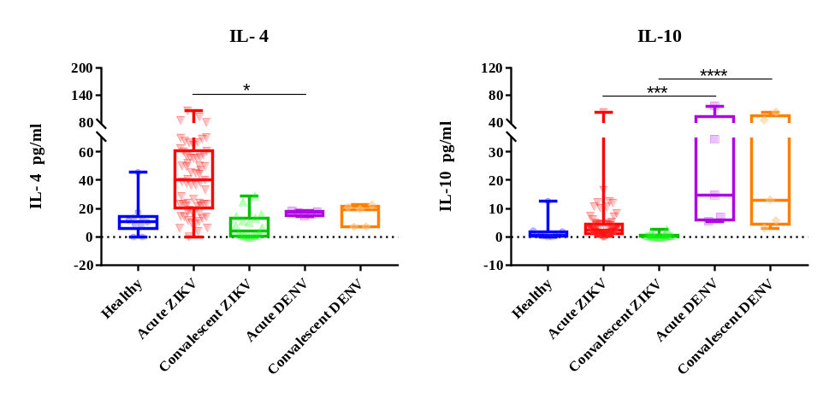
Figure 1. Differences in the levels of IL-4 and IL-10 in the acute and convalescent phases of ZIKV cases compared with DENV cases. Boxplot demonstrates minimum, interquartile range, median, and maximum of each sample group on the x−axis. The asterisk (*) shows a comparison of the medians between two groups. All significant correlations are presented with the degree of significance indicated (* p < 0.05, *** p < 0.001, **** p < 0.0001).

Conclusion: The combined ZIKV-NS1 IgA and IgM detection appears to enhance early ZIKV diagnosis when the levels of either IgM or IgA alone are undetectable. IL-4 and IL-10 may serve as targets for the development of diagnostic tools to detect ZIKV and DENV infections early, respectively.
References:
1. Al-Qahtani, A.A.; Nazir, N.; Al-Anazi, M.R.; Rubino, S.; Al-Ahdal, M.N. Zika virus: a new pandemic threat. Journal of infection in developing countries 2016, 10, 201-207, doi:10.3855/jidc.8350.
2. Heinz, F.X.; Stiasny, K. The Antigenic Structure of Zika Virus and Its Relation to Other Flaviviruses: Implications for Infection and Immunoprophylaxis. Microbiol Mol Biol Rev 2017, 81, doi:10.1128/mmbr.00055-16.
3. Winter, P.M.; Dung, N.M.; Loan, H.T.; Kneen, R.; Wills, B.; Thu le, T.; House, D.; White, N.J.; Farrar, J.J.; Hart, C.A.; et al. Proinflammatory cytokines and chemokines in humans with Japanese encephalitis. J. Infect. Dis. 2004, 190, 1618-1626, doi:10.1086/423328.
4. Priyamvada, L.; Quicke, K.M.; Hudson, W.H.; Onlamoon, N.; Sewatanon, J.; Edupuganti, S.; Pattanapanyasat, K.; Chokephaibulkit, K.; Mulligan, M.J.; Wilson, P.C.; et al. Human antibody responses after dengue virus infection are highly cross-reactive to Zika virus. Proc. Natl. Acad. Sci. U. S. A. 2016, 113, 7852-7857, doi:10.1073/pnas.1607931113.
5. Shuaib, W.; Stanazai, H.; Abazid, A.G.; Mattar, A.A. Re-Emergence of Zika Virus: A Review on Pathogenesis, Clinical Manifestations, Diagnosis, Treatment, and Prevention. The American journal of medicine 2016, 129, 879.e877-879.e812, doi:10.1016/j.amjmed.2016.02.027.
6. Relich, R.F.; Loeffelholz, M. Zika Virus. Clinics in laboratory medicine 2017, 37, 253-267, doi:10.1016/j.cll.2017.01.002.
7. Munoz-Jordan, J.L. Diagnosis of Zika Virus Infections: Challenges and Opportunities. J. Infect. Dis. 2017, 216, S951-s956, doi:10.1093/infdis/jix502.
8. Cabral-Castro, M.J.; Cavalcanti, M.G.; Peralta, R.H.S.; Peralta, J.M. Molecular and serological techniques to detect co-circulation of DENV, ZIKV and CHIKV in suspected dengue-like syndrome patients. Journal of clinical virology : the official publication of the Pan American Society for Clinical Virology 2016, 82, 108-111, doi:10.1016/j.jcv.2016.07.017.
9. Lanciotti, R.S.; Kosoy, O.L.; Laven, J.J.; Velez, J.O.; Lambert, A.J.; Johnson, A.J.; Stanfield, S.M.; Duffy, M.R. Genetic and serologic properties of Zika virus associated with an epidemic, Yap State, Micronesia, 2007. Emerging infectious diseases 2008, 14, 1232-1239, doi:10.3201/eid1408.080287.

Biography


Dr. Petphong had her PhD degree in Microbiology and Immunology at Mahidol University, Bangkok (Thailand), where she started studying tropical infectious diseases, immune responses against tropical pathogens, and the principles and methods of diagnosis of infectious diseases. From 2014-2016, she worked as a medical scientist at the Department of Pathology, Siriraj Hospital in Bangkok. Since 2017, she has been studying immune responses to Zika virus and dengue virus infections and doing scientific work at the Department of Microbiology and Immunology, Faculty of Tropical Medicine, Mahidol University in Bangkok. From 2016-2022, she worked as a medical scientist (part-time) at Pathology Diagnostic Center Co., Ltd., specializing in the detection of blood cancers using flow cytometry and organ specific cancers using molecular tools.

