Ocular surface mucosal immunology in ocular graft-versus-host disease and its clinical implication
Yoko Ogawa, M.D., Ph.D., Department of Ophthalmology, Keio University School of Medicine, Tokyo, Japan.

Abstract (300 word limit)

Ocular GVHD-related inflammation and fibrosis can be an early sign of the onset and also affects the later stage for the long term for many recipients after HSCT as irreversible consequences. Pathogenic fibrosis by interacting between immune cells and mesenchymal cells leads to ocular surface deterioration including cornea, conjunctiva, meibomian glands and lacrimal glands, resulting in a special subtype of severe and intractable dry eye disease. There are no approved topical medications for severe immune-mediated fibrosis on the ocular surface at present time. We report various patterns on ocular surface fibrosis with ocular GVHD after long-term follow-up in patients after subsiding systemic cGVHD. The timing of starting treatment on ocular GVHD is limited and very narrow window of opportunity. Therefore, proper diagnosis and treatment at early stage is important to prevent severe dry eye disease related to GVHD.
Image
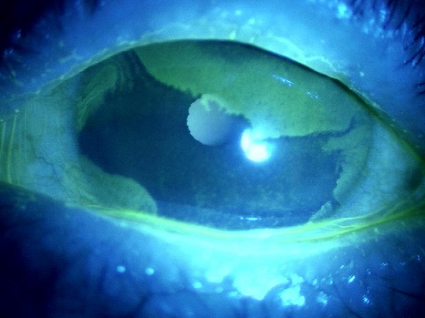

Figure 1. Irregularity of lid margin and conjunctivalization from the limbal region. Chronic diffuse abnormality accompanied with fibrotic changes seen of meibomian glands in eyelids. Conjunctivalization derived from multiple locations of the limbal region.
Recent Publications (minimum 5)
Yang F, Hayashi I, Sato S, Saijo-Ban Y, Yamane M, Fukui M, Shimizu E, He J, Shibata S, Mukai S, Asai K, Ogawa M, Lan Y, Zeng Q, Hirakata A, Tsubota K, Ogawa Y. Eyelid blood vessel and meibomian gland changes in a sclerodermatous chronic GVHD mouse model. Ocul Surf. 26:328-341, 2022.

Ogawa Y, Dana R, Kim S, Jain S, Rosenblatt MI, Perez VL, Clayton JA, Alves M, Rocha EM, Amparo F, Seo KY, Wang Y, Shen J, Oh JY, Vanathi M, Nair S, Na KS, Riemens A, Sippel K, Soifer M, Wang S, Trindade M, Kim MK, Yoon CH, Yagi R, Hiratsuka R, Ogawa M, Shimizu E, Sato Y, Pflugfelder S, Tsubota K. Multicenter prospective validation study for international chronic ocular graft-versus-host disease consensus diagnostic criteria. Ocul Surf. 26:200-208, 2022

Hiratsuka R, Shimizu E, Yamane M, Yazu H, Sato S, Fukui M, Mukai S, Uchino M, Kamoi M, Tatematsu Y, Saijo Y, Negishi K, Tsubota K, Ogawa Y. A single institute validation study comparing the international chronic ocular graft-versus-host disease consensus group diagnostic criteria with clinical parameters. Ocul Surf. 2022 Apr;24:12-14.

Sato S, Shimizu E, He J, Ogawa M, Asai K, Yazu H, Rusch R, Yamane M, Yang F, Fukuda S, Kawakami Y, Tsubota K, Ogawa Y*. Positive Effects of Oral Antibiotic Administration in Murine Chronic Graft-Versus-Host Disease. Int J Mol Sci. 2021 Apr;22(7):374.

Ogawa Y, Kawakami Y, Tsubota K. Cascade of inflammatory, fibrotic processes and stress-induced senescence in chronic GVHD-related dry eye disease. Int. J. Mol. Sci. 2021 Jun 6;22(11):6114.

Ogawa Y, Takeuchi T, Tsubota K. Autoimmune epithelitis and chronic inflammation in Sjogren’s syndrome-related dry eye disease. Int J Mol Sci. 2021 Oct 30;22(21):11820.

Kitko CL, Pidala J, Schoemans HM, Lawitschka A, Flowers ME, Cowen EW, Tkaczyk E, Farhadfar N, Jain S, Steven P, Luo ZK, Ogawa Y, Stern M, Yanik GA, Cuvelier GDE, Cheng GS, Holtan SG, Schultz KR, Martin PJ, Lee SJ, Pavletic SZ, Wolff D, Paczesny S, Blazar BR, Sarantopoulos S, Socie G, Greinix H, Cutler C: National Institutes of Health Consensus Development Project on Criteria for Clinical Trials in Chronic Graft-versus-Host Disease: IIa. The 2020 Clinical Implementation and Early Diagnosis Working Group Report. Transplant Cell Ther. 2021 Jul;27(7):545-557.

Wolff D, Radojcic V, Lafyatis R, Cinar R, Rosenstein RK, Cowen EW, Cheng GS, Sheshadri A, Bergeron A, Williams KM, Todd JL, Teshima T, Cuvelier GDE, Holler E, McCurdy SR, Jenq RR, Hanash AM, Jacobsohn D, Santomasso BD, Jain S, Ogawa Y, Steven P, Luo ZK, Dietrich-Ntoukas T, Saban D, Bilic E, Penack O, Griffith LM, Cowden M, Martin PJ, Greinix HT, Sarantopoulos S, Socie G, Blazar BR, Pidala J, Kitko CL, Couriel DR, Cutler C, Schultz KR, Pavletic SZ, Lee SJ, Paczesny S.National Institutes of Health Consensus Development Project on Criteria for Clinical Trials in Chronic Graft-versus-Host Disease: IV. The 2020 Highly morbid forms report. Transplant Cell Ther. 2021 Oct;27(10):817-835.

Shimizu E, Aketa N, Yazu H, Uchino M, Kamoi M, Sato Y, Tsubota K, Ogawa Y. Corneal higher-order aberrations in the eyes of ocular chronic graft-versus-host disease. Ocul Surf. 2020, 18:98-107.

Yamane M, Sato S, Shimizu E, Shibata S, Hayano M, Yaguchi T, Kamijuku H, Ogawa M, Suzuki T, Mukai S, Shimmura S, Okano H, Takeuchi T, Kawakami Y, Ogawa Y*, Tsubota K. Senescent associated secretary phenotype promotes chronic ocular graft-versus-host disease. FASEB J. 2020 34(8):10778-10800.

 Biography (150 word limit)
Paste your Logo here
Yoko Ogawa has her expertise in ocular graft-versus-host disease. Recent Research Topics: Fibrosis and chronic inflammation of organs are observed in systemic autoimmune disease and graft-versus-host disease after hematopoietic stem cell transplantation. Using a scleroderma mouse, we showed that transplantation of MHC compatible, minor antigen mismatched bone marrow stromal/stem cells (BMSCs) play a role in the pathogenesis of fibrosis. In addition, we are investigating whether senescent cells including macrophages and other immune competent cells are involved in chronic ocular graft-versus-host disease as well as other immune-mediated diseases.Email: yoko@z7.keio.jp

Notes/Comments:

Presenting author details
Full name: Yoko Ogawa
Contact number:819034744554
Twitter account:
Linked In account:
Session name/ number:
Category: (Oral presentation)

