Potential role for amino acids analogues of ursolic acid against breast cancer cell lines
Olga Michalak ¹, Marcin Cybulski ¹, Piotr Krzeczyński ¹, Agnieszka Gornowicz ², Bartosz Trzaskowski ³, Kinga Ostrowska ⁶, Grzegorz Wojciechowski ¹, Marek Kubiszewski ⁴, Wojciech Szymanowski ², Krzysztof Bielawski ⁵, Anna Bielawska ²,
¹Chemistry Section, Pharmacy, Cosmetic Chemistry and Biotechnology Research Group, Łukasiewicz Research Network–Industrial Chemistry Institute, Warsaw, Poland;
olga.michalak@ichp.lukasiewicz.gov.pl (OM); marcin.cybulski@ichp.lukasiewicz.gov.pl (MC); piotr.krzeczynski@ichp.lukasiewicz.gov.pl (PK), grzegorz.wojciechowski@ichp.lukasiewicz.gov.pl (GW)
²Department of Biotechnology, Medical University of Białystok, Białystok, Poland; agnieszka.gornowicz@umb.edu.pl (AG); wojtekszymanowski@wp.pl (W.S.); anna.bielawska@umb.edu.pl (AB)
³Chemical and Biological Systems Simulation Lab, Center of New Technologies, University of Warsaw, Warsaw, Poland; b.trzaskowski@cent.uw.edu.pl (BT)
⁴ Analytical Research Section, Pharmaceutical Analysis Laboratory, Łukasiewicz Research Network–Industrial Chemistry Institute, Warsaw, Poland; marek.kubiszewski@ichp.lukasiewicz.gov.pl (MK)
⁵ Department of Synthesis and Technology of Drugs, Faculty of Pharmacy, Medical University of Białystok, Białystok, Poland; krzysztof.bielawski@umb.edu.pl (KB)
⁶ Department of Organic Chemistry, Faculty of Pharmacy, Medical University of Warsaw, Warsaw, Poland; kostrowska@wum.edu.pl (KO)

Abstract
Statement of the Problem: Breast cancer (BC) is an important global health problem [1] and one of the most common types of cancer among women. For this reason, the development of new drugs is imperative, and research is ongoing to understand the difference between healthy cells and cancer ones. One of the most effective methods for obtaining new drugs is the chemical modification of natural compounds with proven high biological activity. An example of such compound is ursolic acid (UA, 3β-hydroxy-urs-12-en-28-oic acid). Methodology: We designed, synthesized, and characterized a new family of UA derivatives substituted with various amino acids and dipeptides at the C-3 position. The cytotoxicity of all compounds was determined against breast cancer cell lines (MCF-7 and MDA) and DNA synthesis by the inhibition of [³H]–thymidine incorporation in tested cells. Next, we determined the effect of three most active analogues on the concentrations of: MMP-2, MMP-9, Bax, LC3A, LC3B, Beclin-1, caspase-7, IL-6 and TNF-α. Findings: Three most active derivatives showed micromolar IC₅₀ values and reduced the concentrations of MMP-2 and MMP-9. The apoptosis pathway associated with an increase in Bax protein and caspase-7 enzyme levels was postulated as a possible mechanism of action for two of these compounds. Third compound increased the release of autophagic markers (LC3A, LC3B) inducing the autophagy pathway. The same compound revealed inhibition of two proinflammatory cytokines (TNF-α and IL-6). Conclusion: The results of our experimental and computational studies, including: in vitro anticancer activity, molecular docking, and drug-like properties have shown that the new group of ursolic acid derivatives presented here, has an promising profile and therapeutic potential against triple-negative breast cancer cells, i.e., cancer with poor survival prognosis.
[1] Li, W et al. A novel synthetic ursolic acid derivative inhibits growth and induces apoptosis in breast cancer cell lines. Oncol. Lett. 2018, 15, 2323–2329.

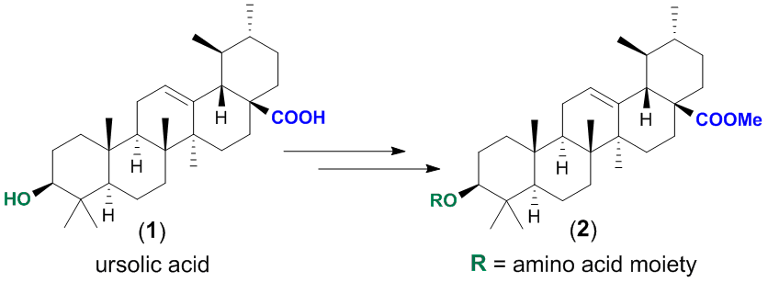
Recent Publications

1.P. Mehta, P. Miszta, P. Rzodkiewicz, O. Michalak, P. Krzeczyński, S. Filipek ‘’Enigmatic Histamine Receptor H₄ for Potential Treatment of Multiple Inflammatory, Autoimmune, and Related Diseases’’ Life (Basel), 2020, 24;10(4):50. doi: 10.3390/life10040050. PMID: 32344736.
2.K. Sidoryk, O. Michalak, M. Kubiszewski, A. Leś, M. Cybulski, E.U.Stolarczyk, J. Doubsky ‘’Synthesis of Thiol Derivatives of Biological Active Compounds for Nanotechnology Application’’ Molecules 2020, 25, 3470.
3.A. Gornowicz, W. Szymanowski, K. Bielawski, K. Leszczyńska, Z. Kałuża, O. Michalak, A. Bielawska ‘’Mucin 1 as a Molecular Target of a Novel Diisoquinoline Derivative Combined with Anti-MUC1 Antibody in AGS Gastric Cancer Cells’’ Molecules 2021, 26(21), 6504.
4.O. Michalak, P. Cmoch, A. Leś, M. Cybulski, P. Krzeczyński, K. Trzcińska, P. Miszta, P. Mehta, S. Filipek ‘’Unexpected Reaction Products of Uracil and Its Methyl Derivatives with Acetic Anhydride and Methylene Chloride’’ J. Org. Chem. 2021, 86, 14321-14332.
5. O. Michalak, P. Krzeczyński, A. Jaromin, P. Cmoch, M. Cybulski, K. Trzcińska, P. Miszta, P. Mehta, J. Gubernator, S. Filipek ‘’Antioxidant activity of novel diosgenin derivatives: Synthesis, biological evaluation, and in silico ADME prediction’’ Steroids 2022, 188, 109115.

Funding: This research was funded by the Polish Ministry of Education and Science under the framework of a Łukasiewicz–Industrial Chemistry Institute statutory project (grant Nº 841333) and Medical University of Bialystok, grant Nº. B.SUB.23.420.

Biography

Olga Michalak (PhD Eng) has experience in the development of new synthetic methodologies and in the development of API synthesis. Her research interests include: synthetic organic chemistry, peptide synthesis and medicinal chemistry. She conducts research at the intersection of chemistry and biology. She is focusing on development of novel synthetic methodologies for the modification of biological molecules. Olga Michalak is currently a leader of Chemistry Group at Łukasiewicz – Industrial Chemistry Institute.
Email: olga.michalak@ichp.lukasiewicz.gov.pl

Notes/Comments:

Presenting author details
Full name: Olga Michalak, Grzegorz Wojciechowski
Contact number: +48 517 883 192
Twitter account:
Linked In account:
Session name/ number: Track 2:Medicinal Chemistry and Drug Discovery
Category: (Oral presentation/ Poster presentation)

