Fatal curiosity: A case of Suicidal attempt by Abrus seeds consumption through online research

Prateek Kumar Dinkar
King George's Medical University, India

Abstract

Abrus precatorius (Jequirity, Indian liquorice, rosary bead, Gunja, or rati) seeds are highly toxic and are often ingested as a means of suicide in India. Gastric symptoms like bleeding; diarrhea, vomiting, and epigastric pain are the common manifestations of this toxicity. Abrin, a toxic substance found in the seeds, is structurally and functionally similar to ricin and is considered even more fatal. We report the first case of Abrus precatorius poisoning, where the internet was utilized to procure a potentially deadly poison with the intention to commit suicide in north India. Such actions are relevant to the medical field, particularly regarding the potential risks associated with the unsupervised procurement and misuse of toxic substances. The case highlights the potentially fatal consequences of ingesting Abrus seeds and the need for prompt medical attention in such cases.

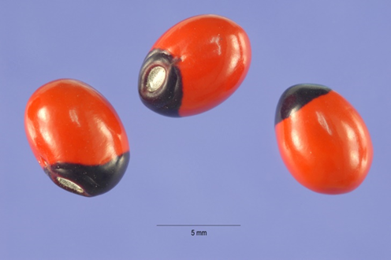

References:

- Jang DH, Hoffman RS, Nelson LS: Attempted suicide, by mail order: Abrus precatorius. J Med Toxicol. 2010, 6:427-430. 10.1007/s13181-010-0099-1
- Dickers KJ, Bradberry SM, Rice P, Griffiths GD, Vale JA: Abrin poisoning. Toxicol Rev. 2003, 22:137-142. 10.2165/00139709-200322030-00002
- Ohba H, Moriwaki S, Bakalova R, Yasuda S, Yamasaki N: Plant-derived abrin-a induces apoptosis in cultured leukemic cell lines by different mechanisms. Toxicol Appl Pharmacol. 2004, 195:182-193. 10.1016/j.taap.2003.11.018
- Benson S, Olsnes S, Pihl A, Skorve J, Abraham AK: On the mechanism of protein-synthesis inhibition by abrin and ricin. Inhibition of the GTP-hydrolysis site on the 60-S ribosomal subunit. Eur J Biochem. 1975, 59:573-580. 10.1111/j.1432-1033.1975.tb02484.x
- Fodstad O, Olsnes S, Pihl A: Toxicity, distribution and elimination of the cancerostatic lectins abrin and ricin after parenteral injection into mice. Br J Cancer. 1976, 34:418-425. 10.1038/bjc.1976.187

Biography:

Dr. Prateek Kumar Dinkar is a resident physician currently working in the Department of Emergency Medicine at King George's Medical University (KGMU) in Lucknow, Uttar Pradesh, India. He holds an MBBS degree from KGMU. Dr. Dinkar has a diverse range of research interests, including endocrine surgery, trauma surgery, pulmonology, emergency medicine, critical care medicine, behavioural psychiatry, and neuropsychiatry. He has three years of research experience and has made significant contributions to the field, particularly in the study of latent tuberculosis infection. In addition to his academic pursuits, Dr. Dinkar is actively involved in various professional societies and organizations. He serves as a peer reviewer for esteemed publications such as BMJ Case Reports, BMC, The British Student Doctor Journal, International Journal of Clinical Research, and Cureus Journal of Medical Science. He is also affiliated with the International Society for Chronic Illnesses, Royal College of Physicians of Edinburgh, and the American College of Physicians. Dr. Dinkar has published several academic papers and has participated in conferences and workshops related to his areas of expertise. He has received certifications and awards for his scholarly work, including appreciation for manuscript peer reviews.

