Alterations in Diversity of Gut Microbiome during schizophrenia
Ayesha Ameen
University of management and technology
Corresponding: ayesha.ameen@umt.edu.pk

Abstract
The gut microbiome, which refers to the collection of microorganisms that reside in the digestive tract, is thought to have a significant role in the emergence of neurological disorders, including schizophrenia. Recent studies indicate that people with schizophrenia exhibit changes in their gut microbiomes, characterized by lower levels of beneficial bacteria like Bifidobacterium and Lactobacillus, and higher levels of potentially harmful bacteria such as Proteobacteria. Additionally, research reveals that the communication between the gut and the brain, known as the gut-brain axis, is disrupted in individuals with schizophrenia. Although the exact mechanisms connecting the gut microbiome and schizophrenia are not yet fully comprehended, scientists propose that alterations in the gut microbiome could impact the immune system and neurotransmitters, thereby contributing to the development of the disorder. Interventions targeting the gut microbiome, such as probiotics and the Mediterranean diet, present a promising therapeutic approach for individuals with schizophrenia. However, further investigation is necessary to fully understand the intricate interplay between the gut microbiome and schizophrenia, including the specific mechanisms through which the gut microbiome influences the development of the disorder.

Regenerate response

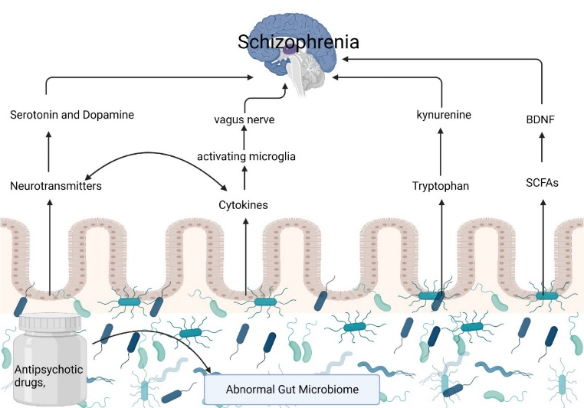

Figure 1: Illustration of different metabolites production in SCZ patients and their gut
Recent Publications
- Athar Hussain, Jinbao Liu, Binoop Mohan, Akif Burhan, Zunaira Nasim, Raveena Bano, Ayesha Ameen, Madiha Zaynab, M. Shahid Mukhtar, Karolina M. Pajerowska-Mukhtar A genome-wide comparative evolutionary analysis of zinc finger-BED transcription factor genes in land plants., Scientific Reports (2022). IF 4.3

- Hussain, A., Asif, N., Pirzada, A.R. et al. Genome wide study of cysteine rich receptor like proteins in Gossypium sp.. Scientific Reports 12, 4885 (2022) IF 4.3

- Madiha Zaynab, Rashid Al-Yahyai, Ayesha Ameen, Yasir Sharif, Liaqat Ali, Mahpara Fatima, Khalid Ali Khan, Shuangfei Li, Health and environmental effects of heavy metals, Journal of King Saud University - Science, Volume 34, Issue 1,2022,101653,ISSN 1018-3647: IF 4.0

- Wahid, B., Amir, A., Ameen, A., and Idrees, M. (2021). Current status of therapeutic approaches and vaccines for SARS-CoV-2. Future microbiology: IF 3.1

- Athar Hussain, Ali Raza, Ayesha Ameen, Haris A Rehman, Hafiz Khawar, Jazaib A Irfan, Wajih Maqsood, Saqib Wains, Najeeb Khan, Muhammad S Nawaz, Aqsa Qurban. Research Progress of AP2/ERF Transcription Factor Family in Important Crops. International Journal of Phytopathology.

- Braira Wahid, Anam Amir, Haris Abdul Rehman, Mehreen Fatima, Ayesha Ameen, Aamna Syed, Hafiz Khawar, Muhammad Nauman Aziz. Quick Recovery of Fulminant Hepatitis E Virus (HEV) Infection in Few Days with Excessive Intake of Plum Juice During Last Trimester of Pregnancy. Pakistan Journal of Medical & Health Sciences.

- Irshad, A., Tahir, A., Sharif, S., Khalid, A., Ali, S., Naz, A., & Ameen, A. (2023). Determination of Nutritional and Biochemical Composition of Selected Pleurotus spps. BioMed Research International, 2023.



Biography
Ayesha Ameen is a Pakistani biotechnologist and lecturer of biotechnology at University of Management and Technology, Lahore, Pakistan. Her research interests includes study of gut microbial diversity, identification of new strains of bacteria and waste management strategies to eliminate pollution from environment. I have published 14 research and review papers in good impact factor and Scopus index journals. I also hold one national patent. I received a master's degree in biotechnology from Forman Christian College University.

Email: ayesha.ameen@umt.edu.pk

Presenting author details
Full name: Ayesha Ameen
Contact number: 03054095036
Twitter account:
Linked In account:
Session name/ number:
Category: (Oral presentation)

