EFFECTS OF THERAPEUTIC EXERCISES ON QUALITY OF LIFE AND UPPER LIMB MUSCLE STRENGTH OF INDIVIDUALS WITH BI-VENTRICULAR HEART FAILURE
DR OLUFUNKE ADEWUMI AJIBOYE (BSc. MSc. FNSP, PhD, FPPC, FCIA) NIGERIA.
ABSTRACT
Despite remarkable progress in heart failure (HF) management, fatigue, Breathlessness, exercise intolerance and muscle wasting remain the hallmarks of the disease leading to impaired quality of life and capacity for activities of daily living (ADLs). The aim of this study was to investigate the effects of exercise training on the quality of life and Upper limb muscle strength of individuals with bi-ventricular heart failure (BVF). Sixty-six subjects with chronic bi-ventricular heart failure (BVF) in Class II and III of New York Heart Association (mean age 54.0 ± 1.6 years) recruited from a Nigerian tertiary Hospital participated in the study. They were randomized into either the exercise group or control group. These subjects were on their prescribed medications and underwent education/counselling sessions. In addition, subjects in the exercise group performed aerobic and resistance training thrice weekly for 12 weeks. The disease-specific QoL was assessed using Kansas City Cardiomyopathy Questionnaire (KCCQ) while SF-36 was used to assess the generic form of QoL. Hand Grip Dynamometer was used to assess the grip strength and One Repetition maximum to determine the upper limb strength of these patients pre and post intervention. The results showed that the exercise group had significant improvement in all domains of QoL while no significant improvement was observed in controls (p < 0.05) except in the Knowledge and Perception domains. There was statistically significant improvement in muscle strength and hand grip of those in the exercise group.. In conclusion, exercise training improves both the quality of life and upper limb strength of individuals with bi-ventricular failure.
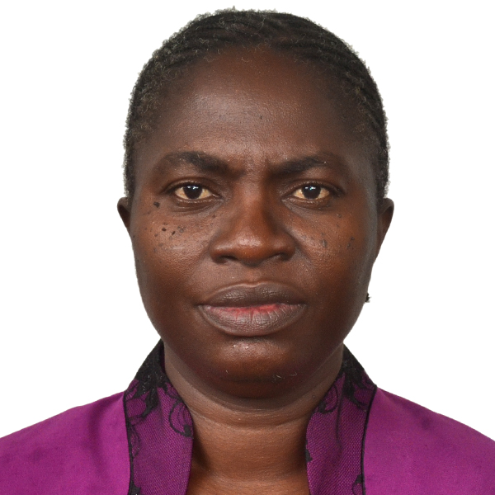

Dr. Olufunke Adewumi Ajiboye (PhD, FNSP, FPPC_{Cardiopulmonary}, FCIA) retired as a Director of Physiotherapy from teaching hospital where she doubled as an Associate lecturer in the sister tertiary Institution. She is currently working with Chrisland University as Senior lecturer and Ag. Head of Department. She has more than 17 published articles in peer reviewed journals of international standard and have presented my research outcomes in more than 20 conferences both at national and international level, many of which won Awards both at national and international level. Her PhD thesis won the Best Thesis Award from the College of Medicine of her university in 2014. She is a member of many Professional Bodies,won 18 Awards /Recognitions /Commendations both nationally and internationally, have attended over 60 Workshops, Conferences & Seminars. She is a chartered Administrator, a seasoned researcher, an experienced clinician and an astute teacher,
- Ubuane PO, Ajiboye OA, Adekunle MO, Njokanma FO et.al., (2022): Reference values and equations for the six‐minute walk distance of Nigerian children aged 6‐11 years: a cross‐sectional study. Pediatric Pulmonology: 1‐13. doi:10.1002/ppul.25986.
- Tella BA, Ajiboye OA, Johnson (2020): Comparison of Gait Parameters of Pregnant Women with Non-Pregnant Women. African Journal of Midwifery and Women's Health 13(4) https://doi.org/10.12968/ajmw.2019.0041
- Aweto H.A, Ajiboye O.A, Anyakwo (2020): Comparative effects of aerobic exercise training and incentive spirometry on selected cardiopulmonary parameters in apparently healthy elderly. Journal of the Nigeria Society of Physiotherapy. Vol. 19(2), 42-47.
- Ajiboye OA, Ajepe TO, Oyefeso TA (2019): Efficacy of thoracic mobility exercise on cardiopulmonary parameters and quality of life of individuals with asthma; a preliminary study; Journal of ACPRC, Volume 51(1) 19-30
- Ubuane PO, Animasahun BA, Ajiboye OA, Kayode-Awe MO, Ajayi OA, Njokanma FO (2018): The historical evolution of the six-minute walk test as a measure of functional exercise capacity: a narrative review. J. Xiangya Med………doi:10.21037/jxym.2018.11.01
- Aweto HA, Ajiboye OA, Anyakwo OI (2020): Comparative Effects of Aerobic Exercise Training and Incentive Spirometry on Selected Cardiopulmonary Parameters in Apparently Healthy Elderly Persons. Journal of the Nigeria Society of Physiotherapy. 19(2), 42-47 DOI: .5897/JNSP2020.0005
- Ajiboye OA, Anigbogu CN, Ajuluchukwu JN, Jaja SI (2015): Exercise Training Improves Functional Walking Capacity And Activity Level Of Nigerians With Chronic Bi-Ventricular Heart Failure. Hong Kong Physiotherapy Journal. 33: 42-49
- Ajiboye OA, Anigbogu CN, Ajuluchukwu JN, Jaja SI (2015): Efficacy and Safety of Combined Aerobic and Resistance Exercise Training in the management of Individuals with Bi-Ventricular Heart Failure . Physiotherapy 101:e43 .
- Aweto HA, Olorunfemi OI, Ajiboye OA (2014): Final year Physiotherapy students’ knowledge and perception of professionalism.Nigerian Journal of Medical Rehabilitation. 7(1).http://www.njmr.org.ng (Available online)
- Ajiboye OA, Anigbogu CN, Ajuluchukwu JN, Jaja SI (2014): Prediction equations for 6- minute walk distance in apparently healthy Nigerians. Hong Kong Physiotherapy Journal. 32(2) 65-72.
- Ajiboye OA, Anigbogu CN, Ajuluchukwu JN, Jaja SI (2013): Therapeutic Effects of Exercise Training on Selected Cardio-pulmonary Parameters and Body Composition of Nigerians with Chronic Heart Failure. Nig. Qt. J. Hosp. Med. 23(4): 295-301.

