Study in transient regime of the electrical parameters of a silicon solar cell with multi vertical junctions connected in parallel and placed in short-circuit: influence of temperature and magnetic field

Pape Diop, PhD Candidade Physics
Cheikh Anta Diop University of Dakar

Abstract
A study of the effect of temperature and magnetic field on the electrical parameters of a parallel vertical junction solar cell, in transient dynamic regime operation, and under polychromatic illumination is presented. The transient voltage, the photocurrent density and the transient capacitance of the solar cell are deduced from the expression of the transient density of minority carriers of excess charges in the base. Indeed, the influence of the optimum temperature on the amplitudes and on the transient decrease of these electrical parameters is also studied. This optimum temperature is obtained by determining the optimum thickness of the solar cell from a given magnetic field.
Indeed, as the temperature increases, there will be thermal agitation resulting in an accumulation of carriers at the junction and therefore a reduction in carrier mobility. If there is thermal agitation, the minority carriers will take longer to cross the junction. The stationary regime will therefore be reached late, hence t0 increases with the increase in temperature.
This work allowed us to observe that in the first moments of decay, the diffusion capacity is minimal, which leads to a rapid but brief drop in amplitudes because with a recombination velocity in short-circuit, a large number of Minority charge carriers in the base pass through the space charge region to participate in photocurrent generation.

.

Image
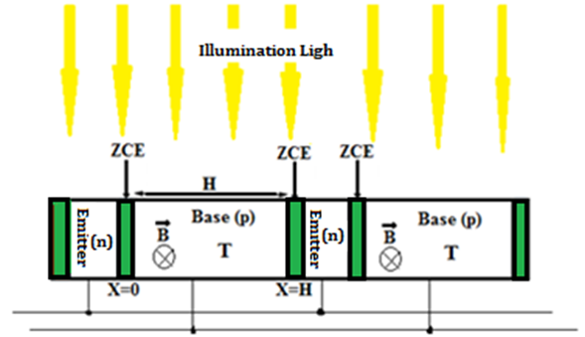

Figure 1:- Structure of (n/p) solar cell with vertical junctions connected in parallel
Recent Publications
- G.Diop, H Yoro.Ba, N. Thiam, Y.Traore, B.Dione, M. Ba., P.Diop(2019) Base thickness optimization of a vertical series junction Silicon solar cell under magnetic field by the concept of back surface recombination velocity of minority carrier. VOL. 14, NO. 23, DECEMBER 2019. ISSN 1819-6608
arpn journal of engineering and applied sciences
- Pape.Diop, S.Gueye, G.Diop,..G.Sissoko(2022) Influence de la température et du champ magnétique sur la décroissance transitoire de la densité des porteurs de charge dans une photopile au silicium a multi jonctions verticales connectées en parallèle et placée en circuit ouvert. Int. J. Adv. Res. 10(08), 69-82. DOI URL: http://dx.doi.org/10.21474/IJAR01/15150
International Journal of advanced Research (IJAR)
- Pape.Diop, B.Dione, P.Traoré,. . (2022)Study of the Transient Voltage of the Silicon Solar Cell with Multi Vertical Junctions Connected in Parallel and Placed in Opened Circuit: Influence of Temperature and Magnetic Field on Transient Decay Euro. J. Adv. Engg. Tech., 2022, 9(10):8-21
European Journal of Advances in Engineering and Technology
4. Samake, P. , Traore, P. , Dione, B. , Diop, Pape , (2022) Influence of the Magnetic Field on the Transient Decay of the Density of Charge Carriers in a Silicon Photocell with Vertical Multijunctions Connected in Series Placed in Open Circuit. Energy and Power Engineering, 14, 747-761. doi: 10.4236/epe.2022.1412041.



Biography
Pape Diop is a teacher-researcher in Electronics and Physics. He has a solid experience in teaching, research and pedagogy. He has published scientific articles on renewable energy and is currently preparing his unique doctoral thesis in Physics at Cheikh Anta Diop University of Dakar.
Email:diopp504@gmail.com

Presenting author details
Full name: Pape Diop
Contact number: +221 773759682
Session name: Physics
Category: (Oral presentation/ Poster presentation)

