Improving the Fatigue Design of Mechanical Systems such as Refrigerator
Seongwoo Woo. Texas A&M PhD, Ethiopian Technical University, Ethiopia.

Abstract (300 word limit)
To enhance the lifetime of mechanical system such as automobile, new reliability methodology – parametric Accelerated Life Testing (ALT) – suggests to produce the reliability quantitative (RQ) specifications—mission cycle—for identifying the design defects and modifying them. It incorporates: (1) a parametric ALT plan formed on system BX lifetime that will be X percent of the cumulated failure, (2) a load examination for ALT, (3) a customized parametric ALTs with the design alternatives, and (4) an assessment if the system design(s) fulfil the objective BX lifetime. So we suggest a BX life concept, life-stress (LS) model with a new effort idea, accelerated factor, and sample size equation. This new parametric ALT should help an engineer to discover the missing design parameters of the mechanical system influencing reliability in the design process. As the improper designs are experimentally identified, the mechanical system can recognize the reliability as computed by the growth in lifetime, LB, and the decrease in failure rate. Consequently, companies can escape recalls due to the product failures from the marketplace. As an experiment instance, two cases were investigated: 1) problematic reciprocating compressors in the French-door refrigerators returned from the marketplace and 2) the redesign of hinge kit system (HKS) in a domestic refrigerator. After a customized parametric ALT, the mechanical systems such as compressor and HKS with design alternatives were anticipated to fulfil the lifetime – B1 life 10 year.

Image
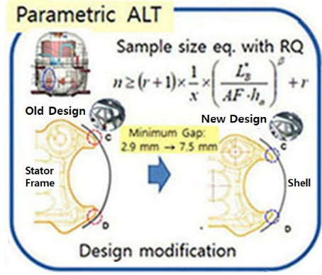
Figure 1: Schematics of Parametric ALT
Recent Publications (minimum 5)
- Woo. S., O’Neal, D.L, Pecht, M., Jun. 2023, Improving the lifetime of mechanical systems during transit established on quantum/transport life-stress prototype and sample size, Mechanical Systems and Signal Processing. 193, 110222.
- Woo, S., O’Neal, D.L., Matvienko, Y.G., Mebrahtu, G., Apr. 2023, Enhancing the Fatigue Design of Mechanical Systems Such as Refrigerator to Reserve Food in Agroindustry for the Circular Economy. Sustainability, 15(8), 7010.
- Woo, S., O’Neal, D.L., Matvienko, Y.G., Mebrahtu, G., Jan. 2023, Enhancing the Fatigue of Mechanical Systems Such as Dispensers Entrenched on Generalized Life-Stress Models and Sample Sizes. Applied Sciences, 13, 1358.
- Woo, S., Matvienko, Y.G., O’Neal, D., Atnaw, S.M., Improving Lifetime of Domestic Compressor Subjected to Repetitive Pressure Loading, Engineering Failure Analysis, Volume 128, October 2021, 105581.
- Woo, S., Matvienko, Y.G., O’Neal, D., 2020, Improving fatigue of mechanical systems such as freezer drawer subject to repetitive stresses, Engineering Failure Analysis, 110, 104404.
- Woo, S., Pecht, M., O’Neal, D., 2019, Reliability design and case study of the domestic compressor subjected to repetitive internal stresses, Reliability Engineering & System Safety, 193, 106604.

Biography (150 word limit)
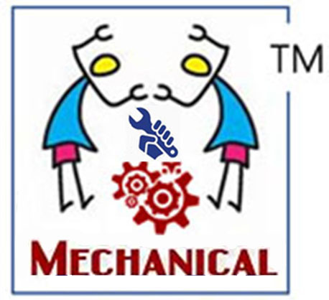
Dr Woo has a BS and MS in Mechanical Engineering, and he has obtained PhD in Mechanical Engineering from Texas A&M. He majors in energy system such as HVAC and its heat transfer, optimal design and control of refrigerator, reliability design of thermal components, and failure Analysis of thermal components in marketplace using the Non-destructive such as SEM & XRAY. In 1992.03–1997 he worked in Agency for Defense Development, Chinhae, South Korea, where he has researcher in charge of Development of Naval weapon System. He was working as a Senior Reliability Engineer in Refrigerator Division, Digital Appliance, SAMSUNG Electronics. Now he is working as associate professor in mechanical department, Ethiopian Technical University.
Email: twinwoo@yahoo.com

Notes/Comments:

Presenting author details
Full name: Seongwoo Woo
Contact number: +251-90-047-6711
Twitter account:
Linked In account:
Session name/ number:
Category: Oral presentation

