Changes in body composition and atherosclerosis parameter in elderly during the COVID-19 pandemic

Bomin Kim, MD and Young jin Tak, MD PhD
Pusan ​​National University Hospital, South Korea

Abstract

Introduction: The COVID-19 pandemic had a significant impact on public health globally, including in South Korea. The implemented government measures such as lockdowns and social distancing resulted in poor dietary and exercise habits among the elderly population, leading to various detrimental health outcomes. This study aims to investigate objective changes in body composition values and atherosclerosis parameters among the elderly during the pandemic.

Methods: This retrospective cohort study involved 145 adults aged 65 years or older. Medical data from the Health Promotion Center of Pusan National University Hospital were collected for two time intervals: the year prior to the COVID-19 (January 01, 2017, to December 31, 2019) and the year during the pandemic (January 01, 2020, to December 31, 2022). We analyzed the mean differences in weight, body mass index, muscle and fat percentage, arterial stiffness (ABI, brachial-ankle PWV) and laboratory results including lipid profile.

Results: The average age was 70.2 years with baseline underlying diseases of diabetes, hypertension, and dyslipidemia. As a result, the body fat mass increased by 1.10 ± 1.41kg, and the waist circumference also increased by 0.479 ± 1.61cm, whereas muscle mass decreased by -1.72 ± 1.72kg. Regarding the atherosclerotic components, baPWV level increased by 169.12 ± 5.51 cm/s during the pandemic (all p < 0.05) (Table 1). Pearson correlation showed that comorbidities, smoking history, and lack of physical activity levels were all negatively associated with changes in body composition and atherosclerotic values, respectively.

Conclusions: The study demonstrated a significant increase in waist circumference, body fat percentage, and arterial stiffness in adults aged over 65 during the COVID-19. The dangerous combination of geriatric obesity and sarcopenia exacerbated during the pandemic, leading to an increased risk of metabolic and cardiovascular disease in Korea. These landmark results suggest an implementation of precise quarantine guidelines and preventive care plans for geriatric health.

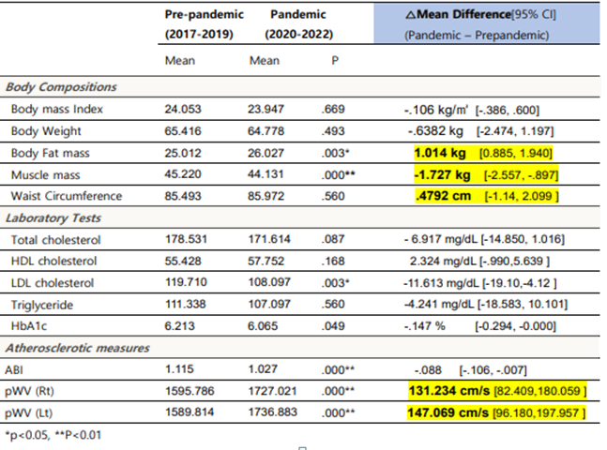
Table 1: Changes in body compositions and laboratory results and atherosclerotic index in COVID-19

Recent Publications
- Tak YJ, Lee SY. Long-Term Efficacy and Safety of Anti-Obesity Treatment: Where Do We Stand? Curr Obes Rep. 2021 Mar;10(1):14-30.
- Tak YJ, Lee SY. Anti-Obesity Drugs: Long-Term Efficacy and Safety: An Updated Review. World J Mens Health. 2021 Apr;39(2):208-221.
- Han H, Cho YH, Tak YJ et al. Elevated C-reactive protein level, obesity, and quality of life. J Pak Med Assoc. 2019 Dec;69(12):1771-1776.
- Choi JI, Cho YH, Lee SY et al. The Association between Obesity Phenotypes and Early Renal Function Decline in Adults without Hypertension, Dyslipidemia, and Diabetes. Korean J Fam Med. 2019 May;40(3):176-181.
- Son SM, Park EJ, Tak YJ et al. Association Between Weekend Catch-Up Sleep and Metabolic Syndrome with Sleep Restriction in Korean Adults: A Cross-Sectional Study Using KNHANES. Diabetes Metab Syndr Obes. 2020 May 1;13:1465-1471

Biography
Dr. Bomin Kim is an aspiring young family medicine doctor with a genuine passion for comprehensive primary healthcare. After completing her medical degree at Pusan National University, Dr. Kim is pursuing her last residency year with broad range of skills in managing chronic illnesses, as well as focusing on preventative care and health maintenance. With variety of experience in the last five years, she has gained valuable experience and has established herself as a trusted, compassionate and skillful physician in her clinic. Inspired by expert senior associates in her hospital, she plans to continue her specialty and PhD degree on obesity and geriatric medicine.

Notes/Comments:

This study was approved by the Institutional Review Board at Pusan National University Hospital (No. 2211-009-120) prior and afterwards of data collection for ethical considerations.
Nothing to disclose regarding conflict of interest.

