Contemporary Circumstances of Solid Waste Management and Hazardous Effects on Human Health in Azad Jammu & Kashmir
¹AshfaqNazir, ¹Zafeer Saqib
¹Department of Environmental Sciences, International Islamic University, Islamabad
E-mail: ashfaqajkepa@gmail.com
ABSTRACT
The State of Azad Jammu & Kashmir (AJ&K)is administratively divided into three divisions which, in turn, are divided into ten districts which colloquially referred to as simply Azad Kashmir, is a region administered by Pakistan as a nominally self-governing entity. A big proportion of solid waste is not managed properly where Solid Waste is scattered unceremoniously. Adverse impacts of unsustainable solid waste management are observed in Azad Jammu & Kashmir (AJ&K). A total of about 200 tons per day of solid waste is generated by 0.583 million people in 10 district headquarters in AJ&K. The existing solid waste collection efficiency is less than 50%. There is no scientific based landfill in Azad Jammu& Kashmir and Waste Management (WM) system is dominated by unhygienic dumping sites. Majority of dumping sites are located near water bodies, particularly on the bank of river Neelum, Jhelum, Poonch and Mahl and on open available spaces thus contaminating ground and surface water. In addition to this, one agony situation is that Hospital Waste is also mixed with Municipal Waste which is the major cause of diseases and people suffer in health problems as the medical waste is not incinerated in any hospital. Stray animals and birds feed on this mixed waste which act like vector of diseases. The Government of AJ&K has been vigorously pursuing the matter of Solid Waste Management in AJ&K but due to non-availability of reliable data and information with respect to generation and classification of waste has been a major obstacle in the way of taking concrete measures towards its sustainable solution. In view of the geographical location of AJ&K, being a watershed for Pakistan, its topographic and demographic situation, the issue of waste management has become a serious environmental hazard for this region. In this study, the sources and components of solid waste were identified; type and the quantity of solid waste disposed, methods of solid waste disposal and impact of improper waste management on health were highlighted. The result shows that excreta and other liquid and solid waste from households and the community, are a serious health risk and lead to the spread of infectious diseases. Risk of spreading diseases can be curtailed to minimum by developing proper system i. e. on spot segregation, proper sanitary landfill, sustainable composting, waste to energy (WtE) and other recycling system can change waste from unwanted materials to important products.
Key words: Solid waste management, Azad Kashmir (AK), waste collection system, future waste management, level of income, waste prioritization, sustainable solid waste management.

Figure: Flow sheet Diagram of Methodology of Solid Waste (generation and Classification) Survey

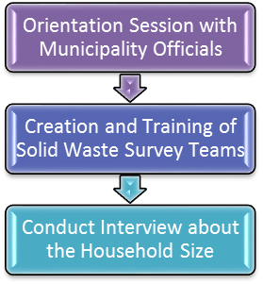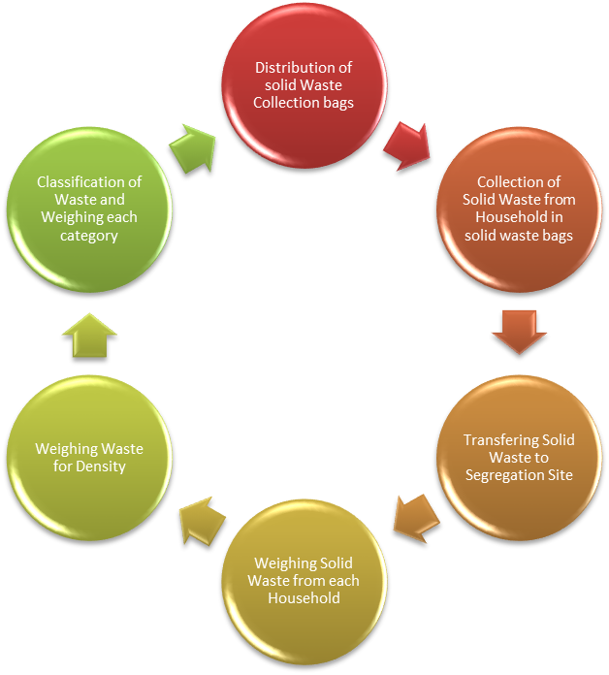
Report Preparation

Data Tabulation, Analysis and Report Writing

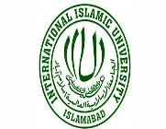

I did my Master in Plant Sciences from the University of Azad Jammu & Kashmir in 2003 and my research topic was “Phytosociological of Study of Sarsawa Hill, District Kotli, Azad Kashmir”. I have worked in a large area of AK during my Master to expand my awareness of plant species, as well as improved my ability to work independently and took on a position of responsibility. Through this experience, I have been able to improve my interpersonal and leadership skills. I have also published my thesis in different Journals.

I completed my MPhil in Environmental Biology from Quaid-e-Azad University, Islamabad in 2007 and my research topic was “Hyperaccumulators of Heavy Metals of Industrial Areas of Islamabad and Rawalpindi” by using different research techniques. I have a number of publications in different Journals.
Now I am doing PhD in Environmental Science from International Islamic University, Islamabad (IIUI). Through this degree program, I would like to continue to gain the knowledge and skills needed to study and develop the future use of Sustainable & Environment Friendly Development, Green Energy in both industrial and domestic markets, and am eager to play a key part in this exciting field and help preserve its integrity. My research topic is “Municipal Solid Waste Management in Azad Kashmir, Current Status, Challenged and Opportunities”
I worked in Azad Jammu & Kashmir Environmental Protection Agency (AJK-EPA) as Assistant Director from June, 2008 to May, 2017.
I served as Environment Expert in Disaster & Climate Resilience Improvement Project (DCRIP) funded by the World Bank. I monitored different development projects which are launched in the State of AJ&K and ensured sustainable and environment friendly development.
Furthermore, I also worked as Health, Safety and Environmental (HSE) Manager in Balakot Hydro Power Project (300 MW), KPK, Pakistan.
Currently, I am serving as Environmental Manager in Sindh Flood Emergency Rehabilitation Project (SFERP) at Sindh Province, Pakistan.

