NON-INVASIVE PREIMPLANTATION GENETIC DIAGNOSTICS

Author: Henrietta Orsolya Gellén ^{1, 2}
Co-authors: Katalin Gombos ^{1,2}, Bence Gálik ^{1,2}, Krisztina Futács², Krisztina Ildikó Szabó-Kalács ^{1,2}, Ákos Várnagy ^{1,2,3}, József Bódis ^{1,3}, Attila Gyenesei ^{1,2} Péter Urbán^{1,2}, and Gábor L. Kovács ^{1,2,3}
1 National Laboratory on Human Reproduction, University of Pécs
2 Department of Laboratory Medicine, Medical School, University of Pécs, Ifjúság útja 13., 7624 Pécs, Hungary
3 Department of Obstetrics and Gynaecology, Medical School, University of Pécs, Édesanyák útja 17, 7624 Pécs, Hungary

Abstract (300 word limit)
Statement of the Problem:
The number of assisted reproductive techniques is increasing due to rising infertility rates in highly industrialized countries. Advanced maternal age increases the risk of fetal aneuploidy, reducing implantation and successful pregnancy chances. Non-invasive pre-implantation genetic testing for aneuploidy has potential, but its practical implementation in routine IVF centers is yet to begin. Our work group developed a clinically applicable NIPGT strategy using spent culture media (SCM) for testing embryos, based on next-generation sequencing (NGS) technology.
Methodology & Theoretical Orientation: For our proof-of concept study we sequenced cell-free embryonic DNA from SCM of Day 3 and Day 5 embryos fertilized with intracytoplasmic sperm injection (ICSI) and the corresponding blank culture media as a background control. The MALBAC WGA method was used to amplify DNA from the culture media samples and the blank control media as well. Sequencing was performed on Illumina 6000 platform and embryonic chromosomal abnormalities were identified by an optimized bioinformatics pipeline applying a copy number variation (CNV) detecting algorithm.
Findings: Analysis of DNA profiles of embryonic SCM demonstrated that higher gDNA copy number is associated with impaired intrauterine development and indicated miscarriage outcomes. We found some chromosomal abnormalities that occur only in a specific region of chromosome 18, where two important genes are located which are associated with congenital abnormalities and involved in various cellular processes and can be related to Edwards syndrome. In some cases, the chromosomal ploidy aberration was found to be multiple, which can be irreconcilable with healthy embryonic development and embryonic viability.
Conclusion & Significance: In the recent presentation we aim to demonstrate the comprehensive workflow covering both wet- and dry-lab procedures supporting a clinically applicable strategy for NIPGT-A. The described integrated approach of non-invasive evaluation of embryonic DNA content of the culture media can potentially supplement existing pre-implantation genetic screening methods.

Image

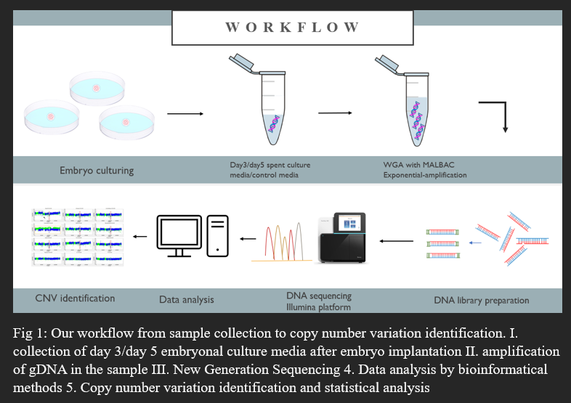
Recent Publications (minimum 5)

Dana Kimelman, Mary Ellen Pavone- Non-invasive prenatal testing in the context of IV and PGT-A, Best Practice & Research Clinical Obstetrics & Gynaecology Volume 70, January 2021, Pages 51-6
- Katalin Gombos, Bence Gálik, Krisztina Ildikó Kalács, Krisztina Gödöny, Ákos Várnagy, Donát Alpár, József Bódis, Attila Gyenesei and Gábor L. Kovács - NGS-Based Application for Routine Non-Invasive Pre-Implantation Genetic Assessment in IVF, International Journal of Molecular Sciences, 2021 Feb 28. doi: 10.3390/ijms22052443
- Palanikumar Balasundaram; Indirapriya Darshini Avulakunta - Edwards Syndrome, StatPearls Publishing; 2023 Jan
- S Palini 1, L Galluzzi, S De Stefani, M Bianchi, D Wells, M Magnani, C Bulletti - Genomic DNA in human blastocoele fluid, Reprod Biomed Online. 2013 Jun;26(6):603-10. doi: 10.1016/j.rbmo.2013.02.012
5. Raminta Zmuidinaite, Fady I. Sharara, and Ray K. Iles - Current Advancements in Noninvasive Profiling of the Embryo Culture Media Secretome, International Journal of Molecular Sciences, 2021 Mar 3. doi: 10.3390/ijms22052513



 Biography (150 word limit)
Henrietta Gellén in a clinical laboratory researcher graduated in 2021. She is a second year PhD student at Pécs University, Faculty of Medicine Doctorate School of Medical Sciences, in addition, she is also involved in education by teaching the Modern Methods in Molecular Genetics course in the MSc program. She’s a member of the National Laboratory on Human Reproduction since 2021. Her research focuses on developing non-invasive molecular diagnostic techniques on embryonic culture media to improve implantation procedures and increase success rates.
Email: ge.heni16@gmail.com

Notes/Comments:

Presenting author details
Full name: Henrietta Orsolya Gellén
Contact number: +36/705306556
Twitter account:
Linked In account:
Session name/ number: Assisted Reproductive Technology (ART)/ Track 19
Category: (Poster presentation)

