Recycling Wastes into Biosorbent – Bead Materials for the Adsorption of Lead (Pb2+) metal ions
Mary Ann M. Arizo, MAT - Bio Sci, PhD Bio Sci (cand), University of the East - Manila, Philippines

Abstract

With the fast development of technological industries, heavy metal pollution of wastewater becomes a key environmental problem throughout the whole world. Various methods for removal of heavy metals from aqueous solutions are not economically and environmental friendly, also such being too expensive and ineffective with treating low concentrations. Adsorption is the most promising technology for removing heavy metals from wastewater by using dead, inactive biomass. This study aims to develop a biosorbent bead material from biosorptive materials obtained from seaweed biomass and shrimp exoskeleton; Alginate and Chitosan. Alginate and Chitosan have been evaluated for their ability to bind with metal ions, and both generally work as an adsorptive agent that separates metal ions from the water solution. Before making the biosorbent beads, initial experiments were done using different parameters such as the concentration of the biosorbent, time interval, and pH of the chemical waste to identify what properties among these parameters are most effective to be applied as components of the biosorbent beads. Using Atomic Adsorption Spectrophotometry, this study identified the amount lead from chemical waste from chemistry experiments gathered from the chemistry department of University of the East- Manila. Statistical analysis of the data showed that the adsorption rate of metal ions of the alginate- chitosan mixture with 5 g (1:1) concentration exhibited the greatest adsorption rate during a 4 hour reaction time. The findings also showed that the chemical waste with ph 3 exhibited the lowest final concentration of lead, compared to pH 4, 5, and 6.

Image
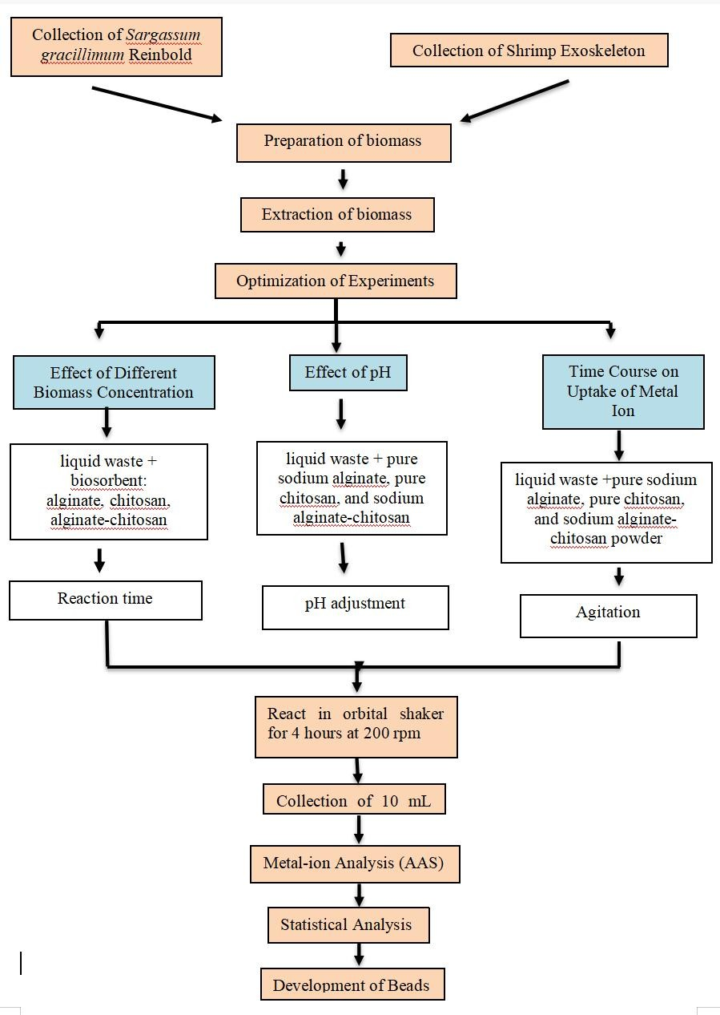
Recent Publications
- Arizo MAM (2018) Seafood wastes highly in demand for wastewater treatment process. Journal of Food Processing & Technology, 2018 Longdom Publishing ISSN: 2157-7110.
- Arizo MAM, Beroncal RAG, Chua WAKT, Lim JJ, Rogando KCS, Maningas, MBB (2016) Immune response of Macrobrachium rosenbergii immersed in aqueous extract of Gracilaria edulis challenged with White Spot Syndrome Virus. Aquaculture, Aquarium, Conservation & Legislation – International Journal of the Bioflux Society (AACL Bioflux) volume 9.
- Arizo MAM, Simeon E, Layosa, MJT, Mortel RMM, Bañez Pineda CB, Lim JJ, Maningas, MBB (2015) Crude fucoidan from Sargassum polycystum stimulates growth and immune response of Macrobrachium rosenbergii against white spot syndrome virus (WSSV). Aquaculture, Aquarium, Conservation & Legislation – International Journal of the Bioflux Society (AACL Bioflux) volume 8.
- Room R, BaborT, Rehm J (2005) Bosorbent - device model for the removal of chromium (Cr) from laboratory chemical wastes utilizing Sargassum - chitosan mixture. 8th Asian Pacific Phycological Forum.
- Sullivan EV, Zahr NM (2017) “Growth and immunomodulatory response of giant freshwater prawn (Macrobrachium rosenbergii) fed with carrageenan supplemented diet. 8th Asian Pacific Phycological Forum.

Biography
Mary Ann M. Arizo is a graduate of B.S. Biology and Masters in Teaching - Major in Biology at the University of the East - Manila Philippines. She is also a PhD major in Biological Sciences candidate at University of Santo Tomas. She is teaching Histology, Parasitology, Microbiology, Immunology, Comparative Anatomy, Biological Techniques, General Zoology and Physiology. She is also engaged in conducting Research Experiments in various fields of application on Immunology of Invertebrates and Vertebrates, Seaweed Applications and Biotechnology, and Molecular Techniques. Ms. Arizo has a dedication in her works in which she has 14 years experience in the filed of teaching and as student research coordinator.
Email: maannmarizo@gmail.com

Notes/Comments:

Presenting author details
Full name: Mary Ann M. Arizo Contact number: 09171695749 Twitter account: N/A
Linked In account: N/A Session name/ number:
Category: (Poster presentation)

