PsychéTox : women and alcohol dependency: hope from new therapeutics possibilities from psychedelic or not?
Raphael SERREAU, MD, PhD, HDR
EPSM Georges DAUMEZON, Fleury les Aubrais, GHT 45
UR PsycoMADD, CHU Paul Brousse AP-HP Paris Saclay University France

Psychétox : Alcoholism and pregnancy : new therapeutic possibility or not allowed? (n=277 words)

Synthesis of psychedelics for a new addictolytic treatment in alcoholism. Is this treatment compatible with pregnancy or breastfeeding period? Psychedelics are of increasing interest in the management of patients suffering from alcohol addiction. Several addictolytic treatments exist but the effectiveness remains modest in maintaining abstinence in alcoholic patients. Women are increasingly affected by alcohol addiction, especially during the reproductive period. The question arises of the teratogenic and fetotoxic risk of exposure to alcohol and taking medication to avoid alcohol dependence. Obtain the synthesis of a new drug in the management of patients suffering from severe alcohol use disorders.
It seems important to verify the reproductive risk of these new molecules in order to consider whether their future use in pregnant or breastfeeding women or not.

Materials and methods
• Development of a pharmaceutical circuit of psychedelics,
• Composition of the capsules according to good pharmaceutical practices.
• Access to a CNRS technical platform in Orléans with a chemist for clinical trials following ANSM recommendations.
• Work on Reprotox and Lactmed databases to assess teratogenicity potential of psychedelic drugs.

Results and conclusions
As of November 25, 2022, successful synthesis of psychedelics for future clinical trials. Study of the teratogenicity of molecules during pregnancy and breastfeeding. We need now evaluate potential teratogenicity of psychedelic drugs. We are working with a new biomolecular platform for fundamental research.

Links of interest:
R. Serreau has no conflict of interest with the synthesis of psilocin or with the synthesis of psilocybin, he has no links of interest with the Pharmaceutical Industry.
The funding was academic by the UR PSYCOMADD, provided by the University of Paris Saclay.

Image

Scheme 20. Synthetic/biocatalytic pathway to psilocin.
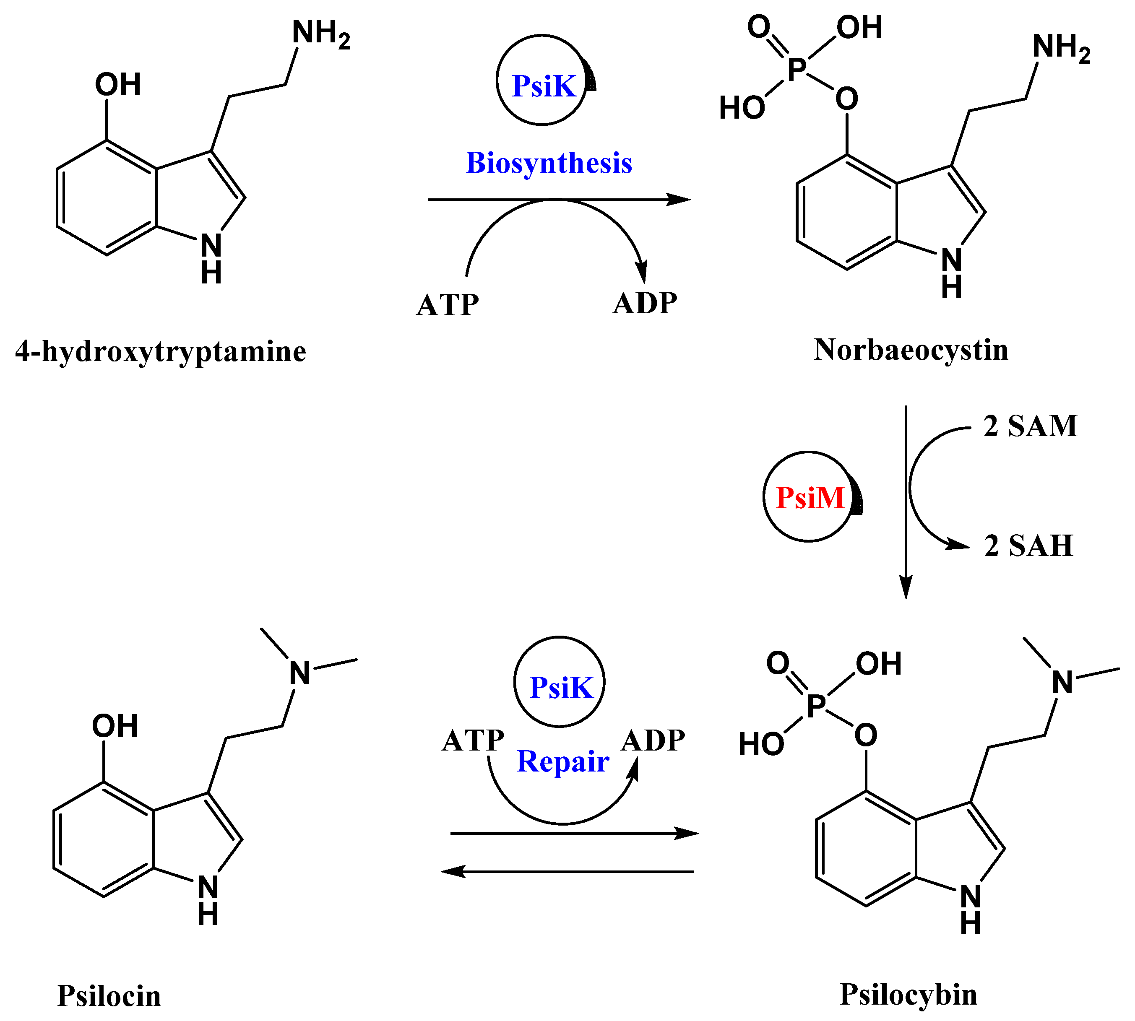
- Rigourd V, Amirouche A, Tasseau A, Kintz P, Serreau R. Retrospective diagnosis of an adverse drug reaction in a breastfed neonate: liquid chromatography-tandem mass spectrometry quantification of dextropropoxyphene and norpropoxyphene in newborn and maternal hair. J Anal Toxicol. 2008;32:787-9
- Rigourd V, de Villepin B, Amirouche A, Bruneau A, Seraissol P, Florent A, Urien S, Magny JF, Serreau R. Ibuprofen concentrations in human mature milk--first data about pharmacokinetics study in breast milk with AOR-10127 "Antalait" study. Ther Drug Monit. 2014;36:590-6.
- Rigourd V, Meritet JF, Seraissol P, Amirouche A, Hachem T, Serreau R. Rapid and sensitive analysis of polymorphisms from breastmilk shows that ibuprofen is safe during certain stages of breastfeeding. Acta Paediatr. 2015;104:e420-1.
- Vacchina V, Séby F, Chekri R, Verdeil J, Dumont J, Hulin M, Sirot V, Volatier JL, Serreau R, Rousseau A, Simon T, Guérin T. Optimization and validation of the methods for the total mercury and methylmercury determination in breast milk. Talanta. 2017;167:404-410
- Serreau R, Amirouche A, Benyamina A, Berteina-Raboin S. Review of synthetic access to therapeutic compounds extracted from psilocybe. Pharmaceuticals. 2022; 16:1-40

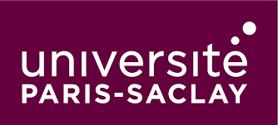

Biography

Dr Raphaël SERREAU is a French medical doctor and a scientist for 20 years. He has done his medical study in Tours and Paris in France. He is a Pharmacology teacher for the midwifes since 1997. Upon completion of his doctorate in Pharmacology at the University of Paris V René Descartes in 2007 about Risk Management Plan during pregnancy and breastfeeding, He was the responsible of the Medic-Al network in Necker Hospital in Paris to January 2017. Since 2013, Since 15th March 2019, He received an habilitation to manage clinical study (HDR) in Burgundy University in Dijon (CNU 48-03). He joined the Research Team of Prof Amine Benyamina in AP-HP University Paris Saclay Hospitals: UR Psycomadd.
Since the 11th of March 2020, Raphaël Serreau create the Clinical Research Unit "PARADICT-O" in Orléans Métropole. He joined the EPSM Georges DAUMEZON Hospital as a Public Health Specialist in Addictions in September 2021.
Email: raphael.serreau@epsm-loiret.fr

Notes/Comments:

Presenting author details
Full name: SERREAU
Contact number: +33616386878
Twitter account:
Linked In account: https://fr.linkedin.com/in/dr-rapha%C3%ABl-serreau-05073118
Session name/ number:
Category: (Oral presentation)

