Vaccine Safety in Pharmacovigilance
Snigdha Singh Assistant Professor, Lloyd Institute, India
The term vaccine pharmacovigilance defines the science and activities related to the detection, assessment, understanding and communication of adverse events following immunization (AEFI) and other vaccine-related or immunization-related issues, and to the prevention of untoward effects of the vaccine or immunization. The etymological roots for the word "pharmacovigilance" are: pharmakon and vigilare. Pharmacovigilance plays a crucial role in ensuring the safety and efficacy of vaccines. Vaccines are complex biological products, and their safety cannot be guaranteed solely through clinical trials. Therefore, post-marketing surveillance through pharmacovigilance is essential for monitoring the safety of vaccines. Loss of confidence in the safety of vaccines threatens the continued success of immunization programs. Pharmacovigilance helps to identify and assess the risks associated with vaccines, including rare adverse events that may not have been detected in clinical trials. It also plays a critical role in detecting and managing any potential safety signals, such as an increase in adverse events following vaccination. This information is essential for regulatory agencies to make informed decisions about the safety of vaccines. There is a need to improve the awareness about reporting among the medical professionals working in public as well as the private sectors to report all suspected AEs associated with immunization so that proper steps can be taken to prevent such incidents in future. The vibrant AEFI program will go a long way in winning the faith of people toward immunization.
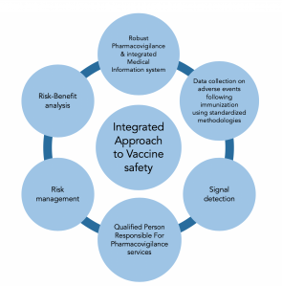

References:
1.0American journal of drug delivery, Prime scholars.com Pharmacovigilance & Drug Safety 2020
2.0https://www.canada.ca/en/public-health/services/publications/healthy-living/canadian-immunization-guide-part-2-vaccine-safety/page-2-vaccine-safety.html
3.0https://www.ncbi.nlm.nih.gov/pmc/articles/PMC6759530/
4.https://www.apcerls.com/pharmacovigilance-services-for-vaccines/


Ms. Snigdha Singh collective experience of over six years in R&D Injectable in Analytical Research Development (ARD) and Development Quality Assurance (DQA). She has worked as compliance officer in ACL (Peptide characterization Laboratory & Extractable and Leachable). Currently working as an Assistant Professor
Email: ssnigdhavit@yahoo.com

Full name: Snigdha
Contact number: +91 9882342870
Mail id: ssnigdhavit@yahoo.com
Category: (Oral presentation/ Poster presentation)

