Green leaf alcohol : Inhalation therapy and their production

Name: Rakhee¹*, Prateek Singh¹, Saleem Javed², Raj Kishore Sharma³, Bipin Gupta⁴

University/Organization: ¹Venkateshwara Mint products, Chandhusi, Uttar Pradesh ; ²Jamia Millia Islamia, A Central University, New Delhi; ³University of Delhi, North campus; ⁴National Physics Laboratory, New Delhi.

Abstract

This research is intended to be a narrative review of the relevant academic literature as well as the work we have work done in our industry. Leaf alcohol (green aroma) is well known for having a potent, distinctive aroma of fresh grass. Inhaling green aromas such as Trans-3-hexenol, Cis-3-hexenol, Trans-2-hexenol and Cis-2-hexenol, can benefit the airways by acting as an antioxidant and an anti-inflammatory¹. Pharmacological activity of these leaf alcohols absorbed through inhalation may be also beneficial to promote brain functions by decreasing mental fatigue, inducing relaxation, and improving cognitive performance and mood. It is frequently used in industries including beverages, confectionery, flavoring, personal care products, perfumery, oral care, nutraceuticals, and pharmaceuticals (to reduce schizoid tendencies, antifungal activity, anticancer, antistress and antimicrobial activity)². Its esters are frequently used as flavoring and fragrance ingredients. Currently, there are two ways to prepare cis-3-hexenol in industrial production: biosynthetic and synthetic. But due to the market's inability to keep up with the increase in demand, leaf alcohol is frequently in short supply. The difficulty and shortcomings of the current techniques for producing leaf alcohol are the cause of the shortage.

A high yield method is developed for leaf alcohol to prepare"Trans-3-hexenol and Cis-3-hexenol" in our industry. The photoreactor technique is used in the presence of UV light and is easy, practical, affordable, and environmentally friendly.

These findings may have beneficial ramifications for landscape design, public wellness, and personal happiness on bigger scales. This abstract discusses the industrial production of natural products, the productivity-boosting effects of new technologies, and the positive effects on psychological and physiological health.

Keywords: Cis-3-hexenol, Trans-3-hexenol, Photoreactor.

Image : Leaf alcohol improves physical health, the mind, behaviour, and emotions.
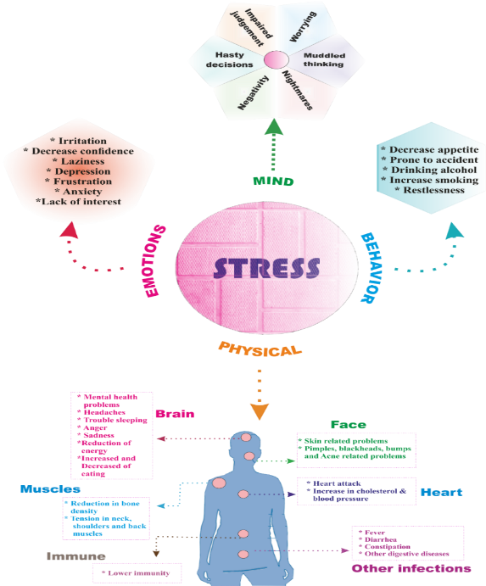
Green aromas improve one's state of mind, behaviour, and emotions.
Recent Publications (minimum 5)
- Antonelli, Michele, Davide Donelli, Grazia Barbieri, Marco Valussi, Valentina Maggini, and Fabio Firenzuoli. 2020. "Forest Volatile Organic Compounds and Their Effects on Human Health: A State-of-the-Art Review". 111:855-876.
- Løtvedt, P. K., Murali, S. K., Salazar, L. T. H., & Laska, M. (2012). Olfactory sensitivity for “green odors” (aliphatic C6 alcohols and C6 aldehydes)—A comparative study in male CD-1 mice (Mus musculus) and female spider monkeys (Ateles geoffroyi). Pharmacology Biochemistry and Behavior, 101(3), 450-457.
- Green Odor Reduces Pain Sensation and Fatigue-like Responses Without Affecting Sensorimotor Function.
- Alleviating effects of plant-derived fragrances on stress-induced hyperthermia in rats.

Biography

Dr Rakhee is currently working as Research scientist in Venkateshwara Mint Products, Pvt. Ltd. Company and Savory Aroma India Pvt. Ltd. company in India. She is expertise in synthesis of natural products, API intermediates in industrial level such as Cis-3-hexenol, Cis-3-hexyn-1-ol, Benzyl alcohol etc. She manage the manufacturing of flavors, fragrances, essential oil, perfume, aromatic compounds, natural extract etc.
Email: rakheerajput1988@gmail.com
Notes/Comments:
Presenting author details
Full name: RAKHEE, Contact number: 9990426868
Twitter account: NIL
Session name/ number:
Linked In account: https://www.linkedin.com/in/rakhee-rajput-570ba186/
Google Scholar link: https://scholar.google.co.in/citations?user=3fdbzO4AAAAJ&hl=en
Facebook link: https://www.facebook.com/rakhee.rajput.1/
Category: (Oral presentation/ Poster presentation): Poster presentation

