Na, K-ATPase as a receptor that modulates neuroplasticity.
Ana Maria M. Orellana

University of São Paulo, Brazil

Abstract
Statement of the problem: The Na, K-ATPase (NKA) is a heterodimeric integral plasma membrane protein, ubiquitously expressed in mammalian cells, that differ from other ion transporters (Orellana et al., 2022). The difference is not only due to its capacity to maintain an electrochemical gradiente across plasma membrane, but also as a receptor for Ouabain (OUA), a cardiotonic steroid (Aperia et al., 2016). Studies from the last two decades, have demonstrated that OUA, can activate a network of signaling molecules through NKA, that will serve as a signal transducer in the cell (Pierre and Xie, 2006). The purpose of this study is to verify whether OUA can modulate neural plasticity as well as adult neurogenesis.
Methodology & theoretical orientation: In vivo and in vitro assays were performed using Wistar rats. All the protocols were performed according to ARRIVE guidelines and following Ethical Committee for Animal Use from University of São Paulo. Intrahippocampal injection of OUA 10 nM were performed in adult male rats as previously described (Kawamoto et al., 2012). Animals were submitted to Morris Water Maze test, to verify the effects of OUA in spatial long-term memory. Furthermore, a neural precursor cell culture obtained from neonatal hippocampus was treated with OUA 10 nM. Microscopy, flow cytometry and biochemical assays were performed.
Findings: Indeed, intrahippocampal injection of OUA, in male adult rats, activated the Wnt/β-Catenin signaling pathway and increased CREB/BDNF and NFᴋB levels, in CA1 neurons. These effects contributed to important changes in the cellular microenvironment, resulting in enhanced levels of dendritic branching in hippocampal neurons, in association with an improvement in spatial reference memory and the inhibition of long-term memory extinction (Orellana et al., 2018). Furthermore, in vitro assays suggest that OUA can enhance hippocampal neurogenesis (Figure 1).
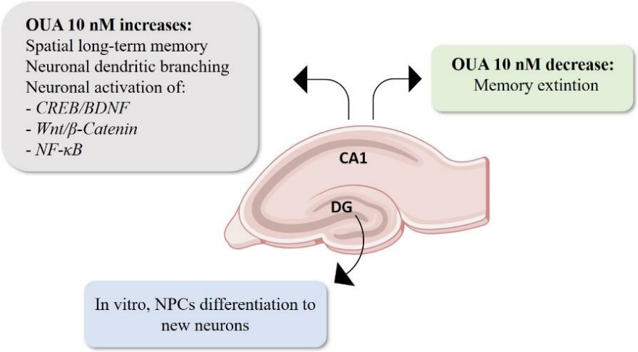
Figure 1. Effects of OUA 10 nM on the adult hippocampus. OUA improve spatial long term-memory and decrease memory extinction. It also increase new neurons generation from neural precursor cells (NPCs), in NPC cell culture.

Conclusion: Na,K-ATPase as a receptor for OUA can modulate neural plasticity related to hippocampal dependent memory in adults.
References
1. Aperia A, Akkuratov EE, Fontana JM, Brismar H. Na+ -K+ -ATPase, a new class of plasma membrane receptors. Am J Physiol Cell Physiol. 2016;310(7):C491-5.
2. Orellana AMM, Kinoshita PF, Nakao VW, de Souza Port's NM, Quintas LEM, Kawamoto EM, Scavone C. The Janus face of ouabain in Na+ /K+ -ATPase and calcium signalling in neurons. Br J Pharmacol. 2022;179(8):1512-1524.
3. Pierre SV, Xie Z. The Na,K-ATPase receptor complex: its organization and membership. Cell Biochem Biophys. 2006;46(3):303-16.
4. Kawamoto EM, Lima LS, Munhoz CD, Yshii LM, Kinoshita PF, Amara FG, Pestana RR, Orellana AM, Cipolla-Neto J, Britto LR, Avellar MC, Rossoni LV, Scavone C. Influence of N-methyl-D-aspartate receptors on ouabain activation of nuclear factor-κB in the rat hippocampus. J Neurosci Res. 2012;90(1):213-28.
5. Orellana AM, Leite JA, Kinoshita PF, Vasconcelos AR, Andreotti DZ, de Sá Lima L, Xavier GF, Kawamoto EM, Scavone C. Ouabain increases neuronal branching in hippocampus and improves spatial memory. Neuropharmacology. 2018;140:260-274.
Biography
Dr. Orellana studied Pharmaceutical Sciences at the University of Campinas. She had her PhD degree in Neuropharmacology at University of São Paulo, where she started studying the different roles of Na,K-ATPase in the Central Nervous System. From 2015-2016 she worked at Karolinska Institute, Sweden, in the group of Dr. Anita Aperia. Since 2017 she has been studying the effects of Na,K-ATPase signaling in neurogenesis, and has been doing scientific work at the Institute of Biomedical Science (ICB-USP) in Brazil. In 2022, she was selected to participate in Interstellar Initiative, organized by New York Academy of Science and Japan Agency for Medical Research and Development. Since 2021, Dr. Orellana belonged to the editorial board of the Journal Frontiers in Aging Neuroscience.

