In vitro Antimycoplasmal Activity of Peganum harmala on Mycoplasma hominis Tunisian strains
Nadine Khadraoui , PhD , Tunisia
Rym Essid, PhD , Tunisia
Olfa tabbene, Professor , Tunisia
Imen Chniba , PhD , Tunisia
Selim Jallouli , Laboratory Technician , Tunisia
Nadia Fares, Laboratory Technician, Tunisa
Behija Mlik, Laboratory Technician, Tunisia
Boutheina Ben Abdelmoumen Mardassi , Professor , Tunisia

Abstract
Mycoplasma hominis is an opportunistic pathogen that can cause various gynecological infections such cervicitis, infertility, and less frequently, extra-genital infections. Previous studies on the antimicrobial susceptibility of Mycoplasma hominis Tunisian strains have highlighted a significant multi-resistance to the most conventional antibiotics. To address this concern, the present study aimed for the alternative of phytotherapy. Peganum harmala seed extract was tested as an antibacterial agent against multidrug-resistant M.hominis clinical strains.
Tunisian Peganum harmala plant was collected, air-dried, grounded and extracted by different solvents. Antibacterial activity was evaluated against M. hominis ATCC 23114 and 20 M. hominis clinical strains and MIC values were determined. Phytochemical analysis and hemolytic activity on human erythrocytes were also performed. The active fraction was then subjected to purification and the chemical identification of the active compound was investigated.
Our results showed that the n-BuOH extract was the most active fraction among the tested fractions since it exhibited an inhibitory effect against M. hominis ATCC 23114 and 80% of the tested clinical strains with MIC between 125 and 1000 µg/ml. The phytochemical analysis of the n-BuOH revealed its metabolic abundance in polyphenols, flavonoids and condensed tannin with levels of 257.37 mg AGE/g, 172.27 mg EC/g and 58.27 mg EC/g, respectively. In addition, P. harmala n-BuOH extract exhibited potent bactericidal activity against all M. hominis isolates with CMB values ranging between 125 and 4000 µg/ml. Further, the active fraction exhibited weak cytotoxicity effect at active concentrations when tested on human erythrocytes. The active compound was identified by gas chromatography–mass spectrometry as an indole alkaloid harmaline.

Image
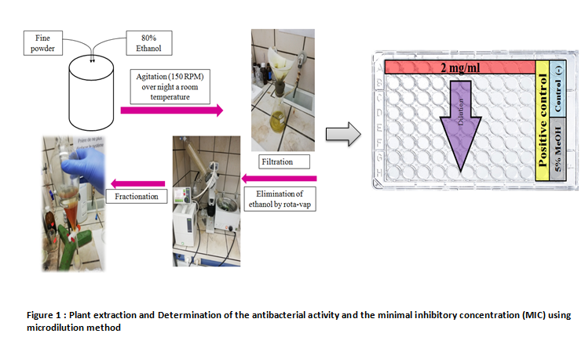
Recent Publications
- Bouabedelli F, Missouni F, Benhamimed E , Djebli N (2016) Phytochemical and antimicrobial study of the seeds and leaves of Peganum harmala L. against urinary tract infection pathogens. Asian Pacific Journal of Tropical Disease .6(10),822-826.
- Boujemaa S, Mlik B, Mardassi H ,Ben Abdelmoumen Mardassi, B (2020) Clonal Spread of Tetracycline Resistance Among Mycoplasma hominis Clinical Strains, Tunisia. Infection and Drug Resistance. 13,2093-2097.
- Khadraoui N, Essid R, Jallouli S, Damergi B , Ben Takfa I , Abid G, Jedidi I, Bachali A , Ayed A , Limam F ,Tabbene O (2022) Antibacterial and antibiofilm activity of Peganum harmala seed extract against multidrug-resistant Pseudomonas aeruginosa pathogenic isolates and molecular mechanism of action. Archives of Microbiology .204 (2), 133.
- Lanao A.E , Chakraborty R.K ,Pearson-Shaver A.L (2021) Mycoplasma Infections. In: StatPearls .Treasure Island (FL), StatPearls.
- Pascual, A., Perez, M-H., Jaton, K., Hafen, G., Di Bernardo, S., Cotting, J., Cotting, J., Greub, G. and Vaudaux, B. (2010) Mycoplasma hominis necrotizing pleuropneumonia in a previously healthy adolescent. BMC Infectious Diseases. 10(1),335.

 Biography

Nadine Khadraoui is a doctorate in Biological Sciences in University of Tunis El Manar, Tunisia. She has completed her PhD entitled ‘Evaluation of anti-infectious activities of Tunisian plants and their molecular mechanism of action’ from the center of Biotechnology of Borj Cedria ,Tunisia .Actually , as a permanent laboratory technician in the laboratory of Mycoplasma at the Pasteur Institute of Tunisia , she’s investigating the prevalence of Mycoplasma infections and antibiotic resistance of these isolates across Tunisian population .She’s currently working on discovering natural compounds isolated from medicinal plants as reservoirs of novel therapeutic agents to combat antibiotic resistance.
Email:
Khadraoui.nadine@gmail.com

Notes/Comments:

Presenting author details
Full name: Nadine Khadraoui
Contact number: +21625177154
Linked In account: Khadraoui Nadine
Session name/ number: Herbal Medicine and Plant Remedies
Category: Poster presentation

